


SUMMARY PROJECT REPORT FOR
ENVIRONMENTAL & SOCIAL IMPACT ASSESSMENT FOR THE PROPOSED CONSTRUCTION AN ABLUTION BLOCK AT KIMAWASCO Head Office SITE

PROJECT: WATER AND SANITATION DEVELOPMENT PROJECT (WSDP)
CREDIT NO.: IDA -60300KE
COUNTRY: REPUBLIC OF KENYA
PROPONENT: KILIFI MARIAKANI WATER AND SEWERAGE COMPANY
SUBMITTED ON: JANUARY 2026

Declaration

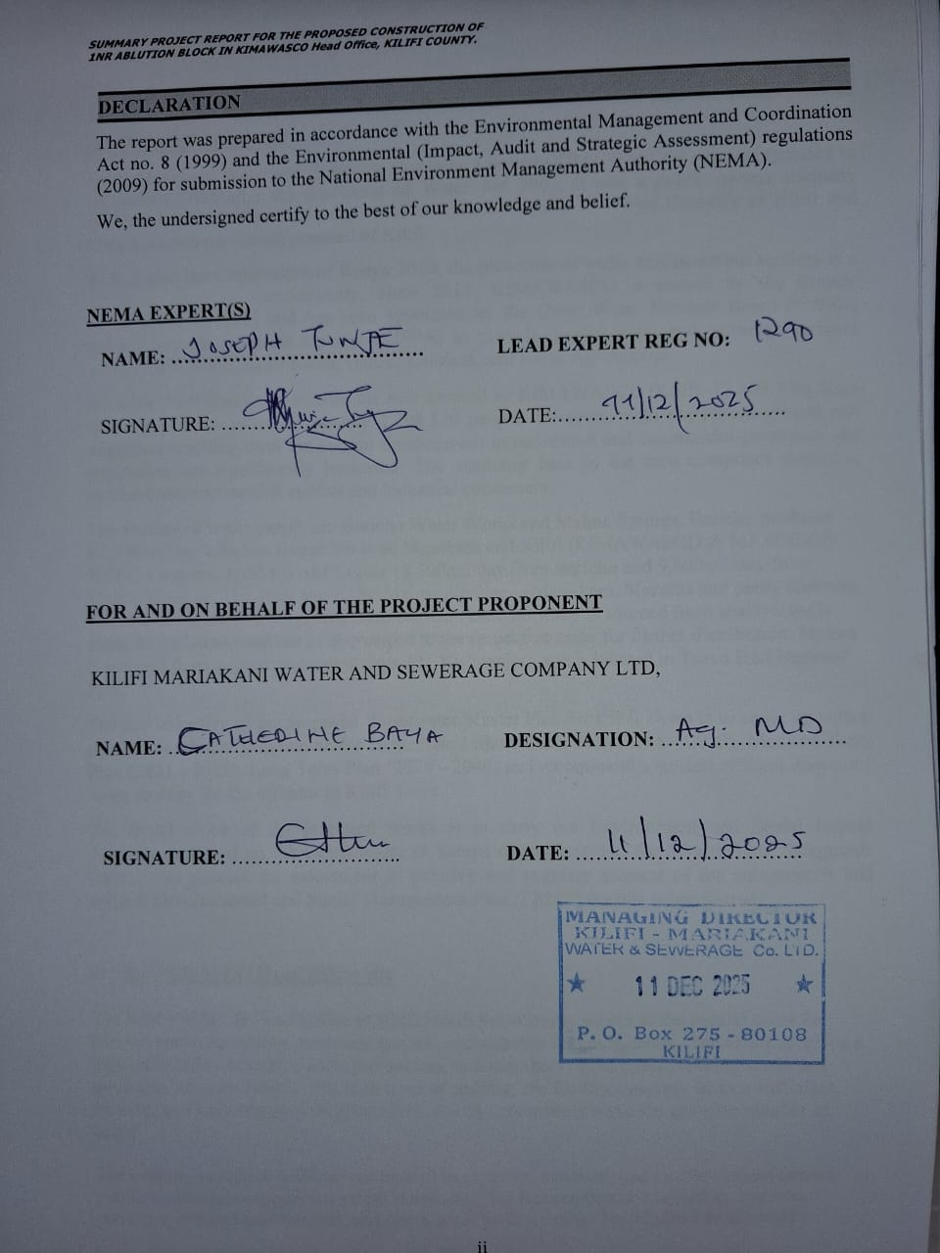

NON- TECHNICAL EXECUTIVE SUMMARY
Project Background
Kilifi Mariakani Water and Sewerage Company Limited (KIMAWASCO) was incorporated in November 2005 after the enactment of Water Act 2002. It was a public owned company incorporated under the Company’s Act and wholly owned by Town Councils of Kilifi and Mariakani and the County Council of Kilifi.
In line with the Constitution of Kenya 2010, the provision of water and sanitation services is a devolved function. Consequently, since 2013, KIMAWASCO is owned by the County Government of Kilifi and has been appointed by the Coast Water Works Development Agency (CWWDA) through service provision agreement (SPA) to provide quality water and sewerage services within Kilifi North, Kilifi South, Ganze, Kaloleni, and Rabai sub counties.
The KIMAWASCO Head Office in Kilifi North Sub-County serves as the central point for administrative operations, customer service, and stakeholder engagement. The office receives a high daily influx of staff, clients, contractors, and members of the public seeking water and sanitation services. Despite this high level of activity, the facility currently lacks a sufficient, modern, and well-designed ablution block that can adequately serve the growing number of users.
The existing sanitation facilities are limited in capacity, outdated, and unable to meet current public health and occupational safety standards. This has resulted in congestion, hygiene concerns, reduced user comfort, and operational inefficiencies. The absence of adequate sanitation also exposes the organization to non-compliance with public health regulations and undermines its image as a water and sanitation service provider. If not addressed, the situation may lead to increased sanitation-related complaints, health risks, poor working conditions for staff, and a compromised customer experience.
The proposed Project
The design of the proposed ablution block inside the KIMAWASCO Office is set to comprise of:
- 8 Nr. Toilets; 4 Nr Male and 4 Nr. Female
- 4 Nr. Shower Rooms; 2 for each Gender.
- 1 Nr. Storeroom
Separate urinals will be provided within the "gents" section to increase the number of people that can use the facility especially during the peak hours.
A septic tank with a holding capacity of 15.9 m3 will be connected to the facility for holding and partial treatment of sewage. This size of septic tank will require desludging after an interval of 3 months.
Every facility will comprise of separate washroom sections for ladies and gentlemen (gents) with equal number of toilets. Each section (for ladies and gents) will be provided with one toilet fitted with special amenities for access and use by Persons with disabilities (PWDs). Two shower rooms equipped with a dressing area, hand-wash basins, mirrors as well as a 900 mm high worktop will also be provided in each section.
A 2,000-litre water tank shall be installed to provide 3 days of storage at the required volume. The tanks will be mounted on top of the roof slab for supply of water to the ablution block especially in emergency cases. Electricity will be also provided for use at night and for security lighting.
Project Justification
The development of a modern ablution block at KIMAWASCO Head Office is justified based on the following grounds:
a) Improvement of Public Health and Hygiene
Adequate sanitation facilities are essential for preventing the spread of diseases and maintaining high hygiene standards. A modern ablution block will promote a clean and healthy environment for staff and visitors accessing services at the office.
b) Compliance With Legal and Regulatory Requirements
Kenyan laws—including the Public Health Act, OSHA 2007, and Building Code regulations—require institutions to provide sufficient sanitation facilities for users. Constructing the ablution block will ensure compliance with national health and safety standards and NEMA environmental requirements.
c) Enhanced Customer Service Experience
The head office is a customer-facing environment where clients regularly visit for billing, inquiries, and technical support. Providing clean, accessible washrooms will significantly improve client comfort and service delivery.
d) Improved Staff Welfare and Productivity
Availability of reliable sanitation facilities contributes to employee dignity, morale, and overall workplace efficiency. Staff will be able to work in a healthy and conducive environment, reducing interruptions due to inadequate facilities.
e) Meeting Increasing User Demand
Growth in KIMAWASCO’s customer base and workforce has increased pressure on existing facilities. The new ablution block will address current demand and provide capacity for future expansion.

f) Institutional Image and Professionalism
As a water and sanitation utility, KIMAWASCO must lead by example in maintaining high sanitation standards. A modern facility will reinforce the organization’s credibility and commitment to quality service delivery.
g) Environmental Sustainability
The project will incorporate hygienic waste management, water-saving fixtures, and environmentally friendly design features, supporting sustainable sanitation solutions.
Environmental and Social Baselines

The proposed project site is located within an urban, institutional setting with low environmental sensitivity, characterized by minimal vegetation (a few mature trees that will not be removed) and no presence of wildlife. The site currently hosts KIMAWASCO administrative offices and is officially designated for water and sanitation services, with no competing land uses or income-generating activities. Kilifi County’s broader economy is supported by tourism, agriculture, fishing, livestock, and industry, although these are not directly linked to the project site. Existing infrastructure, including roads, electricity, and water supply, is already in place, but sanitation facilities are inadequate, necessitating the construction of an ablution block to improve hygiene and welfare. The project will not result in land acquisition, land-use change, displacement, or resettlement.
According to the 2019 Kenya Population and Housing Census, the area covered by Kilifi-Mariakani Water and Sewerage Company (KIMAWASCO), within Kilifi County, has a total population of approximately 1,453,787 people, comprising 704,089 males and 749,673 females. Recent estimates indicate that the population has continued to grow due to natural population increase, rural–urban migration, and rapid development in residential, tourism, and commercial sectors across towns such as Malindi, Kilifi, and Mtwapa. Population projections estimate the county’s population at approximately 1,577,335 in 2023, with further projections indicating it could reach around 1,643,420 by 2025.
The customer base within the service area of KIMAWASCO consists of domestic households, institutional consumers (such as schools and health facilities), commercial establishments, and small industrial users. Rapid population growth and urban expansion have increased demand for reliable water supply and sanitation services within the County.
The ESIA Study
An Environment and Social Impact Assessment has been carried out based on the Government of Kenya regulations and the World Bank Safeguards Operational policies. It entailed an assessment of positive and negative impacts of the sub-project and preparation of an Environmental and Social Management Plan (ESMP) for the subproject.
The study approach and methodology adopted included screening, to determine the extent of the project impacts, desktop data search and analysis for the baseline biophysical and social environmental parameters of the project area. Stakeholder engagement was conducted through public consultations. Consultations with relevant agencies, such as the land department, to facilitate land allocation for the project.
Based on these findings and expert judgement, the expert has compiled the projected social and environmental impacts (positive and negative) likely to emanate from proposed sub - project activities and the Environmental and Social Management Plan (ESMP) which details how adverse impacts will be mitigated.
- Legislative Framework for this Study
The principal National legislation governing issues of environmental concern in Kenya is the Environmental Management & Coordination Act of 1999 and the Environmental Management and Coordination (Amendment) Act, 2015. EMCA calls for Environmental Impact Assessment (EIA) (under Section 58) to guide the implementation of environmentally sound decisions and empowers stakeholders to participate in the sustainable management of natural resources. It is under this provision that the current study has been undertaken.
Other legislations adhered to during this study are the regulations borne of EMCA Cap 387 namely the Environmental Impact Assessment and Audit Regulations 2025; The Environmental Management Coordination Act (Waste Management) Regulations 2025; the Environmental Management Coordination (Water Quality) Regulations 2025; and the Environmental Management and Coordination (Noise and Excessive vibration pollution Control) Regulations 2009 (Legal Notice 61), Air quality Regulations 2009 among others.
Sectoral legislation applicable to this Project includes the Water (Amendment) Act, 2025, the Constitution, The Public Health Act (CAP. 242), among others.
In addition to the local legislation, the Expert identified the various World Bank operational policies relevant to the project. Some of these policies include Operational Policy (OP) 4.01, OP 4.12, as well as the World Bank Policy on Access to Information, 2010.
As per Operational Policy 4.01 the Bank requires environmental assessment (EA) of projects proposed for Bank financing to help ensure that they are environmentally sound and sustainable, and thus to improve decision making. EA should consider the natural environment, human health and safety and all social aspects.
- Conclusions from Public Consultation
As part of the ESIA process, public consultations were conducted with Kilifi Mariakani Water and Sewerage Company Limited (KIMAWASCO) staff and the local community within the project area. The Expert undertook two forms of stakeholder engagement: Key Informant Interviews (KIIs) with the Client, local administrative leaders, and KIMAWASCO management staff, and a public participation meeting held in an open forum at the proposed project site at the KIMAWASCO Head Office in Kilifi on 5th December 2025 (see Appendix B).
The public participation meeting was attended by a total of 42 participants, comprising 24 males and 18 females. Of these, 15 were youth (8 male and 7 female), while 3 participants were identified as vulnerable persons, including elderly persons and persons with disabilities. In addition, six (6) Key Informant Interviews were conducted, involving two KIMAWASCO management staff, two local administrative leaders, and two project technical representatives.
During the consultations, stakeholders raised concerns regarding inadequate sanitation facilities within the area, potential odour and maintenance challenges, accessibility for vulnerable groups, employment opportunities for local youth, and health and safety risks during construction. In response, it was clarified that the proposed project is specifically intended to improve sanitation access and hygiene standards within the project area. The design incorporates proper ventilation, scheduled desludging, and a clear Operation and Maintenance (O&M) framework under KIMAWASCO to ensure sustainability. The facility will include ramps and accessible cubicles to accommodate persons with disabilities. It was further noted that the contractor will be encouraged to prioritise local labour, particularly for non-skilled and semi-skilled positions. Environmental, Health and Safety (EHS) measures will also be implemented during construction, including appropriate signage, use of personal protective equipment (PPE), and controlled work zones.
Overall, it was evident from the consultations that the area requires the proposed sanitation facility development project. The community expressed strong support for the sub-project and acknowledged its anticipated benefits in improving public health, environmental sanitation, and dignity. Stakeholders further recommended the implementation of similar projects in other underserved areas within the county.

- Expected impacts
The project has been rated Category B under the World Bank Operational Policy on Environmental Assessment (OP 4.01). This means that projected impacts will not affect an area broader than the site and facilities subjected to the physical works. These impacts are easily reversible through appropriate mitigation measures provided in this assessment.
The expected impacts emanate from the Pre-Construction/Planning phase, the Construction Phase, the Operation phase and the De-Commissioning Phase of the project.
In general, successful implementation of the project will have high environmental and socio-economic benefits to KIMAWASCO staff and visitors, and the community in general, and will contribute to their health and well-being. Overall, negative expected impacts are related to the planning and construction activities of the project. These impacts are localized and not considered significant and long-lasting and can be mitigated through appropriate mitigation measures. The severity and duration of these impacts can be minimized by ensuring that the construction and operation phase activities adhere to the proper construction and operation standards specified by the design and supervision engineers.
The positive benefits of the project will include:
- Employment during construction
- Improved supply of sanitation services
- Overall improvement in hygiene
Table 1: Summary of the Planning, Construction and Decommissioning Phase Risks and Mitigation Measures
Risk / Potential Impact | Proposed Mitigation Measure
Site-related oil spills due to use of machinery and storage of fuel and lubricants | Proper storage of fuel and lubricants in designated areas with secondary containment; regular inspection and maintenance of machinery; immediate clean-up of spills using absorbent materials; provision of spill kits on-site; training of workers on spill response procedures.
Degradation of air quality from dust and emissions during construction activities | Regular water sprinkling on exposed surfaces and access roads; covering of trucks transporting materials; proper maintenance of vehicles and equipment to minimize exhaust emissions; use of PPE (dust masks) by workers; limiting idling of engines.
Noise pollution from machinery, equipment, and vehicles | Restrict construction activities to daytime hours; regular servicing of equipment; provision of ear protection to workers; advance notice to nearby receptors where necessary.
Generation of solid waste from construction activities and contractor’s camp | Preparation and implementation of a Waste Management Plan; segregation of waste at source; reuse and recycling of suitable materials; safe disposal of non-recyclable waste at licensed disposal sites approved by the County Government.
Occupational and Public Health & Safety risks (accidents, injuries, exposure to hazards) | Implementation of an Occupational Health and Safety (OHS) Plan; provision and enforcement of PPE use; site fencing and controlled access; installation of warning signage; toolbox talks and safety training; first aid kits and trained first aiders on site; insurance cover for workers.
HIV & AIDS and STI transmission risks due to influx of workers | Conduct HIV/AIDS and STI awareness campaigns; collaborate with local health facilities for sensitization programs; enforce a Code of Conduct for workers; provide information, education and communication (IEC) materials.
Gender inequality in access to employment opportunities | Ensure equitable recruitment of men and women where feasible; promote women’s participation in skilled and semi-skilled roles; enforce non-discrimination policies in hiring and remuneration.
Increased crime and insecurity due to storage of construction materials | Secure storage areas; employ security personnel; proper lighting of site; maintain inventory control of materials; collaborate with local administration and community policing initiatives.
Risk of child labour (engagement of persons under 18 years) | Strict prohibition of child labour in contractor agreements; verification of workers’ identification documents; routine audits and supervision to ensure compliance with labour laws.
Risk of sexual harassment and gender-based discrimination at the workplace | Adoption and enforcement of a workplace Sexual Harassment Policy; signing of Code of Conduct by all workers; confidential grievance redress mechanism (GRM); disciplinary action against offenders.
Risk of Gender-Based Violence (GBV), Sexual Exploitation and Abuse (SEA), and Sexual Harassment (SH) linked to labour influx and community interactions | Implementation of a GBV Action Plan; worker Code of Conduct addressing GBV/SEA/SH; establishment of a confidential and survivor-centered GRM; awareness creation within the community; collaboration with local GBV support service providers.
Liability for loss of life, injury, or damage to private property | Contractor to obtain adequate insurance cover; implement safety controls; barricade hazardous areas; continuous supervision of works; prompt compensation for verified damages in accordance with legal requirements.

Table 2: Operation Phase Risks and Mitigation Measures (Including Social Impacts)
Risk / Potential Impact | Proposed Mitigation Measure
Odour nuisance and proliferation of houseflies due to poor maintenance of the ablution block | Regular cleaning and disinfection of the facility; continuous water supply for flushing; proper ventilation; scheduled desludging of the septic tank; routine inspection of plumbing systems; prompt repair of leaks or blockages.
Groundwater pollution from leakage or failure of the septic tank and soak pit system | Ensure proper design and construction of septic tank and soak pit in accordance with public health standards; site the soak pit at safe distances from water sources; periodic inspection of septic tank and pipework for cracks or leakages; scheduled emptying by licensed exhauster trucks; safe disposal of sludge at approved treatment facilities.
Solid waste accumulation within the facility | Provision of clearly marked waste bins inside cubicles (including covered bins for sanitary waste); routine collection and safe storage of waste; disposal through the County-approved waste collection system; installation of signage discouraging disposal of solid waste into toilets; periodic emptying of septic tank sludge by licensed service providers.
Public health risks due to poor hygiene practices or inadequate maintenance | Assign trained personnel for daily cleaning and supervision; provide adequate handwashing facilities with soap; display hygiene awareness signage; maintain adequate lighting and ventilation.
User conflicts and vandalism | Community sensitization on proper use of facilities; engagement of a caretaker; establishment of user guidelines; minor user fees (where applicable) to support maintenance; collaboration with local administration for security oversight.
Exclusion of vulnerable groups during operation | Ensure universal access design (ramps, handrails, accessible cubicles); maintain affordability of user fees; involve community representatives in management oversight.
Occupational health risks to operation and maintenance staff | Provision of appropriate PPE (gloves, boots, masks); training on safe handling of cleaning agents and sludge; vaccination of workers where necessary; adherence to public health guidelines during desludging operations.

- Environmental and Social Management Plan (ESMP)
This Environmental and Social Management Plan (ESMP) has been prepared to reduce, minimize, or altogether eliminate adverse environmental and social impacts of the project. Positive impacts, which constitute project enhancements, do not require mitigation measures.
The ESMP is fully detailed in Chapter 8 of this report. The table below provides a summary of the identified environmental and social impacts, their corresponding mitigation measures, and the parties responsible for implementing these measures.
During project implementation, the Contractor will submit monthly progress reports to the Supervision Consultant and the Project Coordination Unit, which comprises the Environmental and Social Expert and KIMAWASCO, detailing the status of ESMP implementation.
In line with the requirements of the Occupational Health and Safety Act (OSHA) 2007, the Environmental Management and Coordination Act (EMCA) 1999 and its 2015 Amendment, and the World Bank Environmental, Health, and Safety (EHS) Guidelines, all ESHS incidents—including accidents, dangerous occurrences, and occupational diseases—shall be promptly reported to the relevant regulatory authorities using the prescribed formats (DOSHS ML/DOSHS/FORM 1). Reports shall also be submitted to the World Bank.
Records of all incidents will be maintained and made available for inspection throughout the project implementation phase. For every reportable incident, an investigation shall be conducted, and a corrective action plan developed to prevent recurrence.
Table 3:Summary of the Environmental and Social Impacts and Mitigation Measures
Phases | Environmental/Social Component | Performance Indicators | Mitigation Measures | Frequency | Responsibility | Budget in Kshs
Construction | Site Related Oil Spills | Number of spill incidents reported,  mitigation measures taken | - Use of spill kits  - Regular maintenance of machinery  - Secondary containment systems, staff training on spill response | Monthly | Contractor  Site Supervisor | 45,850 to cater for the safety training seminars for this site
Construction | Soil Related Impacts | Soil contamination tests, visible soil degradation observations | - Proper waste disposal  - Containment measures for hazardous materials  - Soil stabilization techniques  - Regular site inspections | Quarterly | Contractor  Resident Engineer | Kshs 12,500 to cater for accidental oil spills and tests on soil to ensure compliance
Construction | Air Quality | Dust levels, emissions readings, community complaints | - Water sprinkling,  - Regular maintenance of vehicles and machinery  - Use of low-emission equipment  - Dust screens | weekly | Contractor  Resident engineer | Kshs.5,000 to cater for dust masks  Kshs 12,400 for spraying water
Construction | Noise Pollution | Noise level readings, worker/community complaints | - Noise barriers  - Scheduling noisy activities during the day  - Regular equipment maintenance  - Provision of ear protection for workers | Weekly | Contractor  Site Supervisor | No additional costs
Construction | Generation of Solid Waste | Volume of waste generated, waste disposal records | - Waste segregation  - Recycling  - Proper disposal at approved sites,  - Composting organic waste  - Waste reduction strategies | Weekly | Contractor  Resident engineer
Construction | Traffic Congestion Socio-Economic Impacts | Delivery schedules, traffic disruption reports | - Traffic management plans  - Coordination with local authorities  - Delivery during off-peak hours  - Site access control | As needed | Contractor | No additional costs
Construction | Occupational Health and Safety | Number of accidents/injuries, safety training records | - Safety gear i.e. Gumboots, safety boots, reflector jacket, hard hat  - Regular safety drills,  - First aid stations,  - Clear safety signage  - Emergency response plans | Monthly | Contractor  Resident engineer | 15,000 for personal protective equipment
Construction | HIV & AIDS Impacts  STIs | Awareness programs conducted, number of participants | - HIV/AIDS education,  - Access to condoms (both male and female) and healthcare,  - Peer education programs  - Community outreach | Quarterly | Contractor  Community Health Workers | 20,000.00 to cater for a comprehensive awareness program including VCT services and provision for ARVs throughout the project period.
Construction | Crime | Incident reports, security patrol logs | - Hiring security personnel  - Securing construction sites  - Community engagement | Monthly | Contractor  Local Law Enforcement | No additional costs
Construction | Child Labour and Protection | Age verification records, number of child labour cases reported | - Strict hiring policies,  - Regular audits,  - Community awareness campaigns  - Worker ID checks | Continuous | Contractor  Resident Engineer | No additional costs
Construction | GBV-SEA / SH | Number of GBV cases reported, grievance redress actions taken | - Awareness campaigns  - Grievance redress mechanism  - Staff training on GBV prevention  - Collaboration with local support services  - Code of conduct should be signed by all employees | As needed | Contractor,  Resident Engineer  KIMAWASCO  Local CBO/ NGO | Cost to be met from the contractors’ budget  Kshs. 25,000
 | Gender Empowerment | Number of women employed | - Equal opportunity hiring  - gender sensitivity training | Quarterly | Contractor  Resident Engineer
 | Gender Equity, Sexual Harassment | Grievance reports, training sessions on gender equity | - Anti-harassment policies  - Anonymous reporting systems  - Mandatory training on harassment prevention  - Clear disciplinary actions | Quarterly | Contractor  Resident engineer | No additional costs
 | Liability for Loss of Life, Injury or Property Damage | Incident reports, compensation records, corrective actions taken | - Insurance coverage WIBA for all workers,  - Worker training  - Emergency response plans  - Regular safety audits | Monthly | Contractor,  Resident engineer | No additional Costs.  Compensation to be determined when it happens.
 | Public Health & Safety | Number of communicable diseases reported | - Regular maintenance of the facility,  - Implementation of proper sludge handling  - Training staff on health and safety protocols.  - Community awareness on hygiene practices | Monthly | KIMAWASCO  Local Health Authorities | No additional costs
 | Impact of wastewater | Records of cleaning schedules, desludging, and soak pit inspections. | - Regular inspection and desludging of septic tanks  - Periodic cleaning and rehabilitation of soak pits  - Using low-flow fixtures and water-efficient technologies to reduce wastewater volume.  - Educating users on responsible water usage | Quarterly | KIMAWASCO  Local Authorities | No additional costs
 | Impacts on water sources | Regular testing for pH, dissolved oxygen, nitrates, and coliform bacteria in nearby water sources | - Routine water quality monitoring of nearby water bodies and groundwater.  - Installation of a well-maintained septic system  - Developing a contingency plan for emergency leaks | Quarterly | KIMAWASCO  NEMA  Water Resources | No additional costs
 | Generation of Solid Waste | Monitoring the amount and type of waste collected and properly disposed of. | - Installing clearly marked waste bins with proper segregation  - Partnering with local waste management services  - Signage encouraging responsible waste disposal. | Monthly | NEMA  KIMAWASCO | 2500.00 to cater for solid waste management such as colour coded bins (red-hazardous, yellow-recyclable & green-organic); as well as sealed collection drums for used oil disposal.  4,170.00 cater for the capital of acquiring dustbins to be used during the operation period of the project. Other costs to be included in the O&M Manual.

- The ESMP Implementation Arrangements
Water and Sanitation Project (WSP) responsibility
Since the Water and Sanitation Project (WSP) has a dedicated team for environmental and social management, it has the capacity to monitor the Environmental and Social Management Plan (ESMP) effectively by:
- Ensuring contractors follow ESMP requirements.
- Monitoring adherence to environmental and social safeguards, as well as national and donor policies i.e. Environmental specialists will ensure that environmental safeguards are met, while social safeguard experts will maintain community relations and mitigate social risks.
- Reviewing reports and ensuring their environmental and social policies are upheld.
Supervision Consultant Role
The supervision consultant will be required to have an Environmental and Social (E&S) specialist to ensure the effective implementation of the Environmental and Social Management Plan (ESMP). Their role will include:
- Oversee that contractors adhere to environmental and social safeguard measures.
- Monitor project activities, identify risks, and recommend corrective actions.
- Assess contractor-submitted environmental and social management plans for alignment with ESMP requirements.
- Ensure worker and public safety measures are in place.
- Address grievances from local communities and ensure stakeholder engagement.
- Provide reports and updates to the WSP’s environmental and social team.
- Document findings and submit reports to the relevant Project Coordinating Teams agencies.
Contractor’s Safeguards’ Team
- Ensuring all environmental and social mitigation measures outlined in the ESMP are properly executed.
- Ensuring that project activities comply with national environmental regulations, donor requirements, and site-specific environmental and social safeguards.
- Implementing and enforcing occupational health and safety (OHS) protocols to protect workers and the surrounding community.
- Conducting regular environmental and social monitoring, maintaining records, and submitting compliance reports to the supervision consultant and the PCU
- Ensuring proper waste disposal, erosion control, dust suppression, noise reduction, and other pollution prevention measures.
- Engaging with the local community, addressing concerns, and managing grievances as per the project's grievance redress mechanism.
- Conducting environmental and social awareness training for workers to promote compliance with safeguards.
- Developing and implementing emergency response plans to handle environmental, health, and safety incidents.
- Reporting
The contractor will be required to submit regular reports to ensure compliance with the Environmental and Social Management Plan (ESMP). These reports will provide updates on environmental and social performance, mitigation measures, and any incidents occurring during project implementation. The required reports and their submission frequency include:
- Contractor's ESMP (C-ESMP) Compliance monthly Report which will cover the contractor’s adherence to the ESMP, including:
- Environmental and social mitigation measures implemented.
- Compliance with occupational health and safety requirements.
- Grievance redress mechanism updates.
- Waste management practices.
- Workplace safety, PPE compliance, and health-related incidents.
- Any corrective actions taken to address non-compliance.

- Monthly Labor Tracking Document which will provide details on:
- Workforce numbers and composition (gender, skill levels, etc.).
- Working hours, wages, and contract conditions.
- Compliance with labour laws and standards.

- Incident Reports (Immediately, As Needed)
- Reports any accidents, environmental spills, safety violations, or social conflicts.
- Includes root cause analysis, corrective measures, and preventive actions

Table of Contents
Declaration ii
NON- TECHNICAL EXECUTIVE SUMMARY iii
1 INTRODUCTION 23
1.1 Need For the Project 23
1.2 The Terms of Reference 24
1.3 ESIA Objectives 24
1.4 Methodology 25
1.4. 1 Environment and Social Scoping 25
1.4.2 Stakeholder Consultations 25
1.5 Socio-economic Assessment 26
2 PROPOSED PROJECT DESCRIPTION 27
2.1 background to the proposed project 27
2.2 Location for the Office Site ablution block 27
2.3 The Proposed project Components 28
2.4 Project Implementation Cost 34
3 BASELINE CONDITIONS OF AFFECTED ENVIRONMENT 35
3.1 Flora and fauna 35
3.2 Socio-Economic activities and Infrastructure 35
3.2.1 Economic Activities 35
3.2.2 Land Use 35
3.2.3 Infrastructure 35
3.2.4 Settlement 35
3.3 Physiographic and Environmental Conditions 36
3.3.1 Climate 36
3.3.2 Topography 37
3.3.3 Geology and Soils 37
3.3.4 Hydrology and Drainage 38
3.4 HOUSEHOLD SOCIO-ECONOMIC SURVEY 38
3.4.1 Population dynamics and household characteristics 39
3.5 Water Supply 42
3.6 Sanitation 44
3.7 Environmental Situation 45
3.7.1 The Project 47
4 Stakeholder Engagement and Public Consultation 49
4.1 General 49
4.2 Applicable Laws, Regulations and Policies to Public Engagement 49
4.3 Public Participation Methodology 49
4.4 Questionnaire Administration 49
4.5 Public Participation Meetings 50
Consultation During Project Duration 50
4.6 Community Relations in Construction Phase 51
4.7 Construction Contractor’s Role in Community Liaison 51
4.8 Community Relations in Operational Phase 52
4.9 Grievance Redress Management Plan 52
5 ALTERNATIVES TO THE PROJECT 53
No Action Alternative 53
Design Alternative 53
Site Alternative 53
6 RELEVANT LEGISLATIVE/ REGULATORY FRAMEWORK 54
6.1 Policy Framework 54
6.1.2 National Environment Policy (NEP) 2013 54
6.1.3 Kenya Vision 2030 54
6.1.4 The National Environmental Sanitation and Hygiene Policy-July 2007 54
6.1.5 National Policy on Gender and Development, 2019 55
6.1.6 National Policy for Prevention and Response to Gender-Based Violence, 2014 55
6.2 Legal Framework 55
6.2.1 Environmental Management and Coordination Act of 1999 (EMCA) and Environmental Management and Coordination (Amendment) Act 2015 55
6.2.2 Environment and Land Court Act, 2011 55
6.2.3 Land Act, 2012 56
6.2.4 County Government Act No. 17 of 2012 56
6.2.5 Physical and Land Use Development Plan Act 2019 56
6.2.6 Occupational Health and Safety Act (OSHA), 2007 57
6.2.7 HIV and AIDS Prevention and Control Act 2011 57
6.2.8 Sexual Offences Act 2006 57
6.2.9 Children's Rights Act 2022 57
6.2.10 Labour Relations Act 2012 57
6.2.11 Traffic Act 2015 58
6.2.12 Public Health Act, Cap 242 58
6.3 The Environmental (Impact Assessment and Audit) Regulations, 2025 58
6.4 Environmental Management and Coordination (Water Quality) Regulations, 2024 59
6.5 Environmental Management and Co-ordination (Waste Management) Regulations, 2024 (Legal Notice 178 of 2024) 59
6.6 Environmental Management and Coordination, Noise and Excessive Vibration Pollution (Control) Regulations, 2009 59
6.7 Environmental Management and Coordination (Air Quality Regulations 2024) 59
6.8 Fire Risk Reduction Rules, 2007 60
6.9 Safety and Health Committee Rules of 2004 60
6.10 First Aid in the Workplace Regulations, 2024, Legal Notice 79 of 2024 60
6.11 OP 4.01: Environmental Assessment 60
6.12 OP 4.11: Physical Cultural Resources 61
6.13 WB EHS General Guidelines 61
6.14 WB EHS Guidelines for Water and Sanitation 61
6.15 WB EHS Guidelines for Materials Extraction 61
7 ENVIRONMENT AND SOCIAL IMPACTS OF THE PROPOSED PROJECT 62
7.1 Impact Identification 62
7.2 Impact Prediction 62
7.3 Mitigation of Impacts 63
7.4 Impact Categories 63
7.5 Impacts Emanating from the Proposed Project 69
8 ENVIRONMENTAL AND SOCIAL MANAGEMENT PLAN (ESMP) 83
8.1 Significance of ESMP 83
8.2 Purpose and Objectives of ESMP 83
8.3 Auditing of ESMP 83
8.4 Project implementation 83
8.7 Environmental and Social Monitoring Plan 93
8.9 Grievance Redress Mechanism 100
• Possible Sources of Grievances 100
8.10 Institutional Framework for Implementation of the Project and the ESMP 102
9.0 CONCLUSIONS AND RECOMMENDATIONS 103
10.0 REFERENCES 104
1.1. INTRODUCTION 119
1.2. ABLUTION BLOCK DESIGN 119
11.1 119
1.3. Proposed Layout 119
List of Appendices 122

Table of Figures
Figure 1 : Kilifi County and Neighbouring Counties 5
Figure 2 :A Google Map Figure of the KIMAWSCO Office Kilifi at coordinates 3°37'42"S 39°50'53"E 8
Figure 3 :The water demand projection for Kilifi Town up to the Ultimate Design Horizon (year 2040). 9
Figure 4 : Typical site layout plan for an ablution block 12
Figure 5 : Projected Land Use 19
Figure 6 : Precipitation in Kilifi County(Source: en.climate-data.org) 23
Figure 7 : Age Distribution of the Population 26
Figure 8 : Religion of the Population 27
Figure 9 : Sources of Energy 27
Figure 10 : Business Types in the Project Areas 28
Figure11 : Household income per month 29
Figure 12 : Main Sources of Water for the Community 29
Figure 13 : Percentage Population Paying for Water 30
Figure 14 : Amount paid per 20-litre jerrican 30
Figure 15 : General Status of the Water Quality 30
Figure 16 : Frequency of fetching water 31
Figure 17 : Common Waste Disposal Methods 31
Figure 18 :Respondents Who Have Toilets in Their Compound 31
Figure 19 :Types of Toilets Respondents Have in Their Compound 32
Figure 20 :Environmental Issues of Concern 32
Figure 21 : Environmental Conservation Initiatives 33
Figure 22 : Implementers of Environmental Conservation Initiative 33
Figure 23 : Will the sanitation Project help in conserving the Environment 34
Figure 24 :Public Awareness of the Intended Construction of the ablution block. 34
Figure 25 : Perceived Impact of the Sanitation Project 35
Figure 26 :Positive Impacts of the Proposed Project 35
Figure 27 : Sample Grievance form 88
Figure 28 : Layout, elevations and a sectional view of the proposed Kimawasco Office Ablution Block 114

List of Tables
Table 1: Summary of the Planning, Construction and Decommissioning Phase Risks and Mitigation Measures vii
Table 2: Operation Phase Risks and Mitigation Measures (Including Social Impacts) viii
Table 3:Summary of the Environmental and Social Impacts and Mitigation Measures x
Table 4: Implementation Costs for Immediate Measures 35
Table 5 : Means of Communication with Internal Stakeholders 52
Table 6: Characterization Of Negative Impacts (Construction Phase) 67
Table 7: Characterization of Operation Phase Impacts 69
Table 8: : The Proposed Environmental and Social Management Plan (ESMP) 87
Table 9: Proposed Environmental and Social Monitoring Plan 96
Table 10: Institutional Framework for ESMP 104

ACRONYMS AND ABBREVIATIONS
AB | Ablution Block
AIDS | Acquired Immunodeficiency Syndrome
CBO | Community Based Organization
CLO | Community Liaison Officer
EIA | Environmental Impact Assessment
EMCA | Environment Management Coordination Act
ESIA | Environmental And Social Impact Assessment
ESMP | Environmental And Social Management Plan
GHG | Greenhouse Gases
GIS | Geographical Information System
GOK | Government Of Kenya
GPS | Global Positioning System
HASP | Health And Safety Plan
HIV | Human Immunodeficiency Virus
HMP | Health Management Plan
ID NO. | Identity Card Number
IDA | International Development Association
K.SHS. | Kenya Shillings
KFS | Kenya Forestry Service
M3 | Cubic Metres
MOWSI | Ministry of Water Sanitation, and Irrigation
NEMA | National Environment Management Authority
NGO | Non-Governmental Organization
NLC | National Land Commission
NMK | National Museums of Kenya
NPEP | National Poverty Eradication Plan
OP | Operational Policy
PEC | Poverty Eradication Commission
PPE | Personal Protective Equipment
SEA | Sexual Exploitation and Abuse
SDB | Sludge Drying Bed
SHF | Sludge Handling Facility
STD | Sexually Transmitted Diseases
KIMAWASCO | Kilifi-Mariakani Water and Sewerage Company Ltd
VCT | Voluntary Counselling and Testing
WASSIP | Water And Sanitation Service Improvement Project
WASSIP-AF | Water And Sanitation Service Improvement Project – Additional Financing
WB | World Bank
WHO | World Health Organisation
WRA | Water Resources Authority
WSSD | World Summit for The Social Development
WTP | Water Treatment Plant
WWTP | Wastewater Treatment Plant

INTRODUCTION
Environmental and Social Impact Assessment (ESIA) is an analytical process that systematically examines the possible environmental consequences of a project´s implementation. ESIA provides a way of assessing key issues effectively and transparently, and highlights opportunities to achieve wider environmental objectives. An ESIA is carried out for new projects that are likely to have significant adverse impacts on the environment.
An Environmental and Social Management Plan (ESMP) is one of the outputs of an ESIA process. An ESMP establishes how impact mitigation measures are to be implemented and monitored. An ESIA provides competent environmental authorities insight on the environmental risks of a project to determine if it should be rejected, approved, or approved conditioned to the implementation of mitigation measures. The ESMP is used to ensure the impact mitigation measures get implemented and provides the elements to monitor key environmental variables.
ESIA became compulsory in Kenya after the enactment of Environmental Management and Coordination Act (1999). This Act has undergone several amendments but the most far-reaching changes came in Environmental Management and Coordination (Amendment) Act (2015). The 2015 amendment was to align the Act with Constitution of Kenya, 2010. Under Kenya’s environmental laws, Environmental Impact Assessment is required for all projects that are likely to have a negative effect on the environment. The law classifies these projects into three groups according to the seriousness of their likely effects, namely: Low Risk, Medium Risk, and High-Risk projects.
The goal of an ESIA is to ensure that decisions on proposed project and activities are environmentally sustainable. Specific objectives of ESIA include:
- Identify impacts of a project on the environment.
- Predict likely changes on the environment because of the development.
- Evaluate the impacts of the various alternatives on the project.
- Propose mitigation measures for the significant negative impact of the project on the environment.
- Generate baseline data for monitoring and evaluation impacts, including mitigation measures during the project cycle.
- Highlight environmental and Social issues with a view to guiding policy makers, planners, stakeholders and government agencies to make environmentally and economically sustainable decisions.
The broad scope of the work is to carry out Environment and Social Impact Assessment of the proposed KIMAWSCO Office Site Ablution Block in Kilifi Town.

1.1 Need For the Project
The strategic importance of this project lies in the need for overall improved sanitation in the ballooning population of Kilifi.
Currently, the sanitation situation in KIMAWSCO Office, Kilifi, poses a significant health hazard to residents and presents an environmental risk. There are no sanitation facilities available for staff and visitors operating near the proposed site.
The implementation of the project will contribute to the improvement of the sanitation situation in the area, improved performance of the economic sectors and the delivery of social services in the project environs
The current sanitation infrastructure in Kilifi Town is insufficient to meet the sanitation needs of the growing population and there is a need for the development of a sustainable water-borne sanitation system.
The main beneficiaries will be: -
- KIMAWASCO Staff are expected to benefit from improved hygiene.
- Visitors will gain from increased comfort and accessibility.
- KIMAWASCO will run the project.
- The local community will experience better public health outcomes and a cleaner environment, with reduced disease transmission

1.2 The Terms of Reference
The TOR requires that an ESIA Study of proposed ablution block in KIMAWASCO Head Office, Kilifi. The ESIA study will, therefore, be a study of potential environmental and social impacts and risks of the project. An Environmental and Social Management Plan (ESMP) with comprehensive mitigation measures and environmental monitoring plan will be drawn and the proponent advised accordingly. The analysis includes, but not limited to the following:
- Evaluation on the project impacts on flora, fauna, soils, air, water and identification of other impacts likely to be generated by the proposed project.
- A description of actions taking place during the main phases of the project (construction, operation, and maintenance) which could lead to environmental damage;
- Identification of the potential impacts of the ablution block relative to surrounding land use as well as the people living or operating in areas associated with the project.
- Preparation of an action plan for the repair of the damage done and for the prevention of any negative environmental and social effects resulting from the proposed project.
- Formulation of a plan to prevent anticipated undesirable impacts from being actualized.
- Evaluation of the relationship of the proposed project to existing policies, legislation and institutional framework;

1.3 ESIA Objectives
The overall objective of the ESIA is to ensure that all environmental consequences due to the construction and operation of the proposed project are identified and where need be, ensuring mitigation measures have been put in place. The specific objectives of the assignment are:
- Analysing the physical, biological, and socio-economic environment of the project area with respect to the results of the proposed project’s design.
- Analysing the physical, biological, and socio-economic environment of the project area with respect to the results of the proposed project’s design.
- Screening of potential environmental and social issues, concerns and impacts relative to siting, construction and operation of various design components to distinguish those that are likely to be significant for a particular sub-component and warranting further study.
- To obtain background biophysical information of the site, legal and regulatory issues associated with the project;
- To generate baseline environmental and socio economic data for monitoring and evaluation of how the mitigation measures will be implemented during the Project cycle
- To allow for public participation;
- To make suggestions of possible alterations to the proposed project design, based on the assessment findings
- To verify the proposed Project compliance with environmental regulations both national and international;
- Recommending measures to mitigate adverse issues, concerns and impacts, and to enhance any likely positive impacts.
- To assess the institutional, legal and regulatory framework governing the project;
- Preparing an Environmental and Social Management and Monitoring Plan indicating impact areas, recommended mitigation measures, and method of monitoring impacts, particularly during construction and operation phases.
- To compile an ESIA project report for submission to NEMA.
Generally, ESIA also aims to ensure that development projects are implemented in an environmentally and Socially sustainable manner. Sustainable development is increasingly becoming a common synonym to environmental management in infrastructure development. It refers to a pattern of resource use that is aimed at meeting present-day human needs while preserving the environment so that these needs can be met in future generations. Sustainable development ties together concern for the carrying capacity of natural systems with the social challenges facing humanity.

1.4 Methodology
The ESIA was undertaken at a level that was commensurate with the scale, complexity and sensitivity of the project. The key stages in the process included scoping, which includes key informant & household consultations, impact assessment, mitigation, review, decision-making and monitoring, as part of the preparation of this project report.

1 Environment and Social Scoping
The scoping process involved the identification of significant environmental and social issues associated with the proposed Works within target locations in the Project area and to share this information with the relevant stakeholders to ensure that identified issues are reflecting the nature of issues on the ground. ESIA Scoping was achieved through reviews of the secondary documents and available data supported with field evaluations. The information was discussed with officials of KIMAWASCO and was employed in the initial determination of the location of the sites for the Ablution block.

Stakeholder Consultations
Informing and consulting the public are integral tasks within any environmental assessment process in Kenya and form part of best practice. Accordingly, the TOR required the ESIA expert to organise and implement a public consultation exercise in undertaking the ESIA process. Informing the local people, leaders and key stakeholders about the proposed project was carried out through community consultative meeting. A public participation meeting was held on 5th December, 2025.
The stakeholders involved include the staff of KIMAWASCO and residents living near the sub - project site, the Ministry of Interior represented by the chief. They were taken through the proposed project, including its objectives, technologies of implementation, and possible impacts associated with the project's implementation. Stakeholders were then given time to ask relevant questions regarding the proposed project to enable the experts to clarify on any issues that they may not have understood properly (Minutes attached in the appendix).

Socio-economic Assessment
The purpose of the socio-economic assessment was to analyse the social, cultural, economic and political conditions of individuals, groups, communities and organisations in the project area.
A survey was done through administering questionnaires to the target respondents with the help of local enumerators. A sample size of approximately 30 households, selected through random sampling, was interviewed for purposes of the analysis. A sample of the Questionnaires filled by the respondents has been included in Appendix C of this report.
Key parameters explored with the use of the questionnaires included:
- Resource use patterns
- Stakeholder characteristics
- Gender issues
- Stakeholder perceptions
- Organisation and resource governance
- Community services and facilities
This information was augmented with information gathered during the public participation meetings.

PROPOSED PROJECT DESCRIPTION

2.1 background to the proposed project
The Kilifi-Mariakani Water and Sewerage Company (KIMAWASCO) is mandated to provide reliable, safe, and accessible water and sanitation services to residents within its service area. The company’s head office in Kilifi North Sub-County serves as the central administrative hub where staff, customers, partners, and members of the public regularly visit to access various services, including customer care, billing, technical support, and management consultations.
Currently, the head office lacks a dedicated and adequately designed ablution block that meets the sanitation needs of both staff and visitors. The existing facilities are either insufficient, outdated, or unable to cope with the increasing number of users. This situation has led to challenges such as congestion, reduced hygiene standards, and inconvenience for office staff and clients.
As part of its commitment to improving workplace conditions and enhancing customer service, KIMAWASCO proposes the construction of a modern ablution block within the head office premises. The project aims to improve sanitation, promote public health, comply with national health and safety standards, and create a more conducive environment for employees and visitors.
The proposed ablution block will enhance the overall efficiency of the head office by providing clean, safe, and accessible sanitation facilities. It will support KIMAWASCO’s long-term goal of strengthening corporate image, ensuring environmental compliance, and promoting dignity and comfort for all facility users.

2.2 Location for the Office Site ablution block
The Office Site Ablution Block is located within the KIMAWASCO Headquarters compound in Kilifi Town, positioned close to the main administrative offices and workshop area. The site lies off the Mombasa–Malindi Highway, within the secured KIMAWASCO premises, ensuring convenient access for staff and visitors. (site plan attached)
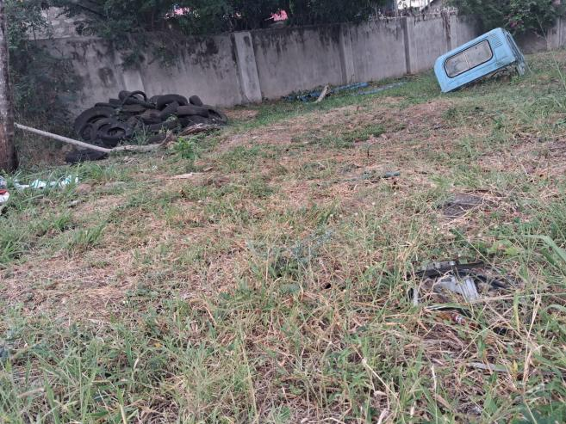
Figure 1 Site for the proposed ablution block.
The chosen location is central, easily accessible, and strategically placed to serve individuals working within or visiting the main office, without interfering with vehicle movement, operations, or service delivery at the headquarters. (Approved PDP for the site is attached in Appendix D.) The GPS location of the proposed ablution block as shown below:

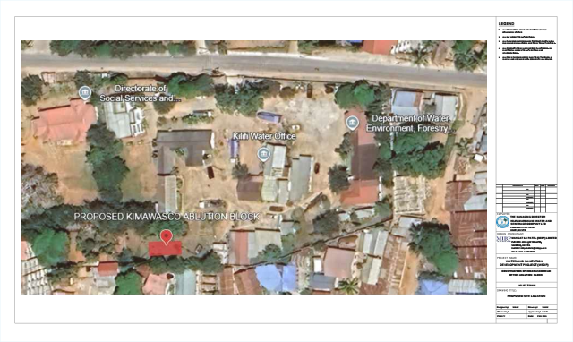
Figure 2: KIMAWSCO Office, Kilifi at coordinates 3°37'42"S 39°50'53"E

2.3 The Proposed project Components
The design of the proposed ablution block inside the KIMAWASCO Office is set to comprise of:
- 8 Nr. Toilets; 4 Nr Male and 4 Nr. Female
- 4 Nr. Shower Rooms; 2 for each Gender.
- 1 Nr. Storeroom
Separate urinals will be provided within the "gents" to increase the number of people that can use the facility especially during the peak hours.
A septic tank with a holding capacity of 15.9 m3 will be connected to the facility for holding and partial treatment of sewage. This size of septic tank will require desludging after an interval of 3 months.
The project will provide a sheltered wheelchair access ramp featuring a protective superstructure and double-height grab rails for safety. All floor surfaces in these areas will specifically use non-slip tiles to prevent accidents.
Every facility will comprise of separate washroom sections for ladies and gentlemen (gents) with equal number of toilets. Each section (for ladies and gents) will be provided with one toilet fitted with special amenities for access and use by disabled persons. The disabled washrooms will be designed with a minimum size of 1.5m by 2.2m to ensure adequate maneuvering space, with clearly marked dimensions for the toilet and rail positioning.Two shower rooms equipped with a dressing area, hand-wash basins, mirrors as well as a 900 mm high worktop will also be provided in each section. To promote contactless handwashing, the design will include automatic soap dispensers and sensor-activated taps.

Each of the units shall be fitted with coat hangers behind the doors for the convenience of the users. Proper ventilation shall be enhanced by the louvered windows and gap between the ring beam and the roof fitted with louvre blocks and plastic-coated coffee tray wires to prevent insect entry.
A 2,000-litre water tank shall be installed to provide 3 days of storage at the required volume. The tanks will be mounted on top of the roof slab for supply of water to the ablution block especially in emergency cases. Electricity will be also provided for use at night and for security lighting.
The key construction activities will include:
- Site clearance and topsoil stripping
- Excavation for structure foundations and for septic tanks and backfilling for reinstatement as appropriate with approved hard-core filling, and Chemical anti-termite treatment to surface of filling with an approved insecticide
- General and steel - reinforced concrete works
- Walling using approved concrete blocks and cement motor
- Installation of roof coverings on timber trusses
- General electrical, plumbing and plumbing works
- Finishes including plaster works, tiling and painting
A personnel office complete with a storage for essential basic commodities, shall be provided at the entrance of the facility.
Management of the facilities will be handled by KIMAWASCO. Management of the facilities will involve keeping the facilities clean and ready for use. KIMAWASCO will be responsible for the repairs of the facility. It will also be responsible for the maintenance of the septic tank. This will involve the provision of exhaustion services and the maintenance of the sanitary lanes to access the septic tanks.
A typical Site Layout, Plan and Elevations of the proposed Ablution Block are given in the figures below.

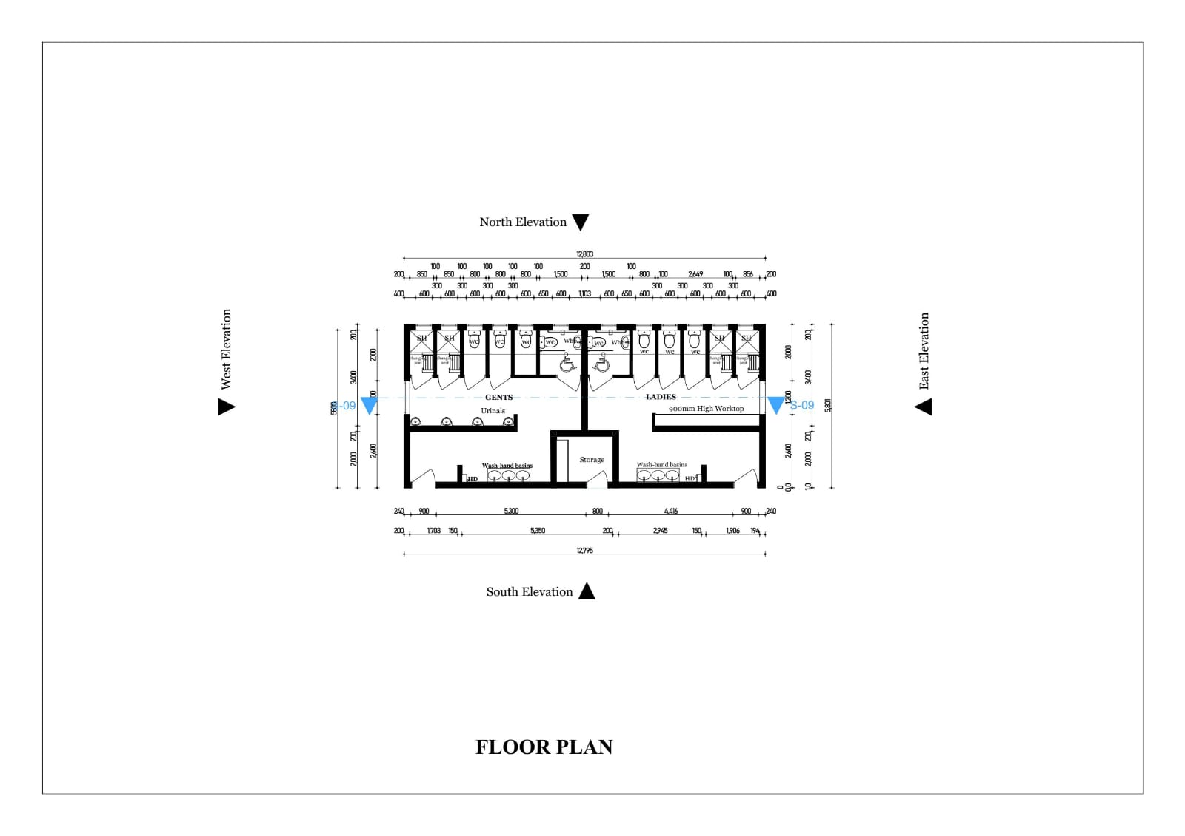
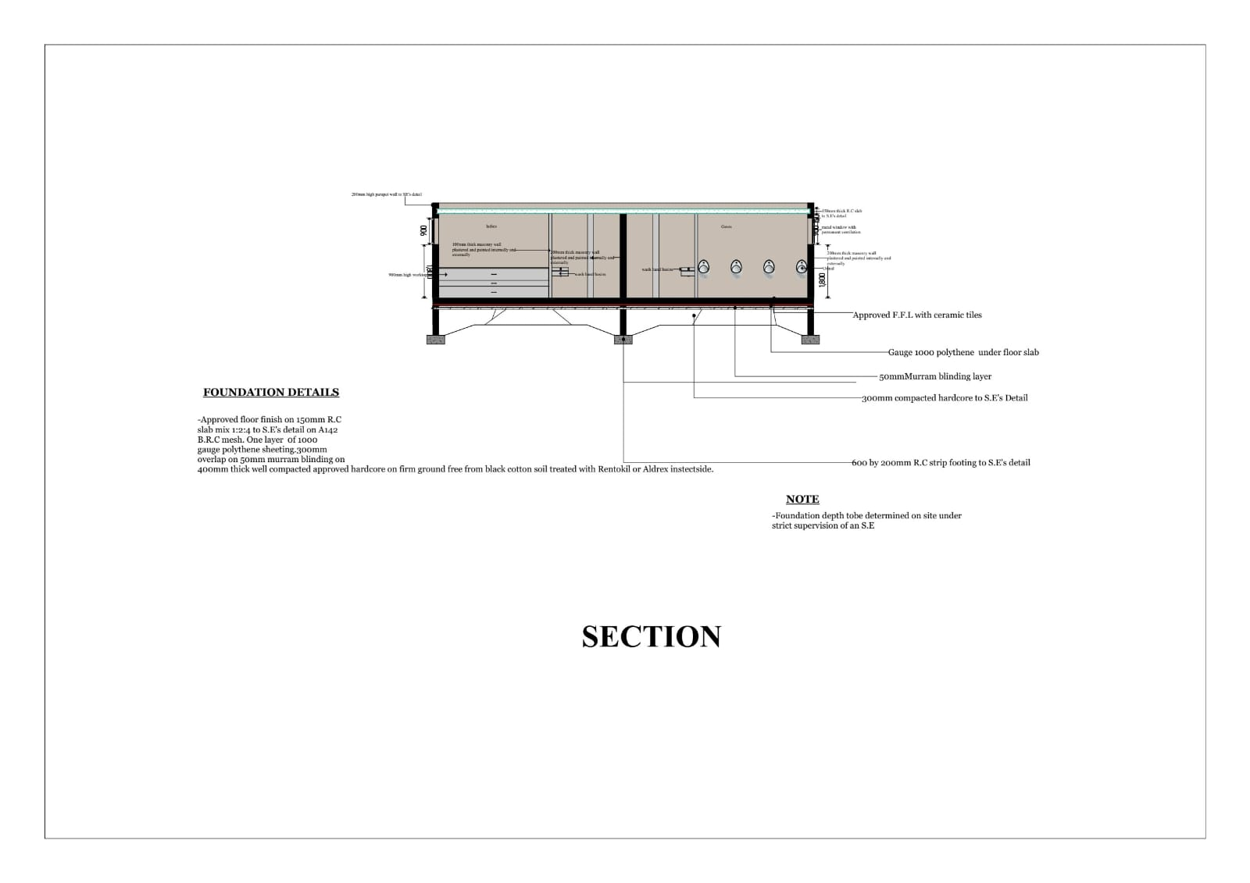
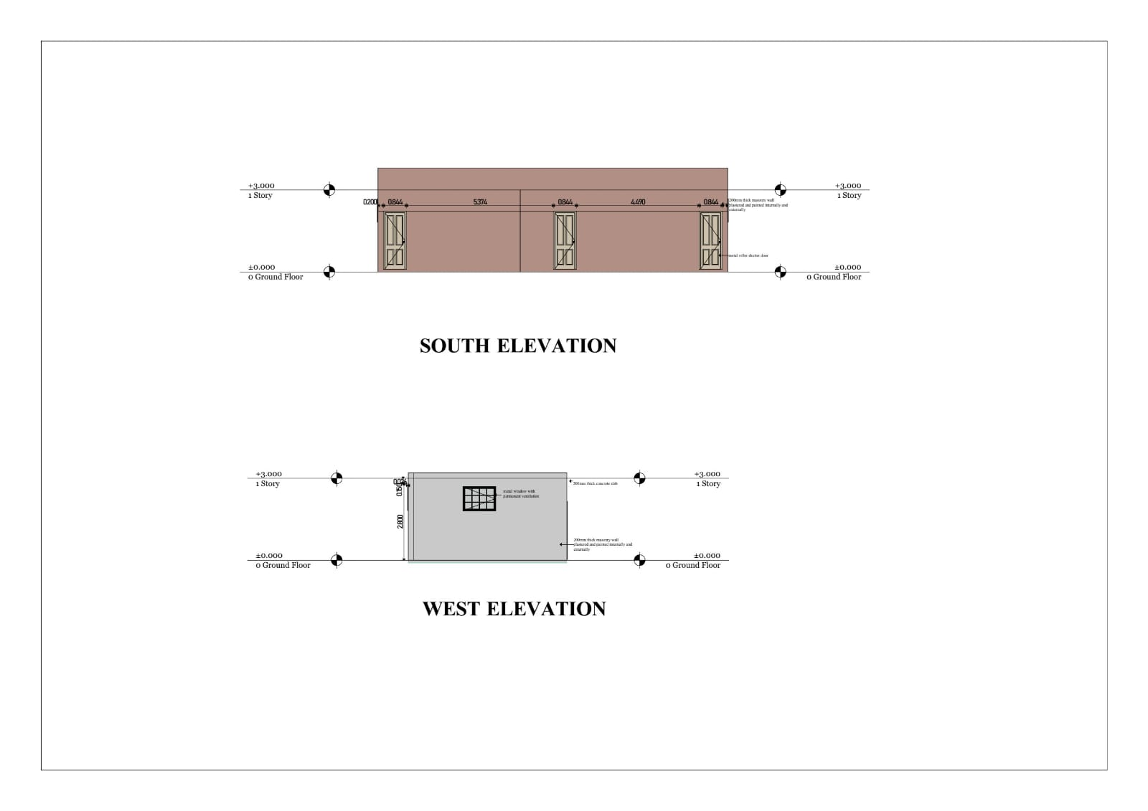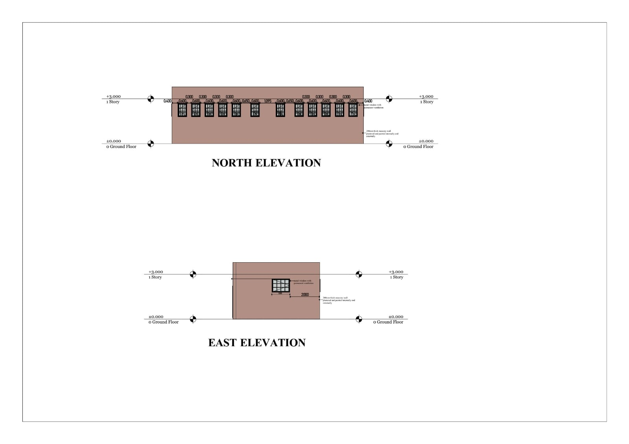

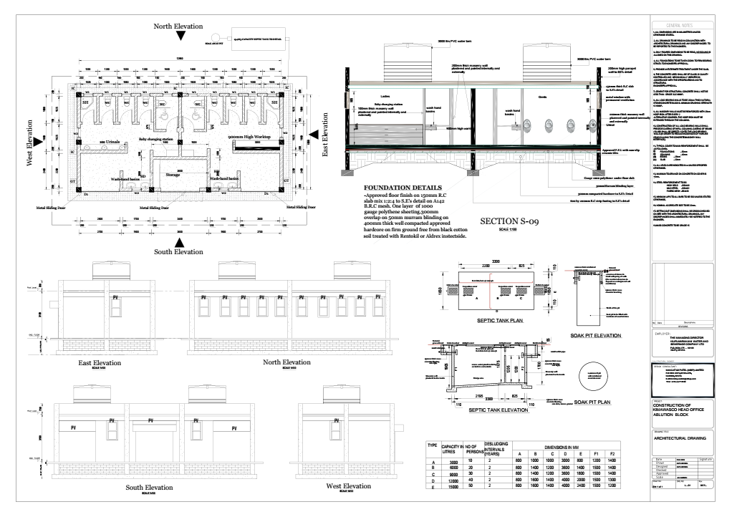

Project Implementation Cost
The Implementation Cost is given in the table below.
Table 4: Implementation Costs for Immediate Measures
s | Component | Number to be Provided | Cost | Cost, USD
1. | Ablution Block | 1 | 8,692,450 | 67,200

BASELINE CONDITIONS OF AFFECTED ENVIRONMENT
This Section discusses the baseline situation in respect of climate, topography, air quality, soils and geology, hydrology, terrestrial ecology, cultural heritage sites and socio-economic structure as well as existing infrastructure and utilities such as water, sewerage, transportation network, electricity, air transport, and solid waste management in the region of the proposed project.

3.1 Flora and fauna
The proposed site is right inside Kilifi town in Sokoni Ward. There is a limited floral and faunal presence. The proposed site for the KIMAWSCO Office ablution facilities features a few mature trees. It is important to note that no trees will be cut or removed during the construction period. Currently, there are no wild animals present, which minimizes concerns related to habitat disruption during the construction process.

Socio-Economic activities and Infrastructure

3.2.1 Economic Activities

Introduction
The larger Kilifi County is endowed with numerous natural resources that have determined its economy. These include numerous tourist sites in Malindi and Kilifi towns, arable land the ocean and pastureland for livestock. The main economic activities include Tourism, Farming, Fishing, Livestock farming, cement manufacturing and Food Processing. At present, the proposed project site (KIMAWASCO Head Office) does not have major commercial or private income-generating activities occur at the site beyond its public utility functions.

Land Use
The site currently hosts administrative offices that are used for the management of water supply and sanitation services, including billing and revenue collection for water provision services within the service area. The land hosts administrative offices that support the management of water supply and sanitation services, including customer service and revenue collection for water provision. The site is officially designated for water and sanitation–related activities and does not support agricultural, residential, commercial, or informal economic land uses. No land take, land-use change, or displacement of existing land uses is anticipated as a result of the proposed construction of the ablution block.

Infrastructure
The existing site is served by basic infrastructure associated with its administrative function. This includes permanent office buildings, access roads, electricity supply, and water connections provided by the water and sanitation company. Sanitation infrastructure at the site is currently inadequate or limited, necessitating the proposed construction of an ablution block to improve hygiene and welfare for staff and visitors. The site is accessible by existing road networks and is integrated within the company’s operational infrastructure.

Settlement
The proposed project site is located within an institutional setting and is not used for residential settlement. No permanent or temporary housing exists within the site boundaries. Surrounding areas are characterized by mixed land uses typical of service or urban areas, with staff commuting daily to the offices. The proposed project will not result in physical or economic displacement, and no resettlement planning is required.

Physiographic and Environmental Conditions

3.3.1 Climate
Kilifi county has a bimodal rainfall pattern with average annual precipitation ranging from 300mm in the hinterland to 1,300mm in the coastal belt. The coastal belt receives an average annual rainfall of about 900mm to 1,300mm while the hinterland receives an average annual rainfall of about 300mm to 900mm. The short rain season is experienced in the months of October, November and December while the Long rains are experienced in the months of March–April and May. The most important season to the hinterland is the short rains for pasture regeneration and water recharge while the long rain season is the most important season for the coastal area for crop production. Areas receiving highest average annual mean evaporation ranges from 1800mm along the coastal strip to 2200mm in the Nyika plateau in the hinterland. The highest evaporation rates are experienced during the months of January to March in the county.
The annual temperatures range between 21⁰C and 30⁰C in the coastal belt and between 30⁰C and 34⁰C in the hinterland. The county experiences a very important wind field with relatively moderate wind speeds ranging from 4.8Km/h along the coastal strip to 12km/h in the hinterlands.
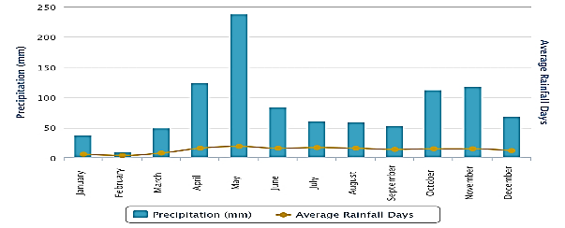
Figure 6 : Precipitation in Kilifi County (Source: en.climate-data.org)
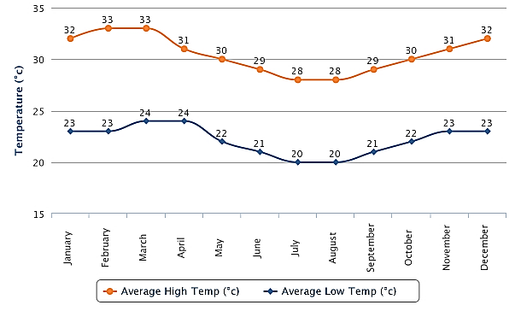
Figure 10: Temperatures in Kilifi County (Source: en.climate-data.org)

Topography
Kilifi County has three major topographical features with marked geological and rainfall characteristics which dictate the resource potential and land use patterns. These are the Coastal Plain, the Foot Plateau and the Coastal Range.
The topography of the project sites is generally flat with minimal undulations and changes in elevation and relief. The land generally slopes towards the ocean. The sites for the ablution block are located within urban areas and are therefore surrounded by buildings used for offices and residences. The proposed project site in KIMAWASCO Head Office in Kilifi is characterised by relatively flat terrain. The area's topography may be subtly influenced by coastal processes, with features shaped by historical marine activity and gradual deposition of sediments over time.

Geology and Soils
The geology of the Kenyan coast is dominated by rifting and breakup of the Paleozoic Gondwana continent and the development of the Indian Ocean. The Proterozoic gneisses of the Mozambique belt form the basement of an intracratonic basin, filled with continental permo- Triassic classics. The sea-level changes, isostatic readjustments and the tectonic movements contribute to the geomorphology of the Kenyan coast. The region is divided into three main physiographic belts namely the flat coastal plain. Next, are the broken severely dissected and eroded belts that consist of the Jurassic Shale overlain in places by a residual sandy plateau. Finally, there is the undulating plateau of sandstone that is divided from the Jurassic belt by a scarp fault.
Areas around the sea have Pleistocene coral reef mainly used as a source of limestone for the cement industry and source of building stone. The seashore of the Kenyan coast has extensive sand beaches which makes a town an attractive tourist destination area. The mineral sands occur in various parts of the Kenyan coast in almost similar geologic environments. Geochemically, mineral sand deposits contain ilmenite, rutile, zirconium as well as other minerals and trace elements that could be of radioactive nature, such as thorium.
Soils in the region gradually change to sandy clayey gravel at depths of 2 – 2.5m deep. The soil types have a strong correlation with the geology and topography of the region and differ widely in depth, texture, physical and chemical properties with variations running parallel to the coastal line due to sedimentation process. The significance of this geological and soil characteristics is the porosity associated with the sedimentary type of soils. Infiltration to the groundwater aquifers of polluting substances from the ground surface is also highly likely. There are five main categories namely;
- Soils developed on higher-level lagoon deposit, sands, which are light with very low fertility, they are excessively drained and very deep.
- Soils in the mangrove swamps, they are poorly drained soils, very deep and excessively saline, the soil texture is medium to heavy.
- Soils developed in shales, they are well-drained to imperfectly drained, they are shallow to moderately deep.
- Soils developed on raised coral reef limestone with a mixture of lagoon deposit; these are light soils, medium to heavy texture and of low fertility
- Soils developed on the lower-level lagoonal deposits are variable and of low fertility. They are complex of very deep soils of varied drainage, colour texture and salinity.
The soils in the proposed project area are primarily sedimentary of origin. It consists of consolidated sand, silts, clays and limestone. These regional profiles match the geological and soil characteristics of the proposed site.

3.3.4 Hydrology and Drainage
The Indian Ocean is the largest water mass in the area and influences the general surface drainage pattern with all land sloping towards the ocean hence all the surface run-off is expected to drain to the sea through the natural drainage systems. However, due to the dense human settlements and activities of the natural drainage systems have been interfered with resulting in occasional flooding. The drainage of the coastal zone generally adjusts to the original slope towards the east that is typical of the general tilt of the Eastern African margin that has been altered by human activities.
Due to the rugged topographic nature upstream and the relatively high soil porosity, drainage in the higher elevations is efficient with no possibility of flooding during rains. However, due to dense settlements, natural drainage systems and channels have been destroyed or blocked by human settlements, roadside economic activities and waste materials.
Kilifi has a hydrological system primarily shaped by sandy soils, which allow for high infiltration and fast drainage, minimizing surface runoff. Water moves swiftly through the sandy layers, resulting in low water retention and a greater dependence on groundwater sources. These hydrological characteristics are representative of the proposed project site.

3.4 HOUSEHOLD SOCIO-ECONOMIC SURVEY
The socio-economic situation of the area was captured based on findings of a stakeholders' survey carried out using a structured questionnaire. A sample group of approximately 50 households were selected through random sampling and interviewed for the purposes of the analysis.

Population dynamics and household characteristics
The general trend shows that most of the people fall in the 19-35 and 6-18 age groups, showing that the area is predominantly made up of young families. Figure 11 shows the population age brackets.

Figure 7 : Age Distribution of the Population
Literacy levels were as follows: - Primary level 44%, Secondary level 24%, college /university 15% and no education at all 17%. Therefore, the areas have average literacy levels, which is common in peri-urban settings.

Figure 12: Household Literacy Level
The surveyed population is predominantly Christian with only 22% of the population being Muslim.

Figure 8 : Religion of the Population
Charcoal is the main source of energy used by the community. It is used by 47% of surveyed families. 38% of families use firewood and 11% use cooking gas. Only 4% use kerosene.

Figure 9 : Sources of Energy
Majority of surveyed household heads rely on businesses to support their families. 50% ran businesses of one kind or another. 17% are formally employed and 21% rely on crop and animal farming. 5% are informally employed and of the remaining 6%, 5% rely on fishing and mining and 1% are unemployed.

Figure 13: Household socio-economic activities
Majority of business owners run small scale businesses. This accounts for 44% of surveyed respondents. 25% own shops and 18% run groceries. Only 3% run Mpesa shops. The remaining 10% are motorcycle taxi (bodaboda) operators.

Figure 10: Business Types in the Project Areas
As most income earners operate small shops and small businesses, a significant portion of the surveyed population earns ksh 15000 or less per month. 21% earn between 15000 and 30000. 6% earn between 30000 and 50000 and only 3% earn more than 50000.

Figure 11: Household income per month

Water Supply
The project areas majorly receive piped water either through public taps or private provided by KIMAWASCO as shown below. These account for a combined total of 81% of access to water. Only 19% of respondents use boreholes.
The expert did not identify boreholes or other water sources near the proposed ablution block sites.

Figure 12: Main Sources of Water for the Community
85% of the surveyed population pay for water.

Figure 13: Percentage Population Paying for Water
Payments for water ranged from kshs2 to kshs10. 52% pay KSh 5, 40% pay KSh 10, and 10% pay more than KSh 10. Only 1% pay KSh 2.

Figure 14: Amount paid per 20-litre jerrican
The water quality is generally good with 64% of the respondents indicating that they had no problems with the water. Only 5% said that the water they had is poorly accessible due to rationing schedules.

Figure 15: General Status of the Water Quality
Majority of respondents fetch water daily. 20% indicated that they fetched water on alternate days of the week and only 5% once a week.

Figure 16: Frequency of fetching water

Sanitation
Disposal of household waste is an important measure of the extent of pollution in the study area. There is a dumpsite designated to receive solid waste but only 22% of respondents who said they have their waste collected by the county have it disposed at the dumpsite. 14% said they have no specific site for disposal and just dump their waste in the area. 46% burn their waste and 18% compost it. There is no recycling done in the area.

Figure 17 : Common Waste Disposal Methods
91% of the households interviewed have access to a toilet, while the rest lack the facility.

Figure 18:Respondents Who Have Toilets in Their Compound
The most common type of toilet in use is a pit latrine. 67% of surveyed respondents said they used pit latrines. Flush toilets with septic tanks accounted for 30% of respondents and only 3% said they used flush toilets connected to the sewer line.

Figure 19 :Types of Toilets Respondents Have in Their Compound

Environmental Situation
Water shortages in the area were the biggest area of concern amongst the surveyed respondents. Mosquitoes and malaria were also of major concern. Other areas of concern included drought, deforestation, overgrazing and poor sanitation. The extinction of endangered species, invasive species and poor drainage only concerned 6% of surveyed respondents.
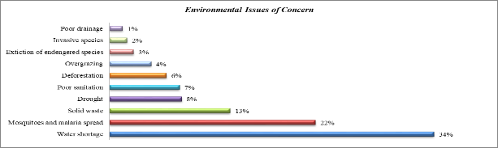
Figure 20:Environmental Issues of Concern
With most respondents dumping their household waste in the area, the collection of solid waste is a major initiative being carried out. Other initiatives being carried out in the area included educating the public, planting trees, cleaning of mosquito sites and construction of toilets.

Figure 21 : Environmental Conservation Initiatives
These activities are primarily carried out by the County government, youth groups, and community-based organisations.

Figure 22 : Implementers of Environmental Conservation Initiative
87% of the population feel that the project will help conserve the environment due to the reduced raw sewage making its way to the underground and surface water sources.

Figure 23: Will the sanitation Project help in conserving the Environment

The Project
Most of the respondents said that they were aware of the works through the public participation meeting.

Figure 24:Public Awareness of the Intended Construction of the ablution block.
95% of the respondents said that they believe the construction of the ablution block will be beneficial.

Figure 25: Perceived Impact of the Sanitation Project
Positive impacts expected from the implementation of the project were primarily associated with hygiene and the environment. 71% of the respondents said that they believed the project would improve hygiene, sanitation and reduce the cases of water-borne diseases. The rest believed the project would improve a business in the area, increase land value and create employment opportunities.

Figure 26:Positive Impacts of the Proposed Project

Stakeholder Engagement and Public Consultation

4.1 General
Public and stakeholder consultation is required under the Environmental Management and Coordination (Amendments) Act 2015, as well as the Environmental Impact Assessment and Audit Regulations (2003) and under the World Bank’s OP 4.01 – Environmental Assessment. Public and stakeholder consultation is useful for gathering environmental and socio-economic information, understanding likely impacts, and determining community as well as individual preferences. Through this process, stakeholders have an opportunity to contribute to the overall project design by making recommendations and raising concerns. In addition, the process creates a sense of responsibility, commitment and local ownership for smooth implementation of the project.
Effective public participation requires the availability of adequate information in public inputs. The latter involves various values, critiques, questions, information, suggestions and other inputs, which are expressed by individuals, groups or organizations among the public to influence decision-making. Public consultations with Interested and Affected Parties (IAPs) were carried out to:
- Inform the local people, leaders and other stakeholders about the proposed project and its objectives;
- Initiate public involvement processes, in a bid to induce and cultivate a sense of peoples’ belongingness to the project;
- Suggest and facilitate the peoples’ roles in the project’s sustainability, in terms of management, maintenance and productivity;
- Seek views, concerns and opinions of people in the area concerning the project.
- Establish if the local people foresee any positive or negative environmental effects from the project and if so, how they would wish the perceived impacts to be addressed;
- Find out if there are issues or places of cultural/or religious importance to the local communities that could be negatively impacted upon by the project and its infrastructure.

4.2 Applicable Laws, Regulations and Policies to Public Engagement
The Environmental Management and Coordination (Amendment) Act (2015) as well as the Environmental Impact Assessment and Audit Regulations (2003) set out the minimum requirements for stakeholder consultation and engagement. Further details of the legal and regulatory requirements that apply to the project are provided in Chapter 6 of this report.

4.3 Public Participation Methodology
Public participation was mainly achieved through direct interviews, observations, questionnaire administration and a public meeting. The team began the public consultation process by holding preparatory meetings to strategize on how to engage the stakeholders in the ESIA process. This was done in consultation with KIMAWASCO.

Questionnaire Administration
Questionnaires were prepared and administered to the staff and sampled households. The team then organized visits to meet the representatives of all the stakeholders identified, whom they met and spent considerable time with, and held discussions with them on their opinions about the proposed project.

Public Participation Meetings
A Public Participation meeting was conducted on 5th December, 2025 at the proposed project site to:
- Establish different values or perspectives within a community on an issue; and
- Provide information and an opportunity for key stakeholders to ask questions.
- Establish a grievance redress committee
The stakeholders provided their opinion on the project and there was a consensus that implementation of the project would be beneficial to the Head Office providing adequate sanitation facilities for both staff and customers that were urgently needed.

Issues Discussed During the Public Participation Meetings
  - Acceptance of the Project
The public was generally in favour of the sanitation measures to be implemented in the project. Most viewed the proposed measures positively, saying that the measures would make great strides in improving the sanitation situation in the KIMAWASCO Head office.
  - Availability of water
Concerns were raised that the water rationing would negatively impact the operation of the ablution block. Locals wanted assurance that once the block was completed, the water rationing they were currently experiencing would not continue. KIMWASCO representatives informed the attendants to the meeting that the water problem was being resolved with connections being made to new water sources and expansions being made to existing sources with the water supply project running concurrently with the ablution block project.
  - The unsuitability of the English type toilets.
Locals attending the meetings informed the expert that English type toilets would not be suitable for ablution block. This is because the large volume of people would make seat type toilets difficult to clean and maintain. They proposed that only the toilets for the disabled be English type and the remaining two be Indian type toilets.
  - Work and employment for the locals
The proposed project will present many employment opportunities both during construction and operation phases and the community members proposed that people from the households within the affected area should be given priority during recruitment. It was made clear that non-technical work would be given to the locals as a way of empowering them as it will increase the income potential of the people within the project area.

Consultation During Project Duration
Continuous consultation should be carried out throughout the construction phase of the project using focus group discussions to ensure interested stakeholders are aware of construction procedures and provide a forum for feedback and recommendations for implementation in the construction.
Interested stakeholders and the recommended means of communicating with them is summarised in the table below.
Table 5 : Means of Communication with Internal Stakeholders
Internal Stakeholders
Employees (Contractor,) | Notice boards, email, Grievance Redress Mechanism, meetings | Contractor | Throughout the project implementation phase
Casual workers and temporary staff | Notice boards, email, Grievance Redress Mechanism, meetings | Contractor | Throughout the project implementation phase

Community Relations in Construction Phase
The primary responsibility for liaison will be borne by the Contractor who will develop his own plan and more detailed proposals for community liaison. This will build on the approach outlined in this section. All potential contractors will be required to draw up this plan as part of the tender process.
The objectives of the Community Relations Programme will be to:
- Provide residents with regular information on the progress of work.
- Inform the project contractor of any community-related issues that may impact construction.
- Monitor implementation of mitigation measures and the impact of construction via direct monitoring and feedback from Project area.
- Identify any significant new issues that may arise during the construction period
- Manage any complaints against the project contractors from residents
The role of community relations officer will be assigned to someone whose responsibilities will be:
- The de-escalation of grievances that have not been resolved in either tier of the proposed GRM
- Maintenance of records of all grievances lodged and resolved.

Construction Contractor’s Role in Community Liaison
The Contractor will be required to prepare and adhere to the requirements of the Environmental and Social Management Plan (ESMP) that sets out how the contractor will meet and monitor the mitigation measures recommended by the Plan.
The role and responsibilities of the Contractor’s Community liaison include:
- Provide a primary interface between the project and affected or interested persons;
- Coordinate and implement required pre-construction activities, namely;
Produce management plans for community relations, construction camps and transport; train staff with community relations responsibilities;
- Implement induction training workshops for all construction staff;
- Assist in the local recruitment process;
- Ensure on-going communication with project and affected or interested persons.

Community Relations in Operational Phase
The objective of the Community Relations Programme in this Phase will be to:
- Maintain constructive relationships between local residents to assist in the operation of the facilities;
- Maintain awareness of safety issues among local residents in the project areas;
- Ensure compliance with land use constraints among landowners in the project areas

Grievance Redress Management Plan
This ESIA provides for Grievance Redress Mechanisms (GRM) which includes instruments, methods and processes by which a resolution to a grievance is sought and provided.

ALTERNATIVES TO THE PROJECT
This chapter describes and examines the various alternatives considered for the project, focusing on the selection of KIMAWASCO Head Office. Alternatives must compare in terms of their potential environmental impacts, capital and recurrent costs, suitability under local conditions, and acceptability by neighbouring land users.

No Action Alternative
If the ablution block is not constructed, the current lack of proper sanitation facilities will persist. This may result in reduced user comfort, convenience, and welfare, particularly during peak operational periods. Limitations in the existing facilities may lead to poor sanitation practices and challenges in proper wastewater management, increasing the risk of soil contamination and potential pollution of nearby water sources.
The continued absence of adequate sanitation infrastructure may also contribute to public health concerns, including an increased risk of waterborne and hygiene-related diseases, especially given the high frequency of staff and customer interactions at the offices.
Failure to implement the project may result in public dissatisfaction, as stakeholders have expressed the need for improved sanitation during consultations. The no action alternative could be perceived as neglecting KIMAWASCO staff and community needs and priorities.

Design Alternative
Different designs for the ablution block, specifically targeting institutional use, were considered. This is because the operation and maintenance of facilities in institutions differ significantly from those that are open to the general public.
During consultations, the public indicated that the proposed English-style toilets could be difficult to maintain and might increase the risk of disease transmission. Consequently, it is recommended that three of the toilets be constructed as Eastern-style (squatting) toilets, while one remains an English-style toilet to accommodate elderly users and persons with special needs.

Site Alternative
The KIMAWASCO office site was selected because it minimizes environmental disruption and aligns with existing land-use plans, reducing the need for extensive modifications or additional land acquisition. Its proximity to essential utilities and transport networks further enhances its suitability, enabling efficient project implementation while supporting broader community development goals.
During the site selection process, alternative locations were considered and evaluated based on environmental, social, and logistical factors. The chosen site was determined to offer the best balance between minimizing impacts, reducing costs, and ensuring accessibility for project operations.

RELEVANT LEGISLATIVE/ REGULATORY FRAMEWORK
There are many laws and regulations governing issues of environmental concern in Kenya. The principal National legislation is the Environmental Management & Coordination Act Cap 387 typically referred to as EMCA. EMCA empowers stakeholders to participate in sustainable management of the natural resources. It calls for Environmental and Social Impact assessment (ESIA) (under Section 58) to guide the implementation of environmentally sound decisions. Projects likely to cause environmental impacts require that an environmental impact assessment study to be carried out. It is under this provision that the current study is being undertaken.
In addition to the local legislation, the Expert has identified some World Bank Policies of relevance to the project.
The following is an outline of the legislative, policy and regulatory framework for which the Proponent shall observe and implement to comply with Environmental Sustainability.

6.1 Policy Framework
Environmental and social policy frameworks aim to help address environmental and social risks in development projects and minimize and mitigate, if not avoid, adverse project impacts on people and the environment.

National Environment Policy (NEP) 2013
The Policy goal is towards a better quality of life for present and future generations through sustainable management and use of the environment and natural resources. The objective of the policy among others is to ensure sustainable management of the environment and natural resources, such as unique terrestrial and aquatic ecosystems, for national economic growth and improved livelihoods.
Applicability; The facility will incorporate appropriate sewerage and containment systems to prevent seepage of wastewater into soil and groundwater resources, thereby minimizing the risk of contamination. This contributes to the protection of both human health and aquatic and terrestrial ecosystems, in line with the policy’s goal of sustainable management and use of environmental and natural resources.

Kenya Vision 2030
The Kenya Vision 2030 is the current National Development blueprint for period 2008 to 2030. The vision has three pillars; economic, social and political. It is recognized that Kenya is a water scarce Country but stated (Kenya, 2007: 115) that the Vision for the water and sanitation sector is “to ensure water and improved sanitation services availability
Applicability; The Project will directly contribute towards achievement the Kenya 2030 vision objectives under the environment and social pillar addressing it at a local level.

The National Environmental Sanitation and Hygiene Policy-July 2007
The Policy is devoted to environmental sanitation and hygiene in Kenya as a major contribution to the dignity, health, welfare, social well-being and prosperity of all Kenyan residents. The Policy recognizes that healthy and hygienic behaviour and practices begin with the individual.
The implementation of the Policy will greatly increase the demand for sanitation, hygiene, food safety, improved housing, use of safe drinking water, waste management, vector control at the household level and encourage communities to take responsibility for improving the sanitary conditions of their immediate environment.

National Policy on Gender and Development, 2019
The goal of the policy is to “achieve gender equality and women’s empowerment in national development so as to enhance participation of women and men, boys and girls, vulnerable and marginalized groups for the attainment of sustainable development”. The policy sets, legislative and administrative measures to address the existing gaps in the realization of gender equality and women’s empowerment.
Applicability; When hiring new employees for the project's implementation, the policy will be crucial. It will be put into place in coordination with the C-ESMP to make sure that the contractor offers equal job opportunities for all genders (Men and Women).

National Policy for Prevention and Response to Gender-Based Violence, 2014
The overall goal of this National Policy is to accelerate efforts toward the elimination of all forms of Gender-Based Violence (GBV) in Kenya. This goal will be achieved through the key objectives of the policy, which aim to:
Ensure a coordinated approach to addressing GBV and promote effective programming;
Strengthen enforcement of laws and policies for GBV prevention and response;
Increase access to quality and comprehensive survivor referral pathways across sectors; and Improve the sustainability of GBV prevention and response interventions.
Applicability: All provisions of this policy shall be adhered to. The Contractor is required to comply with the provisions of the Contractor’s Environmental and Social Management Plan (C-ESMP), which includes a Gender Action Plan to support GBV prevention and response measures during project implementation.

Kenya National Youth Development Policy (2019)
This policy focuses on promoting youth empowerment through employment creation, participation in development, access to basic services, and improved health.
Applicability: The ablution block will provide opportunities for youth employment and skills development in construction and maintenance activities

6.2 Legal Framework

6.2.1 Environmental Management and Coordination Act of 1999 (EMCA) and Environmental Management and Coordination (Amendment) Act 2015
The Environmental Management and Coordination Act of 1999 (EMCA) Cap 387 was enacted to provide an appropriate legal and institutional framework for the management of the environment and for matters connected therewith and incidental thereto. EMCA does not repeal the sectoral legislation but seeks to coordinate the activities of the various institutions tasked to regulate the various sectors. These institutions are referred to as Lead Agencies in EMCA. Lead Agencies are defined in Section 2 as any Government ministry, department, parastatal, and State Corporation or local authority in which any law vests functions of control or management of any element of the environment or natural resource.
EMCA and its subsidiary legislations are enforced by the National Environment Management Authority (NEMA). Section 58, all projects listed in the Second Schedule of the Act must submit a study report to NEMA.
Applicability: The proposed project components are classified under low-risk project in the Second Schedule of 1999 Cap 387 and EMCA (Amendment) Act 2015. Appropriate mitigation measures are included in the project’s ESMP in the ESIA for implementation.

6.2.2 Environment and Land Court Act, 2011
Article 162 of the constitution provides for the creation of specialized courts to handle all matters on land and the environment. Such a court will have the status and powers of a High Court in every respect. Article 159 on the principles of judicial authority, indicates that courts will endeavor to encourage application of alternative dispute resolution mechanisms, including traditional ones, so long as they are consistent with the constitution.
Section 20, of the Environment and Land Court Act, 2011 empowers the Environment and Land Court, on its own motion, or on application of the parties to a dispute, to direct the application of alternative dispute resolution, including traditional dispute resolution mechanisms. The act will be useful in provision of guidelines on resolving disputes that might arise related to land or environment.

Land Act, 2012
It is the substantive law governing land in Kenya and provides legal regime over administration of public and private lands. It also provides for the acquisition of land for public benefit. The government has the powers under this Act to acquire land for projects, which are intended to benefit the public.
This Act provides for the procedure to be followed during compulsory acquisition of land by the Government and the just compensation which should be paid promptly and in full to all persons whose interest in land has been affected.
Applicability; The proposed project site is located on public land owned by the County Government of Kilifi and allocated to KIMAWASCO for the development of the ablution block in line with its mandate as a water and sanitation service provider. The land has been legally set aside for public utility use, and no compulsory acquisition is required for the implementation of the project.(Approved PDP for the site is attached in Appendix D.)

County Government Act No. 17 of 2012
It states that, ‘An Act of Parliament to give effect to Chapter Eleven of the Constitution; to provide for county governments’ powers, functions and responsibilities to deliver services and for connected purposes. Part II elaborate on the functions and powers of the county government, emphasizing its constitutional authority to enter contracts, acquire and hold and dispose of assets, and delegate functions, such as through sub-contracts and partnerships.
Part VI considers administration of decentralization to the sub-county level, including to urban areas and cities.
The County Government Act, 2012, provides the basis for spatial plans as statutory requirements in the county. The Act stipulates a 10-year spatial plan be developed by each county to provide for:
Spatial depiction of the social and economic development programme of the county as articulated in the integrated county development plan;
A clear statement of how the spatial plan is linked to the regional, national and other county plans; and
A clear clarification on the anticipated sustainable development outcomes of the spatial plan.
Applicability; PART VIII of the Act provided for Citizen Participation principles which include timely access to information, data, documents, and other information relevant or related to policy formulation and implementation among others. Similarly, implementation of the proposed project is being done through sustained public participation as provided for by this Act.

Physical and Land Use Planning Act 2019
Part IV of the Act outlines the objectives of development control, which are to:
Ensure orderly physical and land use development;
Ensure the proper execution and implementation of approved physical and land use development plans; and protect and conserve the environment.
Further, Section 56 provides that, subject to the provisions of this Act, the Urban Areas and Cities Act, 2011, and the County Governments Act, 2012, county governments have the authority, within their areas of jurisdiction, to consider and approve all development applications and grant development permissions, among other responsibilities.
Applicability: In accordance with this Act, approvals, including land ownership documents (Appendix E), were obtained from the County Director of Physical Planning (Kilifi County) prior to commencement of the works discussed in this report. The project also adheres to the provisions of the Physical and Land Use Planning (Development Permission and Control) General Regulations, 2021, which provide detailed requirements for development approval and control.

Occupational Health and Safety Act (OSHA), 2007
The Act provides Health and Safety (HS) Guidelines which shall be followed by both the Contractor and Supervising Consultant during implementation of the Project to avoid injuries and even loss of life to workers and neighboring community. OSHA is enforced by the directorate of occupational safety and health services (DOSHS).

HIV and AIDS Prevention and Control Act 2011
The objective and purpose of this Act is to (a) promote public awareness about the causes, modes of transmission, consequences, means of prevention and control of HIV and AIDS; (b) extend to every person suspected or known to be infected with HIV and AIDS full protection of his human rights and civil liberties. In compliance with this Act, the contractor must develop and implement an HIV/AIDS awareness action plan throughout the project period to promote education, prevention, and support initiatives.

Sexual Offenses Act 2006
An Act of Parliament that makes provision about sexual offences aims at prevention and the protection of all persons from harm from unlawful sexual acts and for connected purposes. Sections 15, 17 and 18 focus mainly on sexual offenses on minors (children).
In an effort to comply to provisions of this Act, the contractor will integrate Sexual Exploitation and Abuse (SEA),GBV, SH prevention measures in job descriptions, employments contracts, performance appraisal systems, etc.; development of Code of Conduct, , including whistle-blower protection and investigation and disciplinary procedures; training for all project management; establishment of a Grievance Redress Mechanism(GRM) structure for GBV, SEA SH incidents, investigations and disciplinary procedures; supervision of dedicated SEA focal points in the project and trained community liaison officers among other measures.

Children's Rights Act 2022
This Act of Parliament makes provision for parental responsibility, fostering, adoption, custody, maintenance, guardianship, care and protection of children. It also makes provision for the administration of children's institutions, gives effect to the principles of the Convention on the Rights of the Child and the African Charter on the Rights and Welfare of the Child. The Contractor implementing the project will be required to comply to provisions of the Act during Project implementation.
The contractor has C-ESMP which includes a Children Protection Strategy that will ensure minors are protected against negative impacts associated by the Project including SEA.

Labour Relations Act 2012
An Act of Parliament to consolidate the law relating to trade unions and trade disputes, to provide for the registration, regulation, management and democratization of trade unions and employers organizations or federations, to promote sound labour relations through the protection and promotion of freedom of association. This act will be applied by labour force on site in addressing disputes related to working conditions.

Traffic Act 2015
PART V of the Act provides driving and other offense relating to the use of vehicles on roads. The act provides explicit measures related to; Speed of motor vehicles, Penalties in relation to speed, driving under influence of alcohol, driving on pavement, pedestrian walkway, causing death by driving or obstruction, Reckless driving, Signals and signs to be obeyed, Condition of vehicles, Limitation of loads. This Act will be cited in relation to operation of plant and equipment on site. This act is enforced by the Traffic Police Department and the National Transport and Safety Authority (NTSA).

Public Health Act, Cap 242
This is an Act of Parliament which makes provision for good public sanitation and maintenance of health. Part III section 17-18 highlights what the contractor should do in case of an outbreak of infectious diseases within the area. The infectious diseases apply to smallpox, plague, cholera, typhus fever, acute poliomyelitis, rabies and recently COVID -19.
The Act also makes provision for securing and maintaining health. For instance, the local authorities are supposed to take measures for preventing any pollution dangerous to health of any supply of water that the public uses for domestic purposes and purifying the sources that have been polluted. They are also supposed to act against persons causing pollution to the water sources.
Applicability; The contractor will be required to provide sanitary facilities and solid waste containers for use by construction workers on site.

The Environmental (Impact Assessment and Audit) Regulations, 2025
The Environmental (Impact Assessment and Audit) Regulations, 2003 (as amended) provide the framework under which Environmental Impact Assessments (EIA) are prepared and regulated in Kenya. These regulations are issued under the Environmental Management and Co-ordination Act (EMCA), Cap. 387, and require that no proponent shall implement a project likely to have a negative environmental impact, or for which an EIA is required, unless an EIA has been concluded and approved in accordance with these regulations.
Regulation 4(1) of the Regulations states that:
(a) no proponent shall implement a project likely to have a negative environmental impact; and
(b) for which an environmental impact assessment is required under the Act or these Regulations, unless an environmental impact assessment has been concluded and approved in accordance with these Regulations.
These provisions apply during the preparation of the screening report, summary project report (where applicable), and the full ESIA study and report. The Regulations further require that all EIA studies be undertaken by registered and licensed environmental experts and that an EIA licence be obtained from the National Environment Management Authority (NEMA) before commencement of the project.

Environmental Management and Coordination (Water Quality) Regulations, 2024
(Legal Notice No. 177) Provide a modern legal framework for the prevention of land and water pollution. These regulations establish rigorous standards for wastewater management to ensure the integrity of water resources and define specific quality parameters for various water uses.
Regulation 9: Water Quality Monitoring This regulation mandates that the Authority (NEMA), in consultation with relevant lead agencies, maintains a water quality monitoring regime for sources of domestic water. Key requirements include:
- Frequency: Monitoring must be conducted at least twice every calendar year.
- Record Keeping: Monitoring records must be maintained in the prescribed format as set out in the Second Schedule of the 2024 regulations.
- Scope of Protection: The regulations cover the sustainable management and protection of all water sources, including lakes, rivers, streams, springs, wells, and specifically emphasize the protection of groundwater resources.
Applicability: During the implementation of this project, the contractor is legally obligated to prevent any degradation of water quality within the project area.

Environmental Management and Co-ordination (Waste Management) Regulations, 2024 (Legal Notice 178 of 2024)
Regulation 4 - Restriction on disposal of waste
- No person shall dispose of hazardous waste on a public highway, street, road, recreational area or in any public place except in a designated waste receptacle.
- A person who contravenes sub-regulation (1) commits an offence and shall be liable on conviction to the penalty provided under section 144 of the Act.

Environmental Management and Coordination, Noise and Excessive Vibration Pollution (Control) Regulations, 2009
The Contractor will be required to ensure compliance with the above regulations to promote a healthy and safe working environment. This shall include regular inspection and maintenance of equipment and prohibition of unnecessary hooting by vehicles. The regulations provide for a maximum of 60 dB during the day and 35 dB during the night for a construction site. Provisions of the regulations apply during preparation of this report. Where the is excess noise due to heavy machinery on site the contractor will provide ear protection to site workers.

Environmental Management and Coordination (Air Quality Regulations 2014)
These regulations provide a framework for the prevention, control and abatement of air pollution to ensure clean and healthy ambient air. The regulations establish comprehensive requirements for managing emissions from plant and equipment on construction sites, including:
Regulation 5
- No person shall act in a way that directly or indirectly causes, or is likely to cause, immediate or subsequent air pollution.
- No person shall emit any liquid, solid or gaseous substance or deposit any such substance in levels exceeding those set out in the First Schedule.
(Second Schedule): The regulations identify specific priority pollutants including:
- Particulate matter (dust, black smoke, smog, aerosols), Sulphur oxides (SOx), Nitrogen oxides (NOx), Carbon monoxide (CO), Carbon dioxide (CO2), Hydrocarbons (HC), Volatile Organic Compounds (VOC), and Hydrogen Sulphide.

National Museums and Heritage Act 2006
Under this Act any architectural, archaeological, paleontological, or historical objects discovered unexpectedly—commonly referred to in project management and construction as a "Chance Find"—are protected by law.
Upon the discovery of any archaeological or historical sites, remains, or objects including graves and graveyards during excavation or construction, the Contractor shall immediately halt activities in the area, delineate and secure the site to prevent damage or loss (including deploying a night guard for removable or sensitive items until official handover), and notify the site supervisor, Project Environmental Officer, and Project Engineer so they can alert the local authorities and the Ministry of State for National Heritage and Culture within 24 hours.

Fire Risk Reduction Rules, 2007
The rules require electrical equipment be installed in accordance with the respective hazardous area classification system, flammable materials are stored in appropriately designed receptacles, electrical equipment is inspected after six months by a competent person and the contractor is required to keep records of such inspections, installation and maintenance of firefighting systems in workplaces, fire drills at least once a year, assembly points be marked, undertake annual fire safety audits etc. The contractor is required to store all flammable materials and liquids safely to avoid risk of fire.

Safety and Health Committee Rules of 2004
These rules require the contractor (once they employ more than twenty persons) to establish a health & safety committee to address the health, safety and welfare of workers. The contractor, is required to provide space for meetings for the committee, training of the S&H Committee, appoint a S&H management representative, as well as allowing all staff to attend these meetings with no risk of loss of earnings, opportunities for promotion or advancement. The contractor should also make guidelines on occupational safety and health available to the Committee.

First Aid in the Workplace Regulations, 2024, Legal Notice 79 of 2024
Mandate that Kenyan employers ensure effective first aid provisions. Key requirements include conducting an annual first-aid audit, providing adequate first-aid facilities, appointing and training first-aid personnel, and informing employees about emergency procedures. Employers must also display first aiders’ contact information, ensure vaccination for first aiders, and facilitate emergency transfers. Non-compliance is considered an offense.

OP 4.01: Environmental Assessment
Environmental assessment requires that all projects financed or supported by the World Bank undergo an environmental assessment to evaluate potential environmental and social impacts before project approval and implementation. The policy aims to ensure that projects are environmentally sustainable, socially acceptable, and comply with applicable national and international standards.
Under OP 4.01, projects are categorized based on the magnitude and significance of their potential impacts:
Category A: Projects with potential significant adverse environmental impacts that are sensitive, diverse, or unprecedented.
Category B: Projects with potentially limited adverse environmental impacts, which are site-specific, few in number, and can be mitigated.
Category C: Projects with minimal or no adverse environmental impacts.
The policy requires the preparation of Environmental Impact Assessments (EIA) or Environmental Management Plans (EMP) as appropriate, with public consultation and disclosure of findings. It also emphasizes the integration of environmental considerations into the decision-making process, including project design, implementation, and monitoring.
This SPR is being conducted in line with OP 4.01, mitigation measures have been identified, and public/stakeholder consultations will be undertaken to ensure compliance with both national regulations and World Bank safeguards.

OP 4.11: Physical Cultural Resources
Aims to assist in the preservation of physical cultural resources and to avoid their destruction or damage. This policy applies to movable or immovable objects, sites, structures, groups of structures, and natural features and landscapes that have archaeological, paleontological, historical, architectural, religious, aesthetic, or other cultural significance. As part of the EA process, the project has screened for the presence of known cultural heritage sites. Due to the historical sensitivity of the coastal region, the project design has been adjusted to avoid any encroachment on documented heritage zones. In accordance with OP 4.11, during the project implementation, a formal "chance finds procedure" is to be established if archaeological or cultural resources are encountered during excavation in the sandy strata, the contractor is legally required to suspend work immediately and notify the relevant lead agencies (such as the National Museums of Kenya). Any identified physical cultural resources will be managed through the project’s ESMP, which includes measures for site protection, documentation, and, where necessary, the scientific salvage of artifacts before construction resumes.

WB EHS General Guidelines
The Environmental, Health, and Safety (EHS) Guidelines are technical reference documents with general and industry-specific examples of Good International Industry Practice (GIIP). The EHS Guidelines were first issued on April 30, 2007 and contain the performance levels and measures that are generally considered to be achievable in new facilities by existing technology at reasonable cost.

WB EHS Guidelines for Water and Sanitation
The World Bank Environmental, Health, and Safety (EHS) Guidelines for Water and Sanitation serve as technical reference documents to ensure project performance levels meet international standards. They are designed to minimize environmental, health, and safety risks to workers, users, and surrounding communities, while promoting sustainable management of water resources.

WB EHS Guidelines for Materials Extraction
These guidelines provide technical guidance for the extraction of raw materials, including sand, gravel, and stone, whether from stand-alone quarries or borrow pits supporting the project. Given the project's location in Kilifi, these guidelines are critical for managing the impacts of material sourcing on the local landscape and hydrological systems. Extraction activities must implement rigorous dust suppression, particularly during crushing and transport. The guidelines mandate the prevention of siltation and contamination of water bodies. For this project, specific focus is placed on preventing sediment-laden runoff from borrow pits from entering the local drainage system, which could otherwise facilitate rapid contaminant transport through the porous sandy strata. Mitigation measures must be employed to minimize noise from blasting (if required) and heavy machinery.

ENVIRONMENT AND SOCIAL IMPACTS OF THE PROPOSED PROJECT
This Chapter presents an assessment of the issues likely to arise because of implementation of the proposed Ablution Block at KIMAWASCO Head Office. An environmental or social impact is any change to the existing condition of the environment caused by human activity or an external influence. Impacts may be:
    - Positive (beneficial) or negative (adverse);
    - Direct or indirect, long-term or short-term in duration, and wide-spread or local in the extent of their effect.
Impacts are termed cumulative when they add incrementally to existing impacts. In the case of the Project, potential environmental impacts would arise during the construction and operation phases of the Project and at both stages positive and negative impacts would occur.
In general, successful implementation of the project will have high environmental and socio-economic benefits to the people and will contribute to the health and wellbeing. Overall, expected negative impacts are related to the construction of the various sanitary measures as well as their general operation. These impacts are localized and not considered significant and long-lasting and can be mitigated through appropriate mitigation measures. The severity and duration of these impacts can be minimized by ensuring that the excavation and construction works are limited to short working sections, and that works are carried out rapidly and efficiently.

7.1 Impact Identification
The identification of impacts in the ESIA study generally used the following methods:
- Compilation of a comprehensive list of key environmental and social impacts. These are such as changes in air and water quality, noise levels, wildlife habitats, bio-diversity, landscape, social and economic systems, cultural heritage, settlement patterns, and employment levels.
- Identification of all the sources of impacts such as dust, spoils, vehicles emissions, water pollution, construction camps, etc. using checklists or questionnaires. This was followed by listing possible receptors in the environment (e.g., crops, communities, and migrant labourers) through surveying the existing environmental and socio-economic conditions and consultation with concerned parties.
- Identifying and quantifying various environmental and socio-economic impacts using checklists, interaction matrices and overlays.

7.2 Impact Prediction
Prediction of impacts technically characterises the causes and effects of impacts, and their secondary and synergistic consequences for the environment and the local community. It examines each impact within a single environmental parameter into its subsequent effects in many disciplines (e.g., deterioration of water quality). It draws on physical, biological, socio-economic, and anthropological data and techniques. In quantifying impacts, it employs socio-cultural models, economic models, and expert judgments.
It is worth noting that as prediction techniques of environmental impacts, by their nature, involve some degree of uncertainty.

7.3 Mitigation of Impacts
Each predicted adverse impact is evaluated to determine whether it is significant enough to warrant mitigation. This judgment of significance has been based on one or more of the following:
- Comparison with laws, regulations or accepted standards;
- Consultation with the relevant decision makers;
- Reference to present criteria such as protected sites, or endangered species
- Consistency with government policy objectives
- Acceptability to the local community or the general public

7.4 Impact Categories
Likely potential areas of concerns have been determined and ranked according to the following:
Impact
- Potential environmental impacts which are deemed to be highly significant and need thorough investigation in the ESIA
- Potential environmental impacts that are deemed to be moderately significant, and will require reasonable investigation in the ESIA
- Potential environmental impacts that are deemed low/unlikely to be significant, and need to be listed, and addressed in some way, but which will not require detailed assessment in the ESIA.
Nature:
- Positive: applies to impacts that have a beneficial economic, environmental or social result, such as additional economic activity or enhancement of the existing environmental conditions.
- Negative: applies to impacts that have a harmful or economical aspect associated with them such as economical cost, loss or degradation of environmental resources.
Effect:
- Direct: applies to impacts which can be clearly and directly attributed to a particular impacting activity.
- Indirect: applies to impacts which may be associated with or after a particular impacting activity, but which cannot be directly attributed to it.
Time Range:
- Short Term: applies to impacts whose effects on the environment will disappear within a 1-year period, or within the construction phase.
- Medium Term: applies to impacts whose effects on the environment will disappear within a 5-year period following the construction phase.
- Long Term: applies to impacts whose effects on the environment will disappear in a period greater than 5 years following the construction phase.
Reversibility:
- Reversible: applies to impacts whose significance will be reduced and disappear over time (either naturally or artificially), once the impacting activity ceases.
- Irreversible: applies to impacts whose significance will not be reduced nor disappear over time (either naturally or artificially), once the impacting activity ceases.

A characterisation of expected impacts is shown in the table below.

Table 6: Characterization Of Negative Impacts (Construction Phase)
Aspect | Predicted Impact  (Construction Phase) | Characterization of Impacts
Aspect | Predicted Impact  (Construction Phase) | Impact |  |  | Nature |  | Effect |  | Time Range |  |  | Reversibility
Aspect | Predicted Impact  (Construction Phase) | High | Medium | Low | Positive | Negative | Direct | Indirect | Short Term | Medium Term | Long Term | Reversible | Irreversible
Ambient Air Quality | Increased local pollutant emissions and trace constituents |  | X |  |  | X | X |  | X |  |  | X
Ambient Air Quality | Increased levels of dust and particle emissions from construction vehicles and equipment |  | X |  |  | X | X |  | X |  |  | X
Soil/Water Pollution | Contamination of subsurface | X |  |  |  | X | X |  |  | X | X |  | X
Soil/Water Pollution | Surface water pollution from construction wastes |  | X |  |  | X | X |  | X |  |  | X
Noise and vibrations | Increase of noise and vibration levels due to construction activities |  | X |  |  | X | X |  | X |  |  | X
Health & Safety | General construction related health and safety risks for workers |  | X |  |  | X | X |  | X |  |  | X | X
Health & Safety | HIV/AIDS and increased disease risks. | X |  |  |  | X | X | X | X | X | X |  | X
Solid and liquid waste | Generation of both solid and liquid waste at the construction camps |  | X |  |  | X | X |  | X | X | X | X
Gender | Increased harassment of females within and around the site |  | X |  |  | X | X |  | X |  |  | X
Crime Management | Increased insecurity around the project sites |  | X |  |  | X |  | X |  | X |  | X
Child Labour and Protection | Potential for exploitation of child labour |  | X |  |  | X | X |  | X |  |  | X
Labour influx | Risk of social conflict because of increase in influx population |  |  | X |  | X | X | X |  | X |  | X
GBV/SEA | SEA |  |  | x |  | x | x |  |  |  | x |  | x

Table 7: Characterization of Operation Phase Impacts
Aspect | Predicted Impact  (Operation Phase) | Characterization of Impacts
Aspect | Predicted Impact  (Operation Phase) | Impact |  |  | Nature |  | Effect |  | Time Range |  |  | Reversibility
Aspect | Predicted Impact  (Operation Phase) | High | Medium | Low | Positive | Negative | Direct | Indirect | Short Term | Medium Term | Long Term | Reversible | Irreversible
Air Pollution | Increased particulate and gaseous pollutants |  | X |  |  | X | X |  | x |  |  | x
Mosquitos breeding | Possibility of disease transmission |  | X |  |  | X |  |  |  |  | X | X
Pollution of ground water sources | Pollution of water sources due to seepage | X |  |  |  | X | X |  |  |  | X | X
Health & Safety | - Operation related health and safety risks for workers and public,  - Spillage of sewage during exhaustion while full | x |  |  |  | x | x |  | x |  |  | x
Health &  Safety | Improvement in public health and sanitation through reduced pollution of the seasonal rivers | X |  |  | X |  | X |  | X | X | X
Socio  economics | Improvement of local and regional socio-economy | X |  |  | X |  |  | X |  |  | X
 | Employment and job creation during construction and operation phases |  | X |  | X |  | X |  | X | X | X
Improved local economy | Money spent treating diseases saved |  | X |  | X |  |  | X |  |  | X |  | X
Improved quality of life | Elimination of odours resulting from poor waste collection |  | X |  | X |  | X |  |  |  | X |  | X

7.5 Impacts Emanating from the Proposed Project
The impacts are identified at three stages: -
- Construction
- Operation phase
- Decommissioning
7.5.1 Construction Phase Impacts
Most of the potential environmental and social impacts associated with the construction phase will be negative and temporary and can be mitigated with the use of standard environmental management procedures. The potential social impacts or nuisance will be those typically associated with construction activities involving vehicles, equipment, and workers.
The predicted impacts of the project include the following:
Positive Impacts
The primary positive impact of the project during the construction phase will be the creation of employment opportunities for the local communities. This will have the effect of;
- Creating employment for both skilled and unskilled labourers directly involving the project.
- Creating business opportunities especially for locals as most of them will be involved in small time trades such delivering food to site workers;
- Acting as a source of livelihood for the community members/the youth who will be used to run the project;
- Acting as a source of income for those supplying materials for the project.
Negative impacts
Air Quality
There is expected dust pollution from the site clearance and excavation works. This situation will be mitigated by periodical pouring of water to reduce the harmful effects of dust.
Passage of increased number of vehicular traffic during construction will introduce higher levels of other pollutants such as emissions of exhaust fumes, lead and associated gases such as carbon monoxide, hydrocarbons, and nitrous oxides from vehicles entering and exiting the site along with the operation of necessary equipment. These will need to be monitored all through the construction period.
This sustained high level of dust could impact negatively on various groups of the people who spend considerable time within the area adjacent to the project site, such as construction workers and roadside businesses. Construction workers at the project construction site will be exposed to high dust levels under hot and dry environmental conditions for many hours each day. However, being a localised project with short construction timelines, such effects may not have serious long-term health implications on the workers.
Mitigation measures
- Contractor to provide and enforce use of protective clothing like dust masks by the construction crew.
- All the vehicles and construction machinery should be operated in compliance with relevant vehicle emission standards and manufacturer’s specification to minimize air pollution.
- Workers shall be trained on management of air pollution from vehicles and machinery. All construction machinery shall be maintained and serviced
- Contractor shall comply to the provisions of EMCA 2015 (Air Quality Regulations ,2014);

Traffic Congestion
Traffic congestion is anticipated from site related traffic from Contractor vehicles. The mitigation measures will be as follows:
Mitigation measures
- The Contractor will provide temporary road signs or notices to indicate ongoing work
Solid and Liquid Waste Generation
There is a wide variety of waste generated during construction. This includes debris, timber, stones, rock, metals, paper, plastics, etc. The quantity of waste can be substantial and can be both a health hazard and an eyesore. It also poses the potential for contamination of soils and watercourses because of improper disposal of liquid and solid waste from construction activities.
Careless disposal of used containers for oil, lubricants, paint, and other toxic substances may land in the hands of such individuals who will use them as water containers with grave consequences to health.
There is increased likelihood of littering from increased traffic movement during operations. Some of this litter could be plastic and when ingested by livestock, can cause health hazards.
Mitigation measures:
- Provide adequate waste disposal facilities. Ensure collection of all solid waste from generation points, safe transportation to a central point where they are sorted out and safely disposed according to type to protect the environmental resources.
- Ensure spill kits are provided at the construction sites
- Ensure fuels, oils, lubricants and chemicals are stored in impermeable containers and away from surface drains
- Ensure that the machines are serviced in specific locations off-site to avoid spillage of oils and grease into the surface runoff channels.

Site Related Oil Spills
During construction, oil spills may result from construction site equipment and storage, which may affect the flora, fauna, soils, and surface as well as underground water ways in the area after being swept by rainwater into water courses and seeping into the soil.
If the machinery yard, workshops and labour camps are not properly protected, the roaming animals and birds could be poisoned if they drink contaminated water caused by accidental spillage of oil, petroleum products, solvents and similar category of materials.
Mitigation Measures
- The Contractor should ensure that the employees on site are aware of the company procedures for dealing with spills and leaks e.g. using dispersants or adding biological agents to speed up the oil breakdown for the construction machinery though induction and safety training (the contractor will propose a method of clean-up which will be subject to approval);
- All vehicles and equipment should be kept in good working order, serviced regularly in accordance to the manufacturers specifications and stored in an area approved by the Resident Engineer/Supervising Expert;
- Ensure spill kits are provided at the construction sites
- Ensure fuels, oils, lubricants and chemicals are stored are stored in impermeable containers and away from surface drains

Impacts on Existing Water Resources (Water Quality)
Oil spills and grease generation by construction traffic as well as traffic during operation could lead to pollution by altering the chemical and biological characteristics of surface and ground water resources. This may occur when spilled compounds are swept by rain water from the construction sites, traffic routes and contractor’s camp and into water courses.
There is potential for contamination of water resources because of improper disposal of liquid and solid waste from construction activities and construction camps. No sources of water, shallow wells or otherwise were identified near the ablution block site. The impacts on water sources are therefore expected to be minimal.
Mitigation Measures
- Areas dedicated for hazardous material storage shall provide spill containment and facilitate clean up through measures such as: maximum separation from sensitive features (water bodies); clear identification of the materials present; access restricted to authorized personnel and vehicles only and dedicated spill response equipment
- Provide solid and liquid waste disposal system - a waste collector, NEMA recommended waste disposal guidelines and waste collection bins
- Ensure fuels, oils, lubricants and chemicals are stored are stored in impermeable containers and away from surface drains
- Ensure that the machines are serviced in specific locations off-site to avoid spillage of oils and grease into the surface runoff channels.
Noise Pollution
Noise generation and vibrations from construction machinery and activities could adversely affect the local people. Activities associated with construction will cause increase in noise levels in the vicinity of the construction sites. This impact can be of concern at construction sites within the larger urban environments
Generally, construction noise exceeding a noise level of 70 decibels (dB) has significant impacts on surrounding sensitive receptors within 50m of the construction site.
Mitigation:
- Construction activities to be scheduled carefully to minimize the impact of noise from construction machinery.
- Contractor to strictly adhere to the Excessive Noise and Vibrations (Control) Regulations, 2009.
- Where possible, ensure non-mechanized construction to reduce the use of machinery
- Positioning Powered Mechanical Equipment (PME) so that noise is directed away from sensitive areas;
- Contractor to prepare for approval by KIMAWASCO a Health Management Plan (HMP) detailing means to protect site workers and community from excessive noise and vibrations
- To the extent possible, heavy vehicles should not be used at night across populated areas.
- Ensure that construction equipment is operating optimally and with operational noise mufflers where possible.

Occupational Safety and Health Hazards
Construction staff will be exposed to safety hazards arising from construction activities. It is proposed that the projects be located within existing public lands belonging to the county government. The project works will expose workers to occupational risks due to handling of machinery, construction material and noise, electromechanical works etc.
Construction activities of site clearance, excavation, materials delivery, and concrete mixing as well as construction traffic will generate a lot of dust and this may affect the respiratory system of all site users.
Construction sites may be a source of both liquid and solid wastes. If these wastes are not well disposed these sites may become a breeding ground for disease causing pests such as mosquitoes and rodents.
Mitigation:
- Implement a Health and Safety Plan (HASP) for both civil and electrical works in line with OSHA for approval by KIMAWASCO.
- Posting and maintaining of clear and prominent warning signage at appropriate potential points of entry to hazardous areas.
- Keep verifiable records of all accidents and incidences.
- Ensure alcohol free work force.
- Draft operational policies on safety e.g. Alcohol use, speed limits.
- Spread awareness among the site neighbourhoods to curb vandalism of safety equipment, signages and other installations.
- Ensure that all construction machines and equipment are in good working conditions and to manufacturer’s specifications to prevent occupational hazards.
- Appoint a trained health and safety team for the duration of the construction work.
- Provide workers with appropriate personal protective equipment (PPE)e.g helmets, reflector jackets, gumboots, gloves, masks
- Work to minimize or altogether eliminate mosquito breeding sites.
- Provide adequate and appropriate human and solid waste disposal facilities e.g. Toilets and dustbins.
- Creation of awareness of the Grievance Redress Mechanism (GRM) amongst all the stakeholders through public awareness campaigns

Public health and safety
Dust and air pollution from Construction activities produce dust that can cause respiratory problems. Machinery and construction activities may cause excessive noise, disturbing the community especially those coming to KIMWASCO to seek services. Community members, especially children, may enter the site and get injured. Movement of construction vehicles may endanger pedestrians and nearby residents.

Mitigation:
- Sprinkle water on dusty areas and cover construction materials.
- Limit construction to daytime hours and use well-maintained equipment
- Control vehicle movement, use signs, and assign traffic marshals
- Restrict access using fencing and security personnel.

HIV & AIDS Impacts
It is the youth that are at greater risk of contracting HIV. They account for most new cases and since the construction industry is more likely to employ people in this age group, steps must be taken to minimize the chances of contracting HIV amongst the contractor’s personnel and the locals.
Mitigation:
- Sensitize workers and the surrounding communities on awareness, prevention and management of HIV/AIDS through staff training, awareness campaigns, multimedia and workshops or during community Barazas.
- Use of existing clinics to provide VCT services to construction crew and provision of ARVs for vulnerable community members
- The contractor should provide quality condoms to personnel on site.
- Access to the contractor’s camps by outsiders should be strictly controlled.

Liability risk (Loss of life, injury or damage to private property)
Some of the Construction activities e.g excavations, work at heights, concrete works may lead to accidents that may be mild or fatal depending on various factors. During the implementation of the proposed project, accidents could be due to negligence on part of the workers, machine failure or breakdown or accidental falls from elevated points of the structure. These incidents can be reduced through proper work safety procedures.
In addition, during Construction, there may be damage to private property that may not be foreseen.
Mitigation:
- Develop a site safety action plan detailing safety equipment to be used, emergency procedures, restriction on site, frequency and personnel responsible for safety inspections and controls.
- Provision of requisite PPE as established from risk assessment in the safety action plan and enforcing their usage.
- The workers should receive requisite training especially on the operation of the machinery and equipment.
- There should be adequate warning and directional signs.
- Ensuring that the prepared code of conduct for staff is followed to prevent accidents.
- Provide First Aid Kit within the construction sites and ensure that at any moment during the works, there is a trained first aider on site. The ration of trained first aiders to worker will be as per defined by the OSHA First Aid Rules.
- Recording of all injuries that occur on site in the incident register, corrective actions for their prevention are instigated as appropriate.
- Contractor to ensure compliance with the Work Injury Benefits Act WIBA, and OSHA, and maintain insurance cover throughout the construction period.
- The Contractor to promptly repair any damage done to private property.
- Limit damage to property by observing construction area limits by clear demarcation

Crime Incidences
The facilities will be in high traffic areas with idlers hence the construction sites are prone to have a few incidences of crime including, stealing of construction materials or individual property, drug abuse and alcoholism among others, within and without the construction site.
Mitigation:
- Fencing off the Contractor’s camp
- Working with local committees (e.g. “Nyumba Kumi”) to provide security within the site in addition to the Contractor’s own security.
- Removing any employee who persists in any misconduct or lack of care, carries out duties incompetently or negligently, fails to conform to any provisions of the contract, or persists in any conduct which is prejudicial to safety, health, or the protection of the environment.
- Taking all reasonable precautions to prevent unlawful, riotous or disorderly conduct by or amongst the contractor's personnel, and to preserve peace and protection of persons and property on and near the site.
- Prohibiting alcohol, drugs, arms, and ammunition on the worksite among personnel.
- The contractor and Supervision Expert should report all activities of a criminal nature on the worksite or by the contractor's employees (whether on or off the worksite) to the police and undertake the necessary follow-up. Crime reports should include nature of the offense, location, date, time, and all other pertinent details.

Child Labour and Protection
The Children Act of Kenya prohibits contractors from “employing children in a manner that is economically exploitative, hazardous, and detrimental to the child’s education, harmful to the child’s health or physical, mental, spiritual, moral, or social development. It is also important to be vigilant towards potential sexual exploitation of children, especially young girls. The contractor should adopt a ‘Child Protection Code of Conduct’; that all staff of the contractor must sign, committing themselves towards protecting children, which clearly defines what is and is not acceptable behaviour.
Mitigation:
- Ensure no children are employed on site in accordance with national labour laws.
- Ensure that any child sexual relations offenses among contractors' workers are promptly reported to the police.

Labour Influx Effects
Large construction projects often require labour force and associated goods and services cannot be fully supplied locally for reasons such as worker unavailability and lack of technical skills and capacity. In such cases, the labour force (total or partial) needs to be brought in from outside the project area. This influx is compounded by an influx of other people who follow the incoming workforce with the aim of selling them goods and services, or in pursuit of job or business opportunities. The influx of workers can have adverse social and environmental impacts on local communities, particularly if the communities are rural, remote or small.
Adverse effects include.
- Increased demand and competition for local social and health services, as well as for goods and services, which can lead to price hikes and crowding out of local consumers.
- Increased volume of traffic and higher risk of accidents
- Higher demands on the ecosystem and natural resources
- Increased risk of spread of communicable diseases
- Increase in illicit behaviour and crime.
- Social conflicts within and between communities
Mitigation:
- Reduce labour influx by tapping into the local workforce. Depending on the size and the skill level of the local workforce, a share of the workers required for the project may be recruited locally. This may be easier for unskilled workmen. Specialised workmen may be hired from elsewhere. Local workers may also be trained especially if they are required for the operation of the project.
- Effective contractual obligations for the contractor to adhere to the mitigation of risks against labour influx. Depending on the risk factor, appropriate mitigation measures may be deployed.
- The works contractor should be required, under its contract, to prepare and enforce a No Sexual Harassment and Non-Discrimination Policy, in accordance with national law as well as to the World Bank Code of Conduct guidelines where applicable.
- The contractor should prepare and implement a gender action plan, to include at minimum:
- Gender mainstreaming in employment at the worksite with opportunities provided for females to work, in consonance with local laws and customs
- Gender sensitization of workers (this could be done by the HIV/AIDS services provider; see above)
- Provision of gender disaggregated bathing, changing, sanitation facilities
- Grievance redress mechanisms including non-retaliation.
- Effective community engagement and strong grievance mechanisms on matters related to labour
- All workers to sign employment contract including Code of Conduct
- Sensitize workers on community based social behaviour and conduct.
- Efforts to be geared toward instilling attitudes of tolerance, support and understanding of labour immigrates by the local communities

Gender Equity, Sexual Harassment
Construction workers are predominantly younger males. Those who are away from home on the construction job are typically separated from their family and act outside their normal sphere of social control. This can lead to inappropriate and criminal behaviour, such as sexual harassment of women and girls, exploitative sexual relations, and illicit sexual relations with minors from the local community. In large scale cases, male labour may also lead to an increase in exploitative sexual relationships and human trafficking whereby women and girls are forced into sex work.
Mitigation:
- The works contractor should be required, under its contract, to prepare and enforce a No Sexual Harassment and Non-Discrimination Policy, in accordance with national law where applicable.
- Strive for an equitable distribution of employment opportunities between men and women. Mainstream Gender Inclusivity in hiring of workers as required by Gender Policy 2011 and the 2/3 gender rule;
- The contractor should prepare and implement a gender action plan, to include at minimum:
- Gender mainstreaming in employment at the worksite with opportunities provided for females to work, in consonance with local laws and customs
- Gender sensitization of workers (this could be done by the HIV/AIDS services provider; see above)
- Provision of gender disaggregated bathing, changing, sanitation facilities
- Grievance redress mechanisms including non-retaliation.
- Provide toilets and bathrooms for both male and female workers on site

Gender-Based Violence and Sexual Harassment
This impact is triggered during Project Construction Phase when the Contractor fails to comply with the following provisions;
- Gender Inclusivity requirements in hiring of workers and entire Project Management as required by Gender Policy 2011 and 2/3 gender rule.
- Failure to protect Human Risk Areas Associated with, Disadvantaged Groups, interfering with Participation Rights, and interfering with Labour Rights.
- Ensure clear human resources policy against sexual harassment that is aligned with national law
- Integrate provisions related to sexual harassment in the employee COC
- Ensure appointed human resources personnel to manage reports of sexual harassment according to policy
- The Contractor shall require his employees, sub-contractors, sub-experts, and any personnel thereof engaged in construction works to individually sign and comply with a Code of Conduct with specific provisions on protection from sexual exploitation and abuse
- The contractor will implement provisions that ensure that gender-based violence at the community level is not triggered by the Project, including:
- Effective and on-going community engagement and consultation, particularly with women and girls;
- Review of specific project components that are known to heighten GBV risk at the community level, e.g. Compensation schemes; employment schemes for women; etc.
- The contractor shall develop specific plan for mitigating these known risks, e.g. Sensitization around gender-equitable approaches to compensation and employment; etc
- The contractor will ensure adequate referral mechanisms are in place if a case of GBV at the community level is reported related to project implementation.

Sexual Exploitation and Abuse (SEA)
This impact refers to sexual exploitation and abuse committed by Project staff against communities and represents a risk at all stages of the Project, especially when employees and community members are not clear about prohibitions against SEA in the Project.
- Develop and implement an SEA action plan with an Accountability and Response Framework as part of the C-ESMP. The SEA action plan will follow guidance on the World Bank’s Good Practice Note for Addressing Gender-based Violence in Investment Project Financing involving Major Civil Works (Sept 2018).
- The SEA action plan will include how the project will ensure necessary steps are in place for:
  - Prevention of SEA: including COCs and ongoing sensitization of staff on responsibilities related to the COC and consequences of non-compliance; project-level IEC materials;
  - Response to SEA: including survivor-centred coordinated multi-sectoral referral and assistance to complainants according to standard operating procedures; staff reporting mechanisms; written procedures related to case oversight, investigation and disciplinary procedures at the project level, including confidential data management;
  - Engagement with the community: including development of confidential community-based complaints mechanisms discrete from the standard GRM; mainstreaming of PSEA awareness-raising in all community engagement activities; community-level IEC materials; regular community outreach to women and girls about social risks and their PSEA-related rights;
  - Management and Coordination: including integration of SEA in job descriptions, employments contracts, performance appraisal systems, etc.; development of contract policies related to SEA, including whistle-blower protection and investigation and disciplinary procedures; training for all project management; management of coordination mechanism for case oversight, investigations and disciplinary procedures; supervision of dedicated PSEA focal points in the project and trained community liaison officers.
7.6 Impacts during Operation & Maintenance
During the operation of the sanitation facilities, the positive impacts greatly outweigh the negative impacts, and with proper maintenance, potential negative impacts can be mitigated.
Positive Environmental and Socio-Economic Impacts
The several positive impacts are summarized below:
- Improved overall hygiene of the congested areas hence better overall health and reduction of potential water-borne diseases such as bilharzia and cholera.
- A reduction in health risks that were associated with inadequate access to sanitation services, as a result of improvements in project roads;
- Economic benefits to the section of the community that shall be selected to run and maintain the project for the rest of the project life hence reduced idleness which in most cases leads to crime and drug abuse.
Other potential impacts typically associated with operation and maintenance activities are such as:
Generation of Solid Waste
The establishment of an improved immediate sanitation option for the high population region within the project towns will mostly create benefits but with the provision of such services comes the increase in the generation of solid and liquid waste. When operational, the blocks will generate waste in form of plastics, cartons and wrappings from supplies bought for the maintenance of the ablution block.
Mitigation measures:
- Provide adequate waste disposal facilities. Ensure collection of all solid waste from generation points, safe transportation to a central point where they are sorted out and safely disposed according to type to protect the environmental resources.

Generation of wastewater
During the operation phase of the ablution block at the KIMAWASCO Head Office site, the management of wastewater through the soak pit and septic tank may lead to several negative impacts if not properly managed. One of the primary concerns is the risk of groundwater contamination due to improper functioning or overloading of the septic tank. If the tank reaches its capacity or if solids build up without regular pumping, it can lead to leakage of untreated or partially treated wastewater into the surrounding soil. This can subsequently contaminate the groundwater resources, posing health risks to nearby communities reliant on these water sources for drinking and sanitation.
Additionally, if the soak pit fails to adequately absorb the wastewater, it could result in surface pooling, creating unsanitary conditions. This situation not only increases the risk of waterborne diseases but may also attract pests and create foul odours, affecting the overall quality of life for residents in the vicinity.
Mitigation measures:
- Implement a routine inspection and maintenance schedule for the septic tank to ensure it is functioning properly and is not overloaded. This includes regular pumping to remove accumulated solids before they reach Capacity
- Monitor the soak pit's performance to assess its ability to absorb wastewater effectively, adjusting or enhancements as necessary
- Conduct community outreach programs to educate residents about the importance of not disposing of non-biodegradable items in the ablution facilities, which can clog systems and contribute to overflow and saturation.
- Develop a contingency plan to address potential failure scenarios of the septic tank or soak pit. This plan should outline immediate steps to take in the event of leakage, including containment, remediation, and notification of the local community.
Operational health and safety hazards
Potential of exposure to safety events during operation activities such as slipping and tripping, exposure to cleaning chemicals, electrical fire hazards etc. Unhygienic practices in the ablution block can lead to potential health hazards and outbreak of diseases such as cholera due to cross contamination among the cleaners and maintenance staff as well as members of the public using the facility.
Mitigation measures:
- Formulate and enforce stand operation and maintenance procedures (SOPs) including for cleaning and provide requisite PPE to the cleaners and operations and maintenance staff
- Display hygiene posters to create awareness on good hygiene practices
- Ensure all works and storage areas are tidy, all material deliveries shall be planned to minimize accumulated materials.
- Fire extinguishers should be located at identified fire points around the site. The extinguishers shall be appropriate to the nature of the potential fire.
- First aid kit with adhesive bandages, antibiotic ointment, antiseptic wipes, non-latex gloves, scissors, thermometer, etc. shall be made available.
- Undertake workers training and awareness on the occupation safety and health risks and the SOPs
- Conduct regular medical surveillance for cleaning and O&M staff in line with the Medical Examination rules

Air Quality
The establishment of any sanitation facility may lead to bad odour and poor air quality if the facilities are not well maintained according to plan. This can be more profound in the case of the ablution block, which will affect the immediate surroundings as material involved at the facility is faecal matter.
Mitigation measures:
- Provide adequate framework for disposal of septic waste from ablution block. The WSP will ensure this by providing reliable exhaustion services. Waste from the ablution block will be transported to the sludge management facility that is a component of the project.
- Constant monitoring of the behaviour of the facilities to prevent overuse without emptying of septic waste which may render the facility toxic.
- Ensure reliable water supply to the ablution block and regular cleaning
- Odours generated by the facility can be controlled by use of suppressants.

Noise Pollution
Noise Pollution may occur due to the various hauling trucks that will be used to transport the solid waste and wastewater.
Mitigation measures:
- All transportation vehicles should be kept in good working order, serviced regularly in accordance to the manufacturer’s specifications.
- All transportation vehicles should be licensed by NTSA and meet other standard traffic regulation requirements

Mosquito breeding and disease transmission
Mosquito larvae generally live in small, shallow water bodies where disturbance of the surface layer is uncommon. Waste accumulating in the septic tank can provide opportunity for the breeding of vectors. This can also occur due to spillage that may accumulate near the ablution block site during exhaustion of the septic tanks.
Steps should however be taken to ensure that any potential of vectors breeding in the facility is eliminated.
Mitigation measures:
- Eliminate spillage and all unnecessary standing water.
- Ensure that the covers to the septic tank manholes are maintained properly always closed.
- The septic tank should be emptied regularly to avoid it filling up and overflowing

Infiltration into soils, ground water and water supply
Pollution of ground water may occur due to wastewater infiltrating through the soil through the Septic tanks. Steps should be taken to ensure there is minimal infiltration during the early stages of the treatment.
This may occur when waste spilled during exhaustion is swept by rainwater from the ablution block site into water courses. However, no sources of water, shallow wells or otherwise were identified near the ablution block sites. The impacts on water sources are therefore expected to be minimal.
Mitigation measures:
- Ensure that the Septic Tanks are properly constructed to avoid cracks that may allow wastewater to seep out.
- Ensure that the covers to the septic tank manholes are maintained properly always closed so as to avoid spillage.

Cumulative impacts during Operation and maintenance
Cumulative impacts are those that result from the successive, incremental, and/or combined effects of an action, project, or activity when added to other existing, planned, and/or reasonably anticipated future ones. The assessment of cumulative impacts considers the environmental and socio-economic cumulative effects of the Project in combination with other existing, planned and reasonably predictable future projects and development activities in that region.

Cumulative impacts associated with Soil Contamination
Sludge spills or leachate infiltration could degrade soil quality, affecting nearby ecosystems and future land use.

Mitigation measures:
- Develop a sludge management plan outlining safe handling, transportation, and disposal procedures.
- Conduct quarterly soil testing for heavy metals, nutrients, and pathogens.
Partner with licensed waste handlers to ensure proper final disposal of hazardous materials.

Cumulative impacts associated with water contamination
These impacts arise from the collective effects of wastewater discharge, potential leaks from septic tanks, and the overflow of untreated waste due to inadequate management practices. If not properly managed, these issues can lead to the degradation of local water bodies, affecting biodiversity, drinking water sources, and the overall quality of the ecosystem.

Mitigation measures:
- Implement a routine inspection and maintenance schedule for all septic tanks to check for leaks or malfunctions. This includes ensuring that all manhole covers are sealed properly and remain closed.
- Establish a clear and efficient waste removal and disposal protocol for waste generated from the ablution block, ensuring it is transported to a certified treatment facility for processing.
- Conduct training sessions for staff on the importance of proper waste management, sanitation practices, and emergency response procedures. This will help to ensure compliance with environmental standards.
- Develop and enforce a sludge management plan that outlines safe handling, transportation, and disposal procedures for any waste materials to minimize leachate and spills.
- Engage the local community through awareness programs to educate on the potential impacts of water contamination and promote responsible behaviors that support sanitation efforts.

Impacts during De-Commissioning
De-commissioning of the Project is not envisaged. Project components however will be rehabilitated and/or expanded over time having served their useful life as projected by the design engineer to be 30 years.
As per NEMA requirements, a decommissioning plan shall be prepared and approved by NEMA at least three months before commencement of decommissioning. As a guide, the following presents assessment of likely decommissioning impacts to be considered.
Impact/risk | Mitigation
Waste generation  Demolition activities will result in generation of both solid waste and effluent. The main sources of solid waste will be demolition waste from the toilets. The waste will include materials such as concrete, metal, wood, adhesives, sealants and fasteners. Although demolition waste is generally considered as less harmful to the environment since they are composed of inert materials, there is growing evidence that large quantities of such waste may lead to release of certain hazardous chemicals into the environment. The debris and other solid waste have a potential to pollute the environment and lower water quality of ground and surface water. Effluent from the proposed bio-digester will also need to be disposed appropriately as it has potential to pollute water. | - Prioritize recovery of re-usable materials for sale/ re-use in other locations  - Contract a NEMA licensed waste handler to handle and dispose both solid waste and effluent generated from the demolition activities  - Comply with the provisions of the Environmental Management and Coordination (Waste Management) Regulations, 2024  - Comply with the provisions of the Environmental Management and Coordination (Water Quality) Regulations, 2025
Safety and health hazards  Safety and health risks during demolition are likely to emanate from accidental falls and cuts, injuries from demolition tools and machinery use. Noise and air pollution from demolitions works could pose a health and safety risks to workers, neighbours and visitors to the site. | - Contract a licensed construction company to carry out demolitions  - Install signage to forewarn people on ongoing demolition activities  - Provide and enforce the use of PPE throughout the demolition works  - Avail first aid kits and ensure availability of a trained first aider on site throughout the entire decommissioning period
Site landscape  Decommissioning of the ablution block will leave behind concrete rubbles and associated unwanted materials which if not properly rehabilitated will result in scarred landscape unsightly to the area patrons and nearby businesses | - Incorporate and implement site rehabilitation inclusive of appropriate landscaping and drainage works within the decommission plan.

8 ENVIRONMENTAL AND SOCIAL MANAGEMENT PLAN (ESMP)

8.1 Significance of ESMP
An Environmental and Social Management Plan (ESMP) for developing projects is used to provide a logical framework within which identified negative environmental impacts can be avoided, mitigated and monitored. In addition, the ESMP assigns responsibilities of actions to various actors and provides a timeframe within which mitigation measures and monitoring can be done. The ESMP is a vital output of an Environmental and Social Impact Assessment as it provides a checklist for project monitoring and evaluation. The ESMP outlined below will address the identified potential negative impacts and mitigation measures of the Project.

8.2 Purpose and Objectives of ESMP
The specific objectives of the ESMP are to:
- Serve as a guiding document for the environmental and social monitoring activities for the supervising expert, contractor and the client management including requisite progress reports.
- Provide detailed specifications for the management and mitigation of activities that have the potential to impact negatively on the environment.
- Provide instructions to relevant project personnel regarding procedures for protecting the environment and minimizing environmental effects.
- Document environmental concerns and appropriate protection measures; while ensuring that corrective actions are completed in a timely manner.

8.3 Auditing of ESMP
KIMAWASCO, the Consultant and the contractor shall conduct regular audits to the ESMP to ensure that the system for implementation of the ESMP is operating effectively. The audit shall check that a procedure is in place to ensure that:
- The ESMP being used is the up-to-date version;
- Variations to the ESMP and non-compliance and corrective action are documented;
- Appropriate environmental training of personnel is undertaken;
- Emergency procedures are in place and effectively communicated to personnel;
- A register of major incidents (spills, injuries, complaints) is in place and other documentation related to the ESMP; and
- Ensure that appropriate corrective and preventive action is taken by the Contractor once instructions have been issued

8.4 Project implementation
The programme should incorporate practical timeframes for the construction contract lengths and the periods required for the construction stages. Sufficient time should be allowed for:
- the preparation of tender documents
- tendering and tender analysis, recommendations and acceptance
- and the contractor's mobilization.
To accelerate implementation, some activities can, be initiated before the real start of a project. These initial actions will include the pre-qualification and selection of design and supervision experts and the preparation of tender documents for any site-preparation works in advance of the main construction contract.
8.5 Managing Contractor Environmental and Social Performance.
Ultimately the WSP will be responsible for meeting project Environmental and Social requirements. It will ensure that the contractors employ qualified E&S personnel and that staffing is commensurate with scope and magnitude of work and Environmental and Social risks. The WSP will approve the training, and the monitoring programs and will determine the frequency of the Environmental and Social and ensure that data is shared between the partied involved in the project.
To ensure the effective implementation of the ESMP, it is recommended that the contractor’s personnel include a qualified Environmental Health & Safety Officer, Site Safety and Health Officer and a sociologist
8.6 ESMP Supervision
The main institutions implementing the ESMP will be the resident engineer; the local administration, the WSP-(KIMAWASCO) and the contractor.
Their valuable feedback in conjunction with various county government departments as well as the local administration is proof that they have adequate capacity to not only handle the ESMP but also the project.

Table 8: : The Proposed Environmental and Social Management Plan (ESMP)
Project Phase | Environmental / Social Impact | Mitigation Measure | Responsibility | Cost (KShs.)
Construction | Ambient air quality | - Use Respiratory Protective Equipment (RPE) like masks on construction crew and all visitors to the site.  - Use equipment fitted with water suppression to minimize the amount of dust.  - Drivers should be instructed on the benefits of driving practices that reduce both the risk of accidents and fuel consumption, including measured acceleration and driving within safe speed limits;  - Vehicles and construction machinery to be properly maintained and to comply with relevant emission standards.  - All waste must be transported off- site for processing, not burnt or stored for any longer than is absolutely necessary. | Contractor  Resident Engineer | - Kshs.5,000 to cater for dust masks for the whole project period for the site users.  - Kshs 12,400 for spraying water on the land and excavated surfaces for dust control
Construction | Site Related Oil Spills | - The Contractor should ensure that the employees on site are aware of the company procedures for dealing with spills and leaks e.g., using dispersants or adding biological agents to speed up the oil breakdown for the construction machinery though induction and safety training (the contractor will propose a method of clean-up which will be subject to approval);  - All vehicles and equipment should be kept in good working order, serviced regularly in accordance to the manufacturers specifications and stored in an area approved by the Resident Engineer/Supervising Consultant; | Contractor  Resident Engineer | Kshs. 45,850 to cater for the safety training seminars throughout the project for this site
Construction | Soil Related Impacts | - The valuable top soil containing organic material, nutrients as well as seeds and the soil fauna should be excavated separately and piled in an adequate manner for re-use where applicable.  - Plan emergency response measures in case of accidental oil spills. | Contractor  Resident Engineers | Kshs 12,500 to cater for accidental oil spills and tests on soil to ensure compliance
Construction | Impacts on Water resources | - Ensure proper solid and liquid wastes disposal mainly from the construction camps, sites and offices.  - Ensure proper measures are in place for collection and disposal of spilled oils and lubricants. | Contractor,  Resident Engineer  County Water Officer | Costs included in solid and liquid waste management below.
Construction | Noise and vibrations | - Contractor to agree noise limits/ noise control stations with NEMA and obtain a Construction Noise Permit prior to the commencement of construction work.  - Positioning Powered Mechanical Equipment (PME) so that noise is directed away from sensitive areas;  - Contractor to prepare for approval by KIMAWASCO a Health Management Plan (HMP) detailing means to protect site workers and community from excessive noise and vibrations  - Special care should be taken when construction is taking place near sensitive receptors such as schools and hospitals.  - To the extent possible, heavy vehicles and equipment should not be used at night across populated areas.  - Ensure that construction equipment is operating optimally and with operational noise mufflers where possible. | Contractor  Resident Engineer | No additional Costs
Construction | Public & Occupational Safety & Health | - Ensure consistent use of PPE by workforce. The contractor should commit himself to strict implementation of OSHA regulations during construction and operations.  - Ensure the installation of barriers like fences around active sites and other locations to prevent access to facilities by unauthorized persons.  - The workers should receive requisite training especially on the operation of the machinery and equipment  - There should be adequate warning and directional signs.  - Ensuring that the prepared code of conduct for staff is followed to prevent accidents.  - Develop a site safety action plan detailing safety equipment to be used, emergency procedures, restriction on site, frequency and personnel responsible for safety inspections and controls.  - Cordon off unsafe areas  - Provide first Aid kit within the construction site.  - Creation of awareness of the Grievance Redress Mechanism (GRM) amongst all the stakeholders through public awareness campaigns | Contractor  Resident Engineer  KIMWASCO | Toolbox meetings and awareness trainings shall be included in the safety trainings listed above.  15,000 for personal protective equipment
Construction | Liability for loss of life, injury or damage to private property | - Recording of all injuries that occur on site in the incident register, corrective actions for their prevention are instigated as appropriate.  - Contractor to ensure compliance with the Workmen’s Compensation Act, ordinance regulations and union agreements.  - The Contractor to repair any damage done to private property. | Contractor  Resident Engineer | No additional Costs.  Compensation to be determined when it happens.
Construction | HIV & AIDS Impacts | - Sensitize workers and the surrounding communities on awareness, prevention and management of HIV/AIDS through staff training, awareness campaigns, multimedia and workshops or during community Barazas. Provide information, education and communication.  - Use of existing clinics to provide VCT services to construction crew and provision of ARVs for vulnerable community members | Contractor  Resident Engineer  The County Government  KIMAWASCO | 20,000.00 to cater for a comprehensive awareness program including VCT services and provision for ARVs throughout the project period.
Construction | Socio-economic impacts | - Unskilled and skilled (if available) labour to be hired from the local population as far as possible to minimize on influx of non-residents into the community.  - Use of manual labour during excavation and construction works where possible to ensure more employment of locals and hence ensure project support throughout the construction process.  - Ensure effective and matching contractual provisions for contractor to manage labour influx.  - Sensitize workers and the surrounding community on awareness, prevention and management of HIV / AIDS through staff training, awareness campaigns, multimedia, and workshops or during community Barazas.  - Use of existing clinics to provide VCT services to construction crew and provision of ARVs for vulnerable community members  - The Contractor should enforce and maintain a code of conduct for his employees | Contractor  Resident Engineer | No additional cost
Construction | Child Labour and Protection | - Ensure no children are employed on site in accordance with the law through adoption of child protection code of conduct  - Ensure that any child sexual relations offenses among contractors’ workers are promptly reported to the police for prosecution. | Contractor  Resident Engineer  Local Administration | No additional Costs
Construction | Gender Equity, Sexual Harassment | - The works contractor should be required, under its contract, to prepare and enforce a No Sexual Harassment and Non-Discrimination Policy, in accordance with national law where applicable.  - The contractor should prepare and implement a gender action plan, | Contractor  Resident Engineer  Local Administration | No additional cost
Construction | Gender empowerment | - Ensure equitable distribution of employment opportunities between men and women  - Provide temporary toilets and bathrooms for both male and female workers on site | The contractor  The Resident Engineer | 100,000.00 to cater for hiring male and female mobile toilets at the contractor’s camp.
SEA/GBV | Sexual Exploitation and Abuse by project workers against community members. | Develop and implement a SEA action plan with an Accountability and Response Framework as part of the C-ESMP. The SEA action plan will include how the project will ensure necessary steps are in place for:  o Prevention of SEA: including COCs and ongoing sensitization of staff on responsibilities related to the COC and consequences of non-compliance; project-level IEC materials;  Response to SEA: including survivor-centered coordinated multi-sectoral referral and assistance to complainants according to standard operating procedures; staff reporting mechanisms; written procedures related to case oversight, investigation and disciplinary procedures at the project level, including confidential data management;  Engagement with the community: including development of confidential community-based complaints mechanisms discrete from the standard GRM; mainstreaming of PSEA awareness-raising in all community engagement activities; community-level IEC materials; regular community outreach to women and girls about social risks and their PSEA-related rights;  o Management and Coordination: including integration of SEA in job descriptions, employments contracts, performance appraisal systems, etc.; development of contract policies related to SEA, including whistle blower protection and investigation and disciplinary procedures; training for all project management; management of coordination mechanism for case oversight, investigations and disciplinary procedures; supervision of dedicated PSEA focal points in the project and trained community liaison officers. | Supervision Consultant  GBV Expert  Local CBO  Local NGO | Cost to be met from the contractors’ budget  Kshs. 25,000
Construction | Crime Management | - Fencing around project area.  - Working with local committees (e.g., “Nyumba Kumi Initiative) to provide security within the site in addition to the Contractor’s own security.  - Removing any employee who persists in any misconduct or lack of care, carries out duties incompetently or negligently, fails to conform to any provisions of the contract, or persists in any conduct which is prejudicial to safety, health, or the protection of the environment.  - Taking all reasonable precautions to prevent unlawful, riotous or disorderly conduct by or amongst the contractor’s personnel, and to preserve peace and protection of persons and property on and near the site.  - Prohibiting alcohol, drugs, arms, and ammunition on the worksite among personnel.  - The contractor and Supervision Consultant should register in a log all events of a criminal nature that occur at the worksite.  - The contractor and Supervision Consultant should report all activities of a criminal nature on the worksite or by the contractor’s employees (whether on or off the worksite) to the police and undertake the necessary follow-up. Crime reports should include nature of the offense, location, date, time, and all other pertinent details. | Contractor  Resident Engineer | No additional Costs
Construction | Generation of solid and liquid waste | - Sorting of all wastes collected by the dustbins before transporting to the relevant facilities.  - Continuous removal of solid waste to prevent overloading of the drainage system to ensure its efficiency  - All transporters used should have a license from NEMA. | KIMAWASCO  Contractor | 2500.00 to cater for solid waste management such as colour coded bins (red-hazardous, yellow-recyclable & green-organic); as well as sealed collection drums for used oil disposal.  4,170.00 cater for the capital of acquiring dustbins to be used during the operation period of the project. Other costs to be included in the O&M Manual.
Operation | Air Quality | - Provide adequate framework for disposal of septic waste from ablution block and an adequate provision for the sludge drying beds to handle the waste generated by the ablution block.  - Constant monitoring of the behaviour of the ablution block to prevent overflow of septic waste which may render the facility toxic.  - Ensure reliable water supply to the ablution block and regular cleaning  - Odours generated by the facility can be controlled by use of suppressants. | KIMAWASCO | No additional Cost
Operation | Solid and Liquid waste management | - Maintenance of proper hygiene in ablution block  - Regular emptying of attached septic tank to prevent filling and overflows | KIMAWASCO | No additional cost
Operation | Mosquito breeding and disease transmission | - Eliminate spillage and all unnecessary standing water.  - Ensure that the covers to the septic tank manholes are maintained properly closed at all times.  - The septic tank should be emptied regularly to avoid it filling up and overflowing | KIMAWASCO | No additional costs
Operation | Safety risks | - Formulate and enforce standard operation and maintenance procedures including for cleaning and provide requisite PPE to the cleaners and operations and maintenance staff  - Display hygiene posters to create awareness on good hygiene practices  - Undertake workers training and awareness on the occupation safety and health risks and the SOPs  - Ensure all works and storage areas are tidy, all material deliveries shall be planned to minimize accumulated materials  - Fire extinguishers should be located at identified fire points around the site. The extinguishers shall be appropriate to the nature of the potential fire.  - Establish and communicate emergency response plan with all parties  - First aid kit with adhesive bandages, antibiotic ointment, antiseptic wipes, aspirin, non-latex gloves, scissors, thermometer, etc. shall be made available  - Conduct regular medical surveillance for cleaning and O&M staff in line with the Medical Examination rules | KIMAWASCO | No additional costs
The estimated cost for implementing the ESMP during construction is Kshs. 242,420 (Two Hundred and Forty-Three two Thousand, Four Hundred and twenty Kenyan Shillings) for the site.

8.7 Environmental and Social Monitoring Plan
The purpose of the Environmental and Social Monitoring Plan for the proposed project is to initiate a mechanism for implementing mitigation measures for the potential negative environmental impacts and monitor the efficiency of these mitigation measures based on relevant environmental indicators. The Environmental and Social Management Plan identified certain roles and responsibilities for different stakeholders for implementation, supervision and monitoring. The objectives of the Environmental and Social Monitoring Plan therefore are:
- To ensure that the recommendations in the approved ESIA report are adhered to by the various institutions
- To ensure that the environmental and social mitigation and their enhancement actions are well understood and communicated to all involved stakeholders.
- To ensure that the proposed environmental and social remedial measures are implemented during the project execution stage.
- To evaluate the effectiveness of environmental and social remedial measures.
- To evaluate the effectiveness of various evaluation techniques and procedures.
- To provide the Proponent and the relevant Lead Agencies with a framework to confirm compliance with relevant laws and regulations.
Conversely, environmental monitoring provides feedback about the actual environmental impacts of the project. Monitoring results help judge the success of mitigation measures in protecting the environment.
They are also used to ensure compliance with environmental standards, and to facilitate any needed project design or operational changes. A monitoring program, backed up by powers to ensure corrective action when the monitoring results show it necessary, is a proven way to ensure effective implementation of mitigation measures. By tracking the project’s actual impacts, monitoring reduces the environmental risks associated with the project and allows for project modifications to be made where required.
8.9 Reporting
During implementation, the Contractor will report monthly to the Project management team comprising of the Expert and KIMAWASCO on progress of implementation of the ESHS provisions detailed in this ESIA.
In accordance with the requirement of the Occupational Health and Safety Act (OSHA) 2007, EMCA 1999 and its 2015 revisions, and World Bank EHS guidelines, all ESHS incidents, accidents, dangerous occurrences including occupational diseases shall be promptly reported to the respective regulatory institution in the prescribed manner and template outlined in DOSHS ML/DOSHS/FORM 1 and further to the World Bank. Records of All incidents shall also be maintained and available for inspection through the project implementation phase. Investigation shall be conducted, and a corrective action plan developed for every reportable incident to prevent recurrence.
The table below presents the indicators that will be used to monitor the implementation of the sanitation project. The indicators are selected based on the project and major anticipated impacts.

Table 9: Proposed Environmental and Social Monitoring Plan
Phase | Environmental Component | Performance Indicators | Monitoring Requirements | Frequency of monitoring | Responsibility | Corrective Action
Construction | Increased Traffic hence Congestion | - Level of traffic generated.  - provision and maintenance of adequate signages to reroute vehicles. | - Physical inspection  - Number of complaints | Weekly | Environmental Supervisor  Contractor | Implement recommendations
Construction | Ambient air quality | - Level of dust generated.  - Provision of PPE.  - Respiratory infections reported in the nearby health facility. | - Physical inspection  - Interview residents including workers  - Liaise with other stakeholders | Weekly | Environmental Supervisor | Implement recommendations
Construction | Site Related Oil Spills | - Presence of oil spillage due to the construction activities.  - Availability of approved plan to cater for oil spills | - Physical inspection  - Number of complaints | Monthly | Environmental Supervisor  Contractor | Implement recommendations
Construction | Soil | - Presence of oil spills on the construction site.  - Flow of wastewater on the ground surface. | - Physical inspection  - Number of complaints | Monthly | Environmental Supervisor  Contractor | Implement recommendations
Construction | Impacts on Water resources | - Presence of solid and liquid waste in water resources.  - Evidence of oil spills in water resources. | - Physical inspection  - Number of complaints | Monthly | Environmental Supervisor  Contractor | Implement recommendations
Construction | Noise and vibrations | - Level of noise generated.  - Provision of PPE.  - Compliance with existing noise standard issued by NEMA. | - Liaise with other stakeholders.  - Documentation on complaints about noise | Monthly | Environmental Supervisor | Implement recommendations
Construction | Public & Occupational Safety & Health (including Liability for loss of life, injury) | - Prevalence rates of common diseases.  - Provision of condoms, contraceptives and mosquito nets.  - Conduction of campaign meetings on transmission of diseases like HIV/AIDS and other STDs.  - Availability of adequate solid waste bins.  - System of safe disposal of both solid and liquid waste in place.  - Presence of barriers to restrict access to facility by unauthorised persons  - Availability of first aid facilities.  - Availability of worker insurance for the contractor’s personnel  - Outpatient attendance registers.  - Compliance with the Health and Safety Act. | - Physical inspection  - Documentation Number of complaints  - Interview with residents | Weekly | Environmental Supervisor | Investigate non-compliance and make recommendations  Implement recommendations
Construction | Liability for loss of life, injury or damage to private property | - Record of accidents and damages done to property outside the demarcated project area  - Clear demarcation of working  - Availability of approved site safety plan | - Review of records  - Interviews with staff and local community. | Monthly | Environmental Supervisor | Implement recommendations
Construction | HIV & AIDS | - Number campaign meetings on transmission of diseases like HIV/AIDS and other STDs.  - Number of condom dispensers within the site.  - Number of ARVs provided to vulnerable persons | - Inspection of HIV/AIDS prevention services within the site.  - Number of condoms, ARVs provided. | Monthly | Contractor  Environmental Supervisor | Implement recommendations
Construction | Gender Empowerment | - Number of female employees  - Number of male and female toilets | - Review of company staff records.  - Physical Inspection | Monthly | Environmental Supervisor | Implement recommendations
Construction | Child Labour and Protection | - Code of conduct  - Record of employees including IDs | - Review of records  - Interviews with staff and local community | Monthly | Environmental Supervisor | Implement recommendations
Construction | Gender Equity, Sexual Harassment | - Contractor’s SH Policy  - Number of trainings for staff on SH  - Number of complaints  - HR trained in SH | - Review of grievance redress forms.  - Interviews with local community | Monthly | Environmental Supervisor | Implement recommendations
Construction | SEAH | - SEAH Action Plan  - Code of Conduct  - Number of staff trainings  - SEAH FP  - Community Liaison Officer trained in PSEA  - IEC materials for worker’s sites and community  - Discrete SEAH reporting pathway  - Relevant policies, e.g. investigations and discipline and whistle-blower protection  - Monthly minutes from SEAH coordination meetings | - Review SEAH action Plan  - Self-aware staff  - SEAH Reports | Monthly | Community Liaison Officer  Trained SEA/GBV Officer | Implement recommendations
Construction | Crime Management | - Number of reported crimes  - Number of complaints | - Review of records  - Interviews with staff and local community | Monthly | Environmental Supervisor | Implement recommendations
Construction & Operation | Solid & Liquid waste | - Scattered litter  - Flow of wastewater on the ground surface.  - Provision of sanitary facilities to the construction crews.  - Pollution of the underground water sources | - Physical inspection  - Number of complaints. | Monthly | Environmental Supervisor  Contractor | Implement recommendations
Operation | Air Quality | - Status of housekeeping at the ablution block  - Availability of regular water supply  - Level of odour generated and any associated complaints. | - Physical inspection  - Interview residents including workers  - Liaise with other stakeholders | Quarterly | Environmental Supervisor | Implement recommendations
Operation | Safety risks for operation workers | - health and safety incidents on the sites  - Medical examination reports  - Staff induction and training records | - Standard operation and maintenance procedures  - Reports on injury to workers on the site  - Medical examination records | Quarterly | Environmental Supervisor | Implement recommendations

8.9 Grievance Redress Mechanism
It is imperative to have a workable grievance redress mechanism to take care of any disputes arising from the construction works so that they do not have an adverse effect on the project.
A grievance redress mechanism (GRM) is presented below to ensure the project’s social and environmental safeguards are adhered to. The purpose of the GRM is to record and address any complaints that may arise during the implementation phase of the project. The GRM is designed to address concerns and complaints promptly and transparently with no impacts (cost, discrimination) on project affected persons. The GRM works within existing legal and cultural frameworks, providing an additional opportunity to resolve grievances at the local, project level.
The key objectives of the grievance redress mechanism are:
- Record, categorize and prioritize the grievances;
- Settle the grievances via consultation with all stakeholders (and inform those stakeholders of the solutions)
- Forward any unresolved cases to the relevant authority.
This procedure will not replace the existing legal system for dealing with grievances, however these and interested parties will be persuaded to use the proposed mechanism, and make use of the legal redress as a last resort at their own cost. For ease of handling the Grievances Redress Mechanism, the RAP has been combined with the ESIA mechanisms.

Possible Sources of Grievances
Local communities and stakeholders may always raise a grievance to the KIMAWASCO or County representatives on site and to the area chiefs. The complainants should be informed about this possibility and contact information of the respective organizations at relevant levels should be made available. Many of the factors that may give rise to conflict between complainants and proposed project investments can be a source of conflict with non-complainants as well. These include:
- Inadequate engagement or decision-making processes
- Inequitable distribution of benefits
- Broken promises and unmet expectations of benefits
- Failing to generate opportunities for employment, training, supply or community development
- Environmental degradation
- Violation of human rights
In addition, however, there are some contextual factors that have salience for vulnerable and marginalized people and their relations with project investments. For example, a lack of respect (perceived or actual for indigenous customary rights or culture, history and spirituality), is likely to trigger a strong reaction. Similarly, issues around access to and control of land and the recognition of sovereignty are very important for many indigenous people and can lead to serious conflict if they are not handled sensitively and with due respect for the rights of affected groups.
The Community Liaison Officer and the GRC will consult to determine the validity of claims. If valid, the Committee will notify the complainant that s/he will be assisted and a response will be given in the due time.
- The GRC will meet and respond within 14 days during which time any meetings and discussions to be held with the aggrieved person will be conducted.
- If the complainant’s claim is rejected by the Committees, the Community Liaison Officer will assist the aggrieved person to take the matter to KIMAWASCO. All efforts will be made to try and reach some consensus with the complainant.
- If the aggrieved person does not receive a response or is not satisfied with the outcome by GRC and KIMAWASCO within the agreed time, s/he may lodge his/her grievance to the County NEMA Office, also mandated to help resolve such matters if the grievance of environmental violations). The aggrieved person may escalate their complaints to the upper levels of the Project Coordinating Unit if the grievance is different. If requested, or deemed necessary by the project Committee, the Community Liaison Officer will assist the aggrieved person in this matter.
- Where the matters cannot be resolved through local routes, the grievance will be referred to the NEMA tribunal. The GRC and KIMAWASCO will aid at all stages to the aggrieved person to facilitate resolution of their complaint and ensure that the matter is addressed in the optimal way possible.
After the process, a grievance resolution form will be filled to document the resolution made. A sample of the form is provided below:

Figure 27: Sample Grievance form

8.10 Institutional Framework for Implementation of the Project and the ESMP
The organizational structure elaborates on the role of various stakeholders in administering the ESMP. It further clarifies the role of stakeholders and their responsibility in the exercise in relation to ESIA. The table below shows the various institutions and their role in the implementation of the ESMP.
Table 10: Institutional Framework for ESMP
Name of Institution | Role of Institution
Ministry of Water and Sanitation | - Central agency responsible for holding all information on the ESIA  - Mobilization of financial resources from Government/ County Governments for resettlement and compensation purposes of the approved ESIA
County Government of Kilifi | Responsible for providing land for the project as per the integrated spatial plans.
Water and Sanitation Development Project (WSDP) | - Program under the Ministry of Water and Sanitation in the implementation of the project.  - Represent the ministry in the project.
KIMAWASCO | - Responsible for contracting the works, and supervising and managing the contractor, under the project  - Responsible for day-to-day coordination and implementation of the project.  - Oversee the contractor’s work  - Seek approval from NLC for the acquisition of any parcels required for the sub-projects.  - Assist in the establishment of the GRC  - Establish the GRC operations.  - Implementation and compensation through NLC.  - Ensure the grievance committees are established and working.  - Monitor the ESMP implementation.
NEMA | - Provide approval of the ESIA report  - Review and provide a NEMA license for the ESMP.  - Be part of the GRC and participate in the resolution of grievances.  - Escalate unsolvable grievances to the tribunal.
Contractor | - Implementing the project  - To ensure strict compliance environmental specifications of this ESMP
Supervision Expert | - Ensure that the proposed ESMP is up to date and is being used by the contractor.  - Periodic audits of the ESMP will have to be done to ensure that its performance is as expected.

CONCLUSIONS AND RECOMMENDATIONS
In summary, the implementation of the proposed construction of KIMAWASCO Head Office ablution block project as an immediate measure to cater especially for the needs of the staff and the visitors around under the WSDP program in Kilifi Town will boost the sanitation aspect of the Town through improved overall hygiene. Since the project site is within a high catchment area, it is vital for the facility to be properly maintained as per the guidelines that will be provided by the WSP-KIMAWASCO for them to survive the test of time. While there are some public toilet facilities within the town, they are not adequate to cater for the growing needs of the ballooning population.
The negative impacts identified in this project ESIA report during all the phases of the project including waste generation, air pollution, noise pollution, occupational health and safety impacts, staff/community health and safety impacts, traffic, labour influx and gender impacts will be limited to the specific project location and can be readily mitigated through the measures proposed in the ESMP as well as the preparation and implementation of safeguard plans including but not limited to:
In addition, the recommendations from the public consultation and participation process was incorporated into the findings of this report, some of the major issues addressed in the public participation include how the facility shall be maintained during the operation of the project as well as the water scarcity concerns among the locals within the project area.
The ESIA concludes that the short-term benefits of the project will be realised once the project is fully implemented according to plan. However, the town in its entirety require several additional ablution block notably in public institutions such as the hospitals.
This project has been rated Category B under the World Bank Operational Policy on Environmental Assessment (OP 4.01). This means that projected impacts will not affect an area broader than the site and facilities subjected to the physical works. These impacts are easily reversible through appropriate mitigation measures provided in this assessment. There are incremental costs required to achieve these.

REFERENCES
- Republic of Kenya, Environmental Management and Coordination Act (EMCA, Cap 387),
- Final Wastewater Master Plan for Kilifi County – MIPB and Partners Consulting Engineer
- Government Printer, Nairobi
- Republic of Kenya, Water Act (2016), Government Printer, Nairobi
- Republic of Kenya, Public Health Act, Cap 242, Government Printer, Nairobi.
- Republic of Kenya, Environmental Impact Assessment/Audit Regulations 2025, (Legal Notice No.101) Government Printer, Nairobi
- The Constitution of Kenya, 2010
- The Land Act, No. 6 of 2012
- The Physical and Land use Planning Act, of 2019
- The Occupational Health and Safety Act, 2007
- The HIV and AIDS Prevention and Control Act, No. 14 of 2006
- The Sexual Offences Act, No. 3 of 2006
- The County Governments Act, No. 17 of 2012
- International Finance Corporation and World Bank Environmental, Health and Safety (EHS) Guidelines
- World Bank Operational Policies

APPENDIX A - CHANCE FIND PROCEDURES
Chance find procedures are an integral part of the project ESMP and civil works contracts. The following is proposed in this regard:
- If the Contractor discovers archaeological sites, historical sites, remains and objects, including graveyards and/or individual graves during excavation or construction, the Contractor shall:
- Stop the construction activities in the chance find.
- Delineate the discovered site or area.
- Secure the site to prevent any damage or loss of removable objects. In cases of removable antiquities or sensitive remains, a night guard shall be arranged until the responsible local authorities, or the Ministry of State for National Heritage and Culture take over.
- Notify the supervisor, Project Environmental Officer and Project Engineer who in turn will notify the responsible local authorities and the Ministry of State for National Heritage and Culture immediately (within 24 hours or less);
Responsible local authorities and the Ministry of State for National Heritage and Culture would then oversee protecting and preserving the site before deciding on subsequent appropriate procedures. This would require a preliminary evaluation of the findings to be performed by the archaeologists of the National Museums of Kenya. The significance and importance of the findings should be assessed according to the various criteria relevant to cultural heritage, namely the aesthetic, historic, scientific or research, social and economic values.
Decisions on how to handle the find shall be taken by the responsible authorities and the Ministry of State for National Heritage and Culture. This could include changes in the layout (such as when finding irremovable remains of cultural or archaeological importance) conservation, preservation, restoration and salvage.
Implementation for the authority decision concerning the management of the finding shall be communicated in writing by relevant local authorities.
Construction work may resume only after permission is given from the responsible local authorities or the Ministry of State for National Heritage and Culture concerning safeguard of the heritage

APPENDIX B :- PUBLIC PARTICIPATION


MINUTES OF A MEETING HELD ON FRIDAY 5TH DECEMBER 2025 AT KIMAWASCO OFFICES AT 9.00AM IN KILIFI COUNTY, KILIFI NORTH SUB COUNTY.
MEMBERS PRESENT:
(See attached list)
AGENDA
Minute 01/Prayer
The meeting began with a word of prayer from one of the members of the staff/community/project affected persons.
Minute 02/Official Opening Of Meeting
Public participation is a key component of the Environmental and Social Impact Assessment (ESIA) process as outlined under the Environmental (Impact Assessment and Audit) Regulations, 2003. It ensures that stakeholders, including affected communities, local residents, and relevant authorities, have an opportunity to provide input regarding proposed projects and their potential environmental and social impacts.
This report documents the public participation process undertaken for the proposed construction of an ablution block at KIMAWASCO Head Office.
The primary objective of the project is to improve sanitation facilities for both staff and visitors. This will enhance hygiene standards, reduce congestion in existing facilities, promote public health, and provide inclusive access for persons with disabilities and other marginalized groups. The design and layout of the ablution block are aimed at ensuring efficiency, durability, and ease of maintenance, while supporting KIMAWASCO’s mandate to provide safe and reliable water and sanitation services.
The objectives of the public participation process were to:
- Inform stakeholders about the proposed project, its scope, and objectives.
- Identify potential positive and negative environmental and social impacts of the project.
- Gather stakeholder opinions, concerns, and recommendations.
- Integrate stakeholder inputs into project planning and design.
The proposed project involves the construction of a modern ablution block within the KIMAWASCO Head Office premises. The facility will comprise:
- 8 toilets – 4 designated for male users and 4 for female users
- 4 shower rooms – 2 for male users and 2 for female users
- 1 store room – for cleaning and maintenance equipment
The Safeguards Officer chaired the meeting and congratulated members of the community, staff and personnel for turning up to the occasion. She asked everyone to introduce themselves by names so that members would be familiar with one another. She also asked members to open up and discuss issues they may have in regards to the proposed construction of ablution block.
Minute O3/ Positive effects of the proposed construction
Some of the positive impacts aired included;
- Project Acceptance: Stakeholders welcomed the construction of the ablution block as it addresses sanitation challenges and improves hygiene standards.
- Employment Opportunities: The project is expected to create jobs for local residents during construction and operation, with priority for non-technical roles.
- Inclusion of Marginalized Groups: The facility will provide accessible toilets for persons with disabilities, bridging existing gaps in inclusivity.
- Improved Sanitation and Hygiene: The project will reduce congestion in existing facilities, enhance health outcomes, and improve the overall working and service environment.
1. The public was generally happy with the sanitation measures to be implemented in the project. Most viewed the proposed measures positively, saying that the measures would make the great strides in improving problems in sanitation that are associated with untimely and irregular disposal of waste. That there is need for adequate sanitation facilities in the area.
- Work and employment for the locals
The proposed project will present many employment opportunities both during construction and operation phases and the community members proposed that people from the households within the affected area and even staff should be given priority during recruitment, for extra hassle. It was made clear that non-technical work would be given to the locals as a way of empowering them as it will increase the income potential of the people within the project area.
3. The residents were generally happy with the fact that this project support gender and marginalized group inclusion. Many had a cry that visitors sometimes come who need to use special toilets for easing themselves but the one currently available for use is not favourable to the marginalized. Therefore, this project will bridge the existing gap.
4. The majority of the respondents and stakeholders agreed in unison that there will be general improved sanitation, improvement in hygiene standards due to reduced congestion of the current available amenities. Life standards and human health will be upgraded as a result of better living and sanitary conditions.

Minute O4/Negative Effects of the Construction
Challenges identified included;
1. Availability of water
Concerns were raised that the water rationing would negatively impact the operation of the ablution blocks. Locals wanted assurance that once the blocks were completed, the water rationing they were currently experiencing would not affect the use of the ablution block. KIMWASCO representatives informed the attendants to the meeting that the water problem was being resolved with adjustments to volume and retention capacity.
2.The unsuitability of the English type toilets.
Locals attending the meeting informed the consultant that English type toilets would not be suitable for ablution blocks. This is because the large volume of people would make seat type toilets difficult to clean
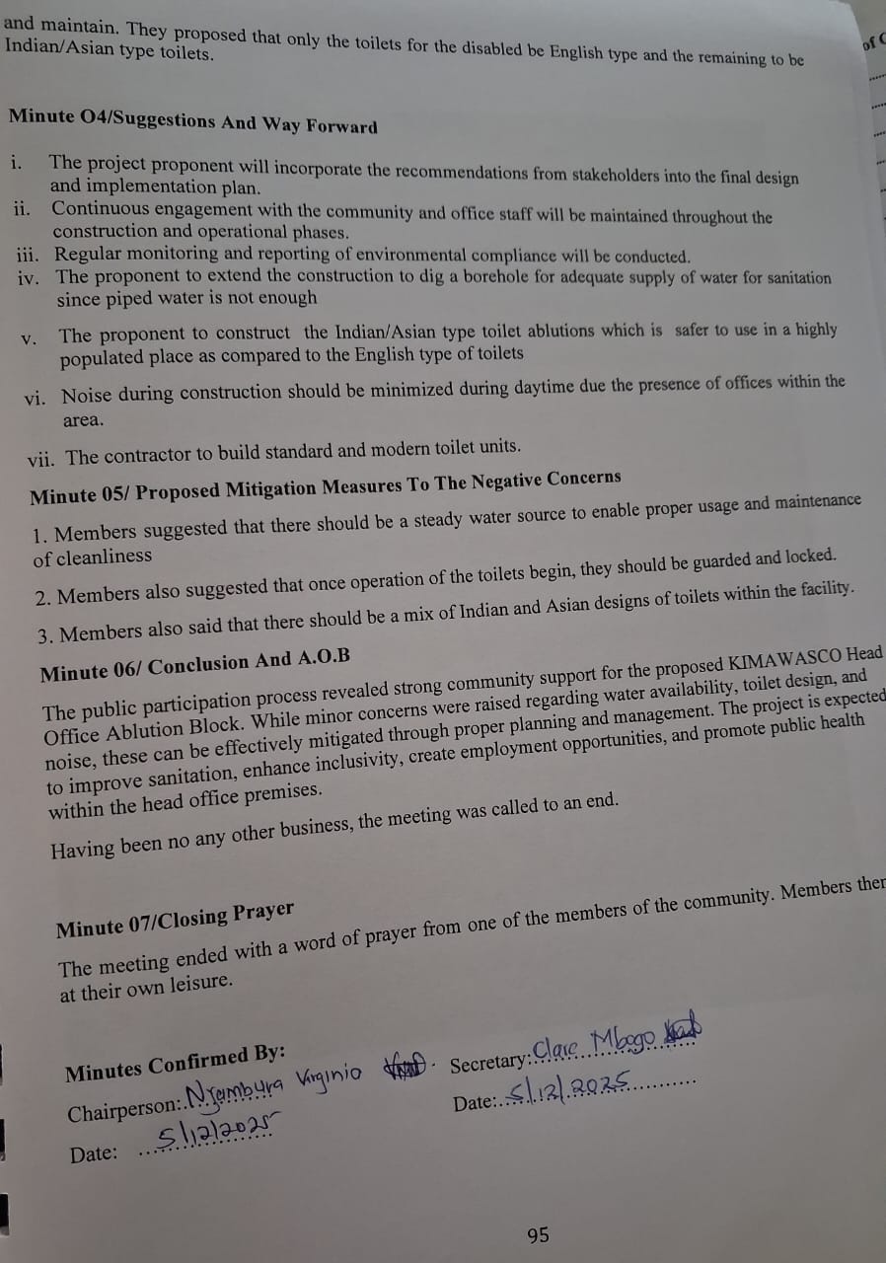

ATTENDANCE LIST

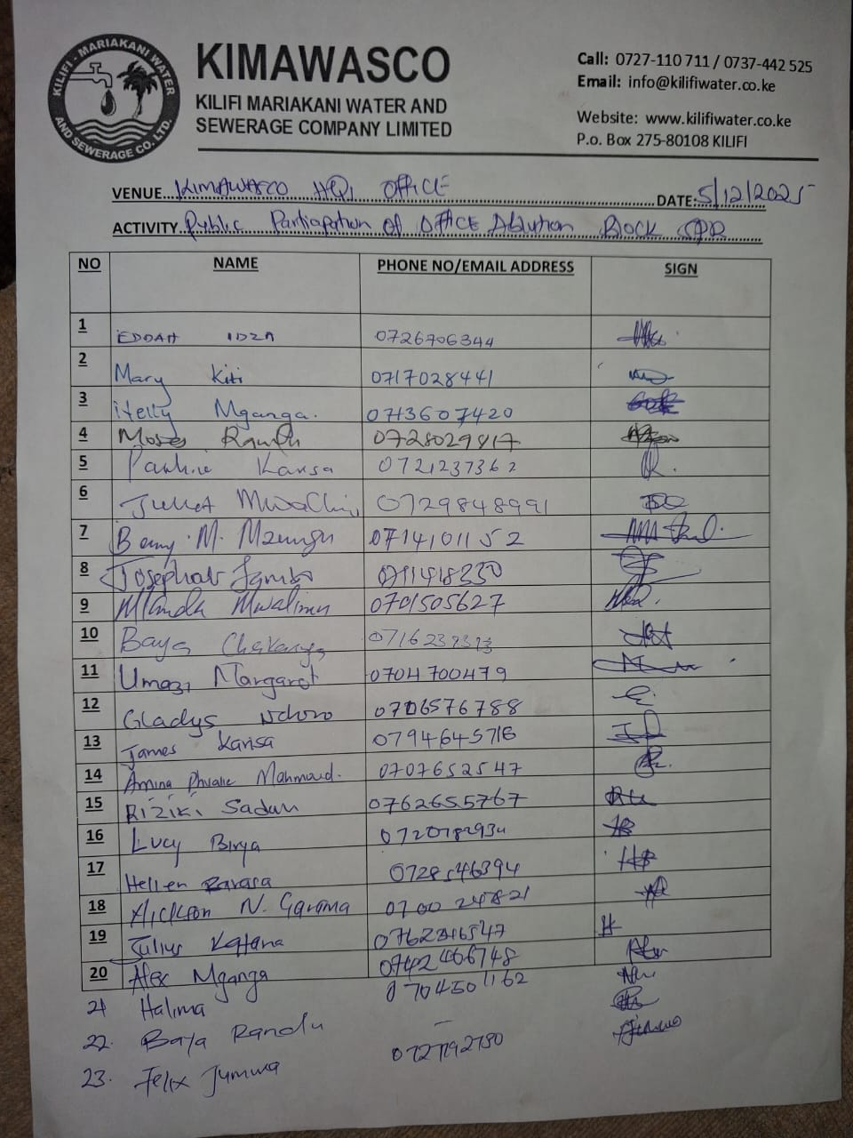

CONSULTATION PHOTOS

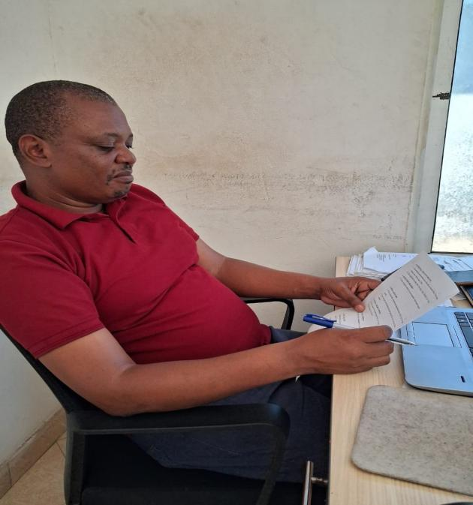 | 
KIMAWASCO staff filing in the project questionnaire | KIMAWASCO staff filing in the project questionnaire
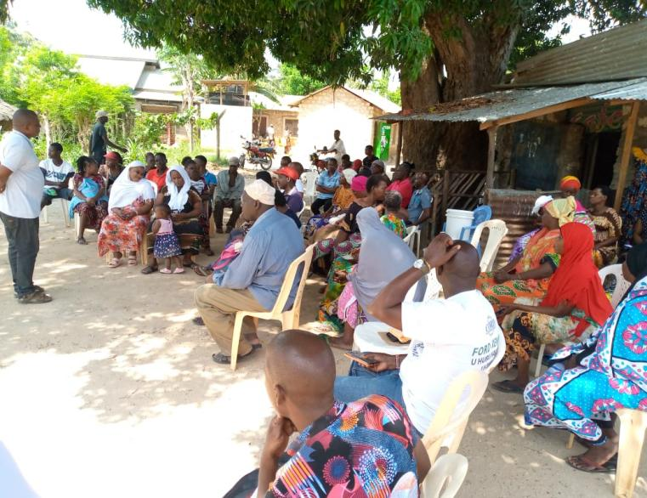 | 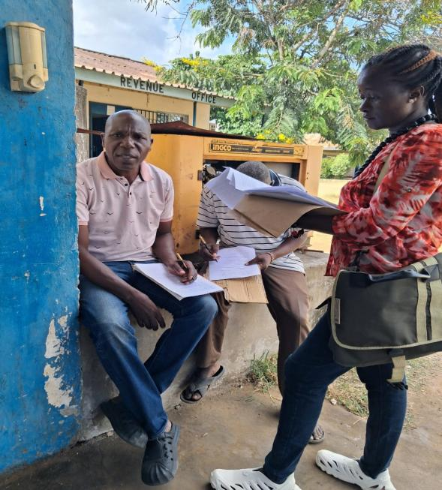
Meeting with neighbouring community for sensitization | KIMAWASCO staff filing in the project questionnaire
 | 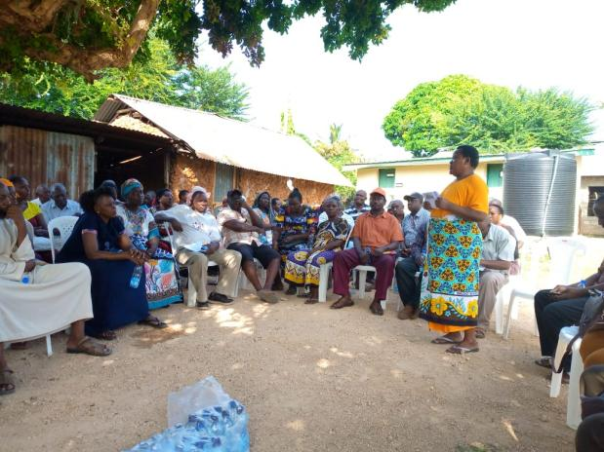
KIMAWASCO staff filing in the project questionnaire | Meeting with neighbouring community for sensitization

APPENDIX C: LAND OWNERSIP DOCUMENT
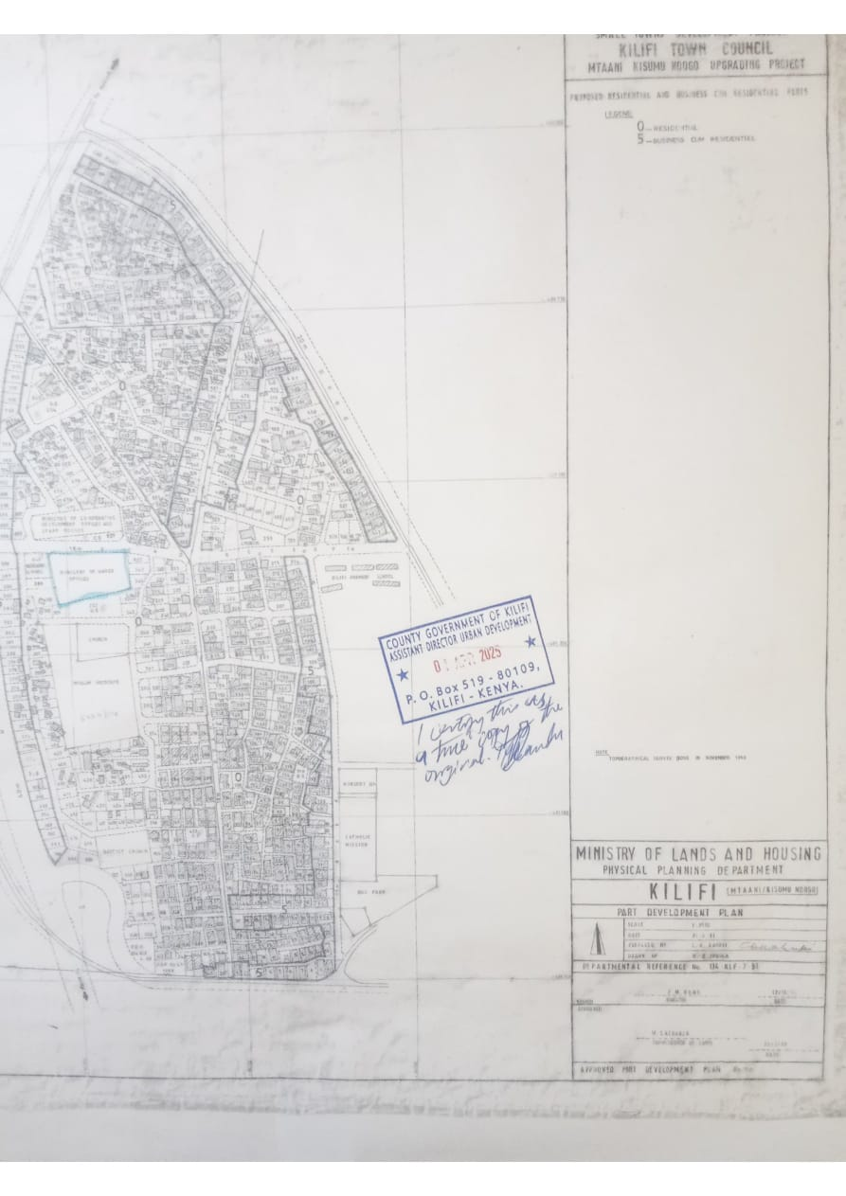

APPENDIX D: THE ABLUTION BLOCK DESIGN


KILIFI – MARIAKANI WATER AND SEWERAGE CO. LTD. (KIMAWASCO)

WATER AND SANITATION DEVELOPMENT PROJECT–(WSDP)

SANITATION ABLUTION BLOCKS WORKS FOR KILIFI-MARIAKANI WATER AND SEWERAGE COMPANY LTD. (KIMAWASCO)

CONSTRUCTION OF 12 NR. ABLUTION BLOCKS FOR KIMAWASCO

CONTRACT No: KE-KIMAWASCO-459000-CW-DIR

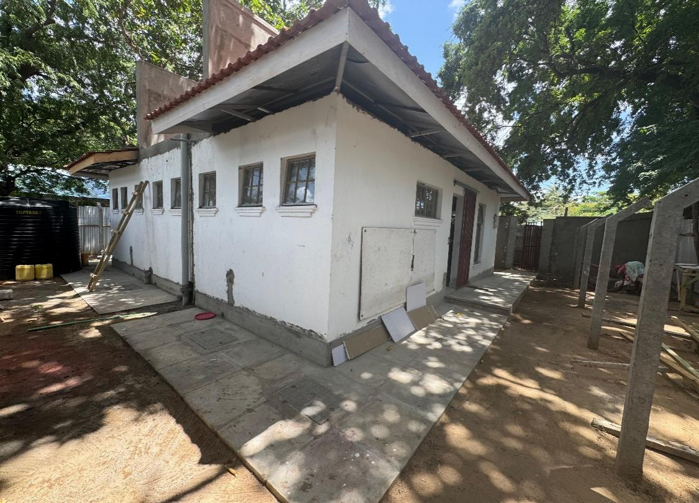
DESIGN REPORT FOR KIMAWASCO OFFICE ABLUTION BLOCK.

Employer:  KILIFI-MARIAKANI WATER & SEWERAGE CO. LTD  P.O. BOX 275, 80108  KILIFI, KENYA  Tel:: +254 727110711 / 737442525  Email: info@kilifiwater.co.ke |  |   Consultants: | MANGAT, I.B. PATEL (MIBP) LIMITED  CONSULTING ENGINEERS  P.O. BOX 48674, 00100 - GPO  NAIROBI, KENYA  E-mail: mibp.nairobi@mibp.co.ke  Tel: +254 - 20 - 2710500  Mobile: 0725 321 201
 |  |  | CES CONSULTING ENGINEERS  Salzgitter GmbH  Nordstraße 23  38106 Braunschweig, GERMANY  E-mail : gek@ces.de
OCTOBER 2025
“DOCUMENT CONTROL”
WATER AND SANITATION DEVELOPMENT PROJECT–(WSDP)

SANITATION ABLUTION BLOCKS WORKS FOR KILIFI-MARIAKANI WATER AND SEWERAGE COMPANY LTD. (KIMAWASCO)
CONSTRUCTION OF 1 NO. ABLUTION BLOCK

CONTRACT No: KE-KIMAWASCO-459000-CW-DIR

EMPLOYER:
Kilifi-Mariakani Water and Sewerage Company Ltd (KIMAWASCO)

CONSULTANT:

 |  | 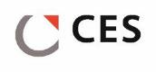
DOCUMENT TITLE: DESIGN REPORT FOR KIMAWACO OFFICE ABLUTION BLOCK

VERSION 01
RECORDS FOR REVISION

VER.: | DATE: | DESCRIPTION/PURPOSE OF ISSUE: | PREPARED BY: | CHECKED BY: | APPROVED BY:
01 | 8th October 2025 | DESIGN REPORT FOR KIMAWASCO ABLUTION BLOCK | M.Kioko  ----------- | N. Hirani  ---------- | R.S. Rupra  ------------

- Table of Contents
DECLARATION ii
EXECUTIVE SUMMARY iii
1 INTRODUCTION 1
Need For the Project 1
The Terms of Reference 2
ESIA Objectives 2
Methodology 3
1.1.1 Environment and Social Scoping 3
1.1.2 Stakeholder Consultations 3
1.1.3 Socio-economic Assessment 4
2 PROPOSED PROJECT DESCRIPTION 5
2.1 Project Area Description 5
2.1.1 Location and Administration 5
2.1.2 Background to the proposed project 7
2.1.3 Location for the Office Site ablution block 7
Existing Water Supply, Demand and Sanitation Systems 9
2.1.4 Water Supply 9
2.1.5 The Ablution Block 10
2.1.6 Implementation Cost for Immediate Measures 13
3 BASELINE CONDITIONS OF AFFECTED ENVIRONMENT 14
3.1 Flora and fauna 14
Socio-Economic activities and Infrastructure 14
3.1.1 Economic Activities 14
3.1.2 Land Use 15
3.1.3 Access to Energy 19
3.1.4 Population Density and Distribution 20
3.1.5 Access to Health 20
3.1.6 Common Health Problems 21
3.1.7 HIV and AIDS Prevalence Rates 22
3.1.8 Gender Based Violence 22
3.1.9 Posts and Telecommunications 22
3.1.10 Transport 23
Physiographic and Environmental Conditions 23
3.1.11 Climate 23
3.1.12 Topography 24
3.1.13 Geology and Soils 24
3.1.14 Hydrology and Drainage 25
HOUSEHOLD SOCIO-ECONOMIC SURVEY 25
3.1.15 Population dynamics and household characteristics 26
3.1.16 Water Supply 29
3.1.17 Sanitation 31
3.1.18 Environmental Situation 32
3.1.19 The Project 34
4 Stakeholder Engagement and Public Consultation 36
General 36
Applicable Laws, Regulations and Policies to Public Engagement 36
Public Participation Methodology 36
4.1.1 Questionnaire Administration 36
4.1.2 Public Participation Meetings 37
Consultation During Project Duration 37
4.1.3 Community Relations in Construction Phase 38
4.1.4 Construction Contractor’s Role in Community Liaison 38
4.1.5 Community Relations in Operational Phase 39
4.1.6 Grievance Redress Management Plan 39
5 ALTERNATIVES TO THE PROJECT 40
No Action Alternative 40
Design Alternative 40
Site Alternative 40
6 RELEVANT LEGISLATIVE/ REGULATORY FRAMEWORK 41
Policy Framework 41
6.1.1 National Environment Policy (NEP) 2013 41
6.1.2 Kenya Vision 2030 41
6.1.3 The National Environmental Sanitation and Hygiene Policy-July 2007 41
6.1.4 National Gender and Development Policy, 2019 42
6.1.5 National policy for prevention and response to gender-based violence, 2014 42
Legal Framework 42
6.1.6 Environmental Management and Coordination Act of 1999 (EMCA) and Environmental Management and Coordination (Amendment) Act 2015 42
6.1.7 Environment and Land Court Act, 2011 42
6.1.8 Land Act, 2012 43
6.1.9 County Government Act No. 17 of 2012 43
6.1.10 Physical and Land Use Development Plan Act 2019 43
6.1.11 Occupational Health and Safety Act (OSHA), 2007 44
6.1.12 HIV and AIDS Prevention and Control Act 2011 44
6.1.13 Sexual Offences Act 2006 44
6.1.14 Child Rights Act (Amendment Bill) 2014 44
6.1.15 Labour Relations Act 2012 44
6.1.16 Traffic Act 2015 45
6.1.17 Public Health Act, Cap 242 45
Regulations and Rules 45
6.1.18 The Environmental (Impact Assessment and Audit) Regulations, 2003 amended in 2019 45
6.1.19 Environmental Management and Coordination (Water Quality) Regulations, 2006 45
6.1.20 Environmental Management and Coordination, Waste Management Regulations, 2006 46
6.1.21 Environmental Management and Coordination, Noise and Excessive Vibration Pollution (Control) Regulations, 2009 46
6.1.22 Environmental Management and Coordination (Air Quality Regulations 2014) 46
6.1.23 Fire Risk Reduction Rules, 2007 46
6.1.24 Safety and Health Committee Rules of 2004 46
6.1.25 First Aid in the Workplace Regulations, 2024, Legal Notice 79 of 2024 46
7 ENVIRONMENT AND SOCIAL IMPACTS OF THE PROPOSED PROJECT 48
Impacts Emanating from the Proposed Project 54
8 ENVIRONMENTAL AND SOCIAL MANAGEMENT PLAN (ESMP) 69
Significance of ESMP 69
Purpose and Objectives of ESMP 69
Auditing of ESMP 69
Project implementation 69
Environmental and Social Monitoring Plan 79
Grievance Redress Mechanism 86
8.1.1 Possible Sources of Grievances 86
Institutional Framework for Implementation of the Project and the ESMP 89
9 CONCLUSIONS AND RECOMMENDATIONS 90
10 REFERENCES 91
1.1. INTRODUCTION 112
1.2. ABLUTION BLOCK DESIGN 113
11.1.1 113
1.2.1. Proposed Layout 113
11.1.2 List of Appendices 115
DESIGN REPORT FOR KIMAWASCO ABLUTION BLOCK

INTRODUCTION
Most Coastal Towns except Mombasa Island and West Mainland lack operational and adequate Sewerage Systems and Sewage Treatment Plant(s). Consequently, majority of residents rely on on-plot sanitation means such as pit latrines and septic tanks. Currently, a major setback of the use of these on-plot sanitation systems is lack of proper sludge handling facilities which would ensure adequate further treatment and disposal of sludge once these systems are emptied. This unregulated and haphazard disposal of untreated sewage sludge has resulted to pollution of the environment and prevalence of water-borne diseases.
As part of the recommendations of the Master Plan, each of the project Towns is planned to have a Sewerage System and Sewage Treatment Plant(s) for improved sanitation. However, as an immediate intervention, Ablution Blocks and Sludge Handling Facilities are to be developed for the Project Towns, which currently lack adequate sanitation systems. It was upon this background that the development of an ablution block was proposed to be built in KIMAWASCO’S office to serve the customers, employees and general public accessing KIMAWASCO grounds for services.

ABLUTION BLOCK DESIGN

Proposed Layout
The design of the proposed ablution block inside the Kimawasco Office is set to comprise of:
- 8 Nr. Toilets; 4 Nr Male and 4 Nr. Female
- 4 Nr. Shower Rooms; 2 for each Gender.
- 1 Nr. Storeroom
Separate urinals will be provided within the "gents" to increase the number of people that can use the facility especially during the peak hours.
A septic tank with a holding capacity of 15.9 m3 will be connected to the facility for holding and partial treatment of sewage. This size of septic tank will require desludging after an interval of 3 months.
Every facility will comprise of separate washroom sections for ladies and gentlemen (gents) with equal number of toilets. Each section (for ladies and gents) will be provided with one toilet fitted with special amenities for access and use by disabled persons. Two shower rooms equipped with a dressing area, hand-wash basins, mirrors as well as a 900 mm high worktop will also be provided in each section.
Each of the units shall be fitted with coat hangers behind the doors for the convenience of the users. Proper ventilation shall be enhanced by the louvered windows and gap between the ring beam and the roof fitted with louvre blocks and plastic coated coffee tray wires to prevent insect entry.
A 2,000 litre water tank shall be installed to provide a 3-day storage of the volume required. The tanks will be mounted on top of the roof slab for supply of water to the ablution block especially in emergency cases. Electricity will be also provided for use at night and for security lighting.
A typical Site Layout, Plan and Elevations of the proposed Ablution Block are given in Figure 1.1 on Page 6 below.
A proposed BoQ estimate for carrying out the works is attached in Appendix 1.

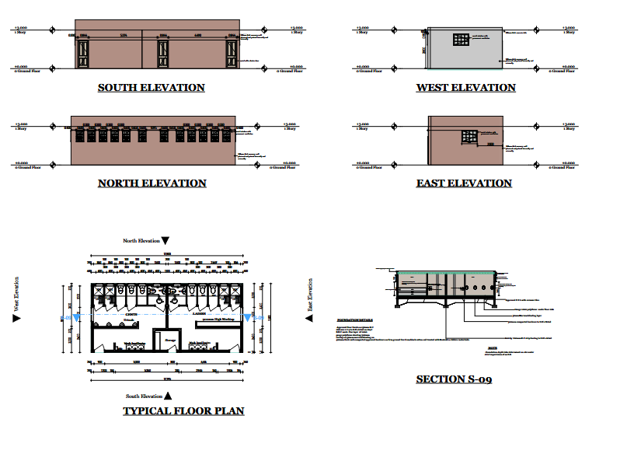
Figure 28 : Layout, elevations and a sectional view of the proposed Kimawasco Office Ablution Block

List of Appendices

Appendix 1: Revised Bills of Quantities

Appendix 1
Revised Bills of Quantities

1 | SUB-STRUCTURES
 | SITE CLEARANCE & TOP SOIL STRIPPING
1.1 | Clear area within the site of all grass, bushes, shrubs, hedges, grub up roots and cart away to tips as directed by the Engineer. | m² | 200 | 300.00 | 60,000.00
 |  |  |  |  | -
1.2 | Cut down trees, grub up roots and burn debris. Girth n.e. 1.2m (Provisional). | Nr | 1 | 4,500.00 | 4,500.00
 |  |  |  |  | -
1.3 | Excavate over site for buildings, roads, etc.average 150mm deep to remove vegetable soil and stack part of material for use as and where directed by the Engineer, cart away surplus to tips. | m² | 200 | 450.00 | 90,000.00
 |  |  |  |  | -
 | EXCAVATION |  |  |  | -
 | The rates shalll include for all strutting, shuttering, stabilising the excavation faces, and keeping the excavation free of water by pumping, bailing or other means. |  |  |  | -
 |  |  |  |  | -
1.4 | Excavate below stripped level to formation level in common material, part backfill after construction and remainder, cart away to tips or use as fill on site, all as directed by the Engineer. Maximum depth n.e. 1.0 m | m³ | 40 | 1,000.00 | 40,000.00
 |  |  |  |  | -
1.5 | -Ditto- but maximum depth 1.0 m to 2.0 m | m³ | 20 | 1,000.00 | 20,000.00
 |  |  |  |  | -
 | Extra Over Excavation in any Position For:- (Provisional) |  |  |  | -
 |  |  |  |  | -
1.6 | Excavating in rock Class "A" | m³ | 15 | 3,500.00 | 52,500.00
 |  |  |  |  | -
1.7 | Excavating in rock Class "B" | m³ | 9 | 3,500.00 | 31,500.00
 |  |  |  |  | -
1.8 | Excavating in rock Class "C" | m³ | 6 | 3,500.00 | 21,000.00
 |  |  |  |  | -
 | Approved Selected Filling as Described:- |  |  |  | -
 |  |  |  |  | -
1.9 | Fill and ram selected excavated materials around foundations and buildings. | m³ | 40 | 2,500.00 | 100,000.00
 |  |  |  |  | -
 | Approved Hardcore Filling as Described:- |  |  |  | -
 |  |  |  |  | -
1.10 | Provide and deposit approved imported hardcore in maximum 150mm thick layers in making up levels including achieving satisfactory compaction. | m³ | 23 | 2,000.00 | 46,000.00
 |  |  |  |  | -
1.11 | Provide, lay and level out fine crushed stone, sand or gravel blinding 50mm thick to surface of filling, including watering and rolling to achieve satisfactory compaction. | m² | 150 | 1,000.00 | 150,000.00
 |  |  |  |  | -
 | Disposal of Surplus Spoil:- |  |  |  | -
 |  |  |  |  | -
1.12 | Cart away surplus excavated materials to an approved dumping site. | m³ | 20 | 850.00 | 17,000.00
 |  |  |  |  | -
 | Anti-Termite Treatment |  |  |  | -
 |  |  |  |  | -
1.13 | Chemical anti-termite treatment to surface of filling with an approved insecticide. | m² | 150 | 1,000.00 | 150,000.00
 |  |  |  |  | -
 | Damp-proof Membrane |  |  |  | -
 |  |  |  |  | -
1.14 | 500 Gauge polythene sheeting, laid over hardcore | m² | 150 | 1,000.00 | 150,000.00
 |  |  |  |  | -
 | Concrete Work: |  |  |  | -
 |  |  |  |  | -
 | Mass Concrete Class 15/20mm Maximum Aggregate as Described in:- |  |  |  | -
 |  |  |  |  | -
1.15 | 50mm Thick blinding under foundation concrete, column bases or over hardcore | m² | 150 | 1,500.00 | 225,000.00
 |  |  |  |  | -
 | Guaranteed Strength Reinforced Concrete Class 25/20mm Maximum Aggregate as Described in:- |  |  |  | -
 |  |  |  |  | -
1.16 | Foundation trenches for strip footing | m³ | 8 | 25,000.00 | 200,000.00
 |  |  |  |  | -
1.17 | Column footing | m² | 1 | 25,000.00 | 25,000.00
 |  |  |  |  | -
1.18 | Columns | m² | 1 | 25,000.00 | 25,000.00
 |  |  |  |  | -
1.19 | 150mm thick surface bed | m² | 23 | 3,000.00 | 69,000.00
 |  |  |  |  | -
1.20 | 150mm thick ramp laid to slope not exceeding 15 degrees fromhorizontal at entrance | m² | 2 | 3,000.00 | 6,000.00
 |  |  |  |  | -
1.21 | Extra over concrete for tamping whilst still green to make ribbed finish | m² | 2 | 3,000.00 | 6,000.00
 |  |  |  |  | -
 | Reinforcement |  |  |  | -
 |  |  |  |  | -
 | Fabric Reinforcement No. A142 Mesh Size 200 x 200mm Weighing 3.95 kgs Per m², Including Bends, Tying Wire and Distance Blocks:- |  |  |  | -
 |  |  |  |  | -
1.22 | Fabric reinforcement with minimum 200mm wide side and end laps, laid in bed. | m² | 150 | 750.00 | 112,500.00
 |  |  |  |  | -
 | Provide and Fix High Tensile Steel Reinforcement to SRN 127 including Cutting, Bending, Propping with Spacers and Tying as Specified :- |  |  |  | -
 |  |  |  |  | -
1.23 | Reinforcement, all diameters | Kg | 970 | 375.00 | 363,750.00
 |  |  |  |  | -
 | Formwork |  |  |  | -
 |  |  |  |  | -
 | Provide and Fix Shuttering Including Propping, Strutting and Striking, all as Specified |  |  |  | -
 |  |  |  |  | -
 | Sawn Formwork - Class F1 Finish:- |  |  |  | -
 |  |  |  |  | -
1.24 | Vertical sides of strip footing | m² | 65 | 450.00 | 29,250.00
 |  |  |  |  | -
1.25 | Vertical sides of column bases | m² | 7 | 850.00 | 5,950.00
 |  |  |  |  | -
1.26 | Vertical sides of column | m² | 11 | 850.00 | 9,350.00
 |  |  |  |  | -
 |  |  |  |  | -
 |  |  |  |  | -
 | Wrot Formwork - Class F3 Finish:- |  |  |  | -
 |  |  |  |  | -
1.27 | Edges of beds, pavings, plinths and risers of steps not exceeding 300mm wide. | m | 65 | 300.00 | 19,500.00
 |  |  |  |  | -
 | Walling. |  |  |  | -
 |  |  |  |  | -
 | Solid Concrete Block Walling With Concrete Blocks to BS 2028, Type "A" with Minimum Crushing Strength of 3.7N/mm² at 28 Days, Reinforced with 20 swg Hoop Iron at alternate course, and Bedded, Jointed and Pointed in Cement Mortar (1:4):- |  |  |  | -
 |  |  |  |  | -
1.28 | 200 mm Walling | m² | 40 | 4,500.00 | 180,000.00
 |  |  |  |  | -
 | Damp-proof course: |  |  |  | -
 |  |  |  |  | -
 | Bituminous felt damp-proof course as described:- |  |  |  | -
 |  |  |  |  | -
1.29 | 200mm Wide under walls | m | 65 | 750.00 | 48,750.00
 |  |  |  |  | -
1.30 | 100mm Wide under walls | m | 15 | 750.00 | 11,250.00
 | Sub-Total for Sub-Structures |  |  |  | 2,268,800.00
 |  |  |  |  | -
 | SUPERSTRUCTURE |  |  |  | -
 |  |  |  |  | -
2 | CONCRETE, FORMWORK, REINFORCEMENT |  |  |  | -
 |  |  |  |  | -
 | Guaranteed Strength Reinforced Concrete Class 25/20mm as Described in: |  |  |  | -
 |  |  |  |  | -
2.1 | Ring beams 200x200mm | m³ | 3 | 18,000.00 | 54,000.00
 |  |  |  |  | -
2.2 | Roof slab 150mm thick | m³ | 13 | 18,000.00 | 234,000.00
 |  |  |  |  | -
2.4 | Columns 200x200mm | m³ | 2 | 18,000.00 | 36,000.00
 |  |  |  |  | -
 | Formwork |  |  |  | -
 |  |  |  |  | -
 | Provide and Fix Shuttering Including Propping, Strutting and Striking, all as Specified |  |  |  | -
 |  |  |  |  | -
 | Wrot Formwork - Class F3 Finish :- |  |  |  | -
 |  |  |  |  | -
2.5 | Roof Slab soffit | m² | 85 | 600.00 | 51,000.00
 |  |  |  |  | -
2.6 | Ring Beams | m² | 25 | 600.00 | 15,000.00
 |  |  |  |  | -
2.7 | Column | m² | 12 | 600.00 | 7,200.00
 |  |  |  |  | -
 | Reinforcement |  |  |  | -
 |  |  |  |  | -
 | Provide and Fix High Tensile Steel Reinforcement to SRN 127 Including Cutting, Bending, Propping with Spacers and Tying as Specified :- |  |  |  | -
2.9 | Reinforcement, all diameters | Kg | 1,800 | 300.00 | 540,000.00
 | Sub-Total for Super-Structures |  |  |  | 937,200.00
3 | WALLING |  |  |  | -
 |  |  |  |  | -
 | External Walls |  |  |  | -
 | Solid Concrete Block Walling With Concrete Blocks to BS 2028, Type "A" with Minimum Crushing Strength of 3.7N/mm² at 28 Days, Reinforced with 20 swg Hoop Iron at alternate course, and Bedded, Jointed and Pointed in Cement Mortar (1:4):- |  |  |  | -
 |  |  |  |  | -
3.1 | 200mm Thick walling | m² | 115 | 3,800.00 | 437,000.00
 |  |  |  |  | -
 | Labours |  |  |  | -
 |  |  |  |  | -
3.2 | Extra over walling for ruled horizontal and flush vertical joints | m² | 115 | 150.00 | 17,250.00
 |  |  |  |  | -
 | Precast Concrete Louvre Block Walling :- |  |  |  | -
 | Internal Walls |  |  |  | -
 | Solid Concrete Block Walling With Concrete Blocks to BS 2028, Type "A" with Minimum Crushing Strength of 3.7N/mm² at 28 Days, Reinforced with 20 swg Hoop Iron at alternate course, and Bedded, Jointed and Pointed in Cement Mortar (1:4):- |  |  |  | -
 |  |  |  |  | -
3.3 | 200mm Thick walling | m² | 115 | 3,800.00 | 437,000.00
 |  |  |  |  | -
3.4 | 100mm Thick walling | m² | 35 | 1,800.00 | 63,000.00
 | Sub-Total for Walling |  |  |  | 954,250.00
 |  |  |  |  | -
4 | WATERTANK |  |  |  | -
 | Supply, deliver and install a cylindrical polyethylene water storage tank, 2000 litres (2,000L capacity), including all fittings, base preparation, hoisting into position, and all necessary connections to inlet/outlet pipes as specified. |  |  |  | -
4.1 | TopTank Cylindrical Water Storage Tank 2000 Litres | Nr | 1 | 25,000.00 | 25,000.00
 | Sub-Total for Watertank |  |  |  | 25,000.00
5 | METALWORK |  |  |  | -
 |  |  |  |  | -
 | Pressed Metal Louvre Doors |  |  |  | -
 |  |  |  |  | -
 | Supply and Fix the following Pressed Metal Louvre Doors with 100 x 50mm Stiles and Top Rails, 150 x 50mm Middle and Bottom Rails With Pressed Metal Infill Louvres and 100 x 50mm Pressed Metal Frames, Including Hinges, Pad Bolts and Tower Bolts, All To Manufacturer's Details, with three coats gloss paint complete with Opening Accessories Including Bedding and Pointing Around Frames in Cement Mortar:- |  |  |  | -
 |  |  |  |  | -
5.2 | Single door size 900 x 2400mm high (D2) | Nr | 2 | 18,000.00 | 36,000.00
 |  |  |  |  | -
 | Windows  Supply and fix the following Standard Section Steel Casement Windows, including 4mm Thick Clear Sheet Glass glazed to steel casements with putty. Complete with opening accessories, including building in lugs ti jambs and head and water-proofing and filing around opening with approved compound; and including burglar proofing fabricated from 12 x 12mm mild steel square bars at 150mm centres vertically and 150mm horizontally and fixed internally to surrounding wall with 12mm mild steel fish-tailed lugs at maximum 600mm centres; all finished with three coats oil paint |  |  |  | -
 |  |  |  |  | -
5.4 | Steel casement windows size 797mm x 1597mm | Nr | 2 | 8,500.00 | 17,000.00
 |  |  |  |  | -
5.4 | Steel casement windows size 797mm x 1597mm | Nr | 10 | 8,500.00 | 85,000.00
 |  |  |  |  | -
5.4 | Steel casement windows size 797mm x 1597mm | Nr | 2 | 8,500.00 | 17,000.00
 | Sub-Total for Metalwork |  |  |  | 155,000.00
 |  |  |  |  | -
6 | TIMBER DOORS |  |  |  | -
 |  |  |  |  | -
 | Door Frame |  |  |  | -
 |  |  |  |  | -
 | Wrot Cypress Door Frames size 100 x 50mm with a suitable rebate to receive hinged door panel, including suitable mild steel clamps fixed to back of frame and fixing to door opening size and all necessary woodwork finishes (prepare, knot, prime, stop and apply two undercoats and one finishing coat hard gloss paint to woodwork):- |  |  |  | -
6.1 | Frame to fit door opening 700mm wide x 2100mm high. | Nr | 10 | 3,500.00 | 35,000.00
 |  |  |  |  | -
6.2 | Frame to fit door opening 800mm wide x 2100mm high. | Nr | 3 | 3,500.00 | 10,500.00
 |  |  |  |  | -
6.3 | Frame to fit door opening 900mm wide x 2100mm high. | Nr | 2 | 3,500.00 | 7,000.00
 | Doors  Supply and fix 50mm thick prime grade cypress panelled door with 50mm x 100mm stiles and top rails, 50 x 150mm middle and bottom rails and infill panels in 50 x 100mm T & G battens. Rate to include for 3 Nr 100mm steel heavy duty washered butt hinges, three lever mortice lock as "Union" Ref 681-06-02 and rubber door stop and three coats of gloss paint complete with bedding and pointing around frames in cement mortar. (See door Details in Standard Drawings):- |  |  |  | -
6.4 | Door Size 700mm wide x 2080mm high. | Nr | 10 | 10,000.00 | 100,000.00
 |  |  |  |  | -
6.5 | Door Size 800mm wide x 2080mm high. | Nr | 3 | 11,000.00 | 33,000.00
 |  |  |  |  | -
6.6 | Door Size 900mm wide x 2080mm high. | Nr | 2 | 11,000.00 | 22,000.00
 |  |  |  |  | -
6.7 | Stainless steel buffer coat hooks | Nr | 12 | 300.00 | 3,600.00
 |  |  |  |  | -
6.8 | 100mm D-Pull handles | Nr | 12 | 500.00 | 6,000.00
 | Sub-Total for Timber Doors |  |  |  | 217,100.00
 |  |  |  |  | -
7 | CEILING |  |  |  | -
 |  |  |  |  | -
 | 12mm Thick Approved Plasterboard in Sheets Size 2400 x 1200mm Fixed to and Including 50 x 50mm Sawn Cypress Grade 2 Battens at 600mm Centres in Both Directions Complete with Gauge Jointing Material |  |  |  | -
 |  |  |  |  | -
7.1 | Horizontal ceiling fixed to underside of trusses | m² | 300 |  | -
 |  |  |  |  | -
7.2 | 12mm Cornice 50mm high, plugged | m | 110 |  | -
 |  |  |  |  | -
7.3 | Extra over ceiling lining for forming removable access trap door size 600 x 600mm with 100 x 38 mm sawn treated cypress trimming joists between tie beams,120 x 20mm (finished ) wrot cypress frame all round and 20mm blockboard removable panel set loose on top of framing | Nr | 2 |  | -
 | Sub-Total for Ceiling |  |  |  | -
 |  |  |  |  | -
7 | RENDERING |  |  |  | -
 |  |  |  |  | -
 | 12.5mm Thick Cement and Sand Render as Described Externally on :- |  |  |  | -
 |  |  |  |  | -
7.1 | Blockwork and concrete surfaces | m² | 80 | 400.00 | 32,000.00
 |  |  |  |  | -
 | Screeds |  |  |  | -
 | Bonded cement and sand (1:4) screed bed in one coat, well bonded to concrete base as described:- |  |  |  | -
 |  |  |  |  | -
7.2 | 38mm Thick screed laid level to receive floor tiling (measured separately) | m² | 85 | 400.00 | 34,000.00
 |  |  |  |  | -
7.3 | 12mm (minimum) Thick Cement and sand backing (1:4) with approved plasticiser to receive granito floor laid to skirtings, treads and risers (measured separately) | m² | 13 | 400.00 | 5,200.00
 |  |  |  |  | -
 | Bonded cement and sand (1:4) screed bed in one coat with approved hardener incorporated in the mix, well bonded to concrete base as described:- |  |  |  | -
 |  |  |  |  | -
 | Bonded cement and sand (1:4) screed bed in one coat with approved hardener incorporated in the mix, well bonded to concrete base as described:- |  |  |  | -
 |  |  |  |  | -
7.4 | 12mm (minimum) Thick screed laid level to receive ceramic wall tiles (measured separately) | m² | 150 | 250.00 | 37,500.00
 | Sub-Total for Rendering |  |  |  | 108,700.00
 |  |  |  |  | -
8 | PLASTERING |  |  |  | -
 |  |  |  |  | -
 | 12.5mm Thick Gauged Cement Plaster as Described Internally on :- |  |  |  | -
 |  |  |  |  | -
8.1 | Blockwork and concrete surfaces | m² | 70 | 350.00 | 24,500.00
 | Sub-Total for Plastering |  |  |  | 24,500.00
 |  |  |  |  | -
9 | PAINTING AND DECORATING |  |  |  | -
 |  |  |  |  | -
 | Prepare and Apply Three Coats Exterior Quality Plastic Emulsion Paint:- |  |  |  | -
 |  |  |  |  | -
 | Externally on:- |  |  |  | -
 |  |  |  |  | -
9.1 | Fair-faced concrete surfaces | m² | 70 | 275.00 | 19,250.00
 |  |  |  |  | -
 | Internally on:- |  |  |  | -
 |  |  |  |  | -
 | Wall Tiles |  |  |  | -
 |  |  |  |  | -
 | Coloured Ceramic Wall Tiles from Saj Co. as supplied by M/s Tile & Carpet Centre, or other equal and approved |  |  |  | -
 |  |  |  |  | -
9.2 | 200 x 300mm Thick coloured wall tiles laid on backing (measured separately) and joints filled in approved filler to match colour of tiles | m² | 150 | 1,200.00 | 180,000.00
 |  |  | .
 | Sundries |  |  |  | -
 |  |  |  |  | -
9.3 | PVC tiling edge to external corners of tiles (Provisional) | m | 100 | 100.00 | 10,000.00
 | Sub-Total for Painting and Decorating |  |  |  | 209,250.00
 |  |  |  |  | -
10 | FLOOR FINISHES |  |  |  | -
 |  |  |  |  | -
 | Ceramic Floor Tiling |  |  |  | -
 |  |  |  |  | -
 | Coloured Ceramic Floor Tiles from Saj Co. as supplied by M/s Tile & Carpet Centre, or other equal and approved |  |  |  | -
 |  |  |  |  | -
10.1 | 300 x 300mm Tiles laid on screed (measured separately) and joints filled in approved filler to match colour of tiles | m² | 85 | 1,500.00 | 127,500.00
 |  |  |  |  | -
10.2 | Ditto but laid as skirting 100mm high | m | 13 | 500.00 | 6,500.00
 | Sub-Total for Floor Finishes |  |  |  | 134,000.00
 |  |  |  |  | -
11 | PLUMBING AND DRAINAGE |  |  |  | -
 |  |  |  |  | -
 | Builders Work in Connection with Sanitary Fittings |  |  |  | -
 | Allow for cutting and leaving all necessary holes, notches, mortices, sinkings and chases both in the structure and its finishes and for all making good in connection with the following (All Provisional): - |  |  |  | -
 |  |  |  |  | -
11.1 | White vitreous china squatting level washdown W.C. suite complete | Nr | 6 | 3,750.00 | 22,500.00
 |  |  |  |  | -
11.2 | Hand held Bidet Shower complete | Nr | 6 | 3,000.00 | 18,000.00
 |  |  |  |  | -
11.3 | White vitreous china washbasin complete | Nr | 6 | 4,000.00 | 24,000.00
 |  |  |  |  | -
11.4 | Shower unit complete | Nr | 2 | 4,500.00 | 9,000.00
 |  |  |  |  | -
11.5 | Mirror size 3000 x 600mm | Nr | 2 | 2,000.00 | 4,000.00
 |  |  |  |  | -
11.6 | Toilet roll holder | Nr | 6 | 600.00 | 3,600.00
 |  |  |  |  | -
11.7 | Recessed soap tray | Nr | 2 | 600.00 | 1,200.00
 |  |  |  |  | -
11.8 | Chrome plated shower rail size 25mm diameter x 900mm long complete with fixtures | Nr | 2 | 1,250.00 | 2,500.00
 |  |  |  |  | -
11.9 | Electronic hand driyer | Nr | 2 | 7,500.00 | 15,000.00
 |  |  |  |  | -
11.10 | Collapsible seat in washroom | Nr | 2 | 15,000.00 | 30,000.00
 |  |  |  |  | -
11.11 | Collapsible baby changing platform | Nr | 2 | 1,150.00 | 2,300.00
 |  |  |  |  | -
 | Sanitary Appliances |  |  |  | -
 |  |  |  |  | -
11.12 | White vitreous china squatting level wash down Water Closet suit complete with high level 6 litre cistern and flush pipe. | Nr | 6 | 10,000.00 | 60,000.00
 |  |  |  |  | -
11.13 | 1.5m long polished chrome flexible hose,20mm dia. Handheld stainless steel bidet shower with flexible coupling | Nr | 6 | 2,500.00 | 15,000.00
 |  |  |  |  | -
11.14 | Urinal bowl with urinal automatic flushing system complete with cistern and flush pipes | Nr | 4 | 6,500.00 | 26,000.00
 |  |  |  |  | -
11.15 | Wall mounted washbasin as "Twyfords Entice 575" with one tap & 32mm waste grit *basin mixer as "Europath Astra" with aerator & pop -up waste.*32mm CP bottle trap with tail pipe, cap-nut & wall flange as "Cobra" 340 &C-342/1/2/3 or approved equivalent | Nr | 6 | 11,000.00 | 66,000.00
 |  |  |  |  | -
11.16 | Shower unit complete with shower head and all taps and connections to water tank and connection to foul water drainage | Nr | 2 | 8,500.00 | 17,000.00
 |  |  |  | .
11.17 | White vitreous china 1000mm x 1000mm basin for shower room | Nr | 2 | 6,750.00 | 13,500.00
 |  |  |  |  | -
11.18 | Mirror size 3000 x 600mm plugged and screwed to wall with chromium plated domed screws complete with 5mm thick foam back rest. | Nr | 2 | 3,000.00 | 6,000.00
 |  |  |  |  | -
11.19 | Drier shall be operated by infrared sensor which switches on when hands are placed are placed under the hot- air outlet. The machine switches off when the hands are withdrawn or after 40secs. It shall be capable of delivering 36Litres/sec of warm air at 50º C above ambient temperature at an average speed of 17m/s and a relative drying time of 35 seconds with a power supply of 2.2Kw 240V,50Hz."Starmix" Automatic Hand Drier Model No.T50E.or approved equivalent | Nr | 2 | 7,500.00 | 15,000.00
 |  |  |  | .
11.20 | Wall mounted collapsible 890mm x 560mm platform | Nr | 2 | 10,000.00 | 20,000.00
 |  |  |  |  | -
11.21 | Wall mounted collapsible 890mm x 560mm baby changing room | Nr | 2 | 10,000.00 | 20,000.00
 |  |  |  |  | -
 | Foul/Waste drainage |  |  |  | -
 |  |  |  |  | -
11.22 | Excavate pipe trench in ordinary ground for 160mm diameter pipe between n.e 2m | m | 25 | 400.00 | 10,000.00
 |  |  |  |  | -
11.23 | Provide lay and joint uPVC pipes golden brown Class 41 160mm diameter. Include for all fittings and connections to inspection chambers. | m | 25 | 450.00 | 11,250.00
 |  |  |  |  | -
11.24 | Allow a Provisional Sum of Kshs. 100,000 for plumbing works | Item | P.S | 100,000.00 | 100,000.00
 |  |  |  |  | -
 | Inspection Chambers |  |  |  | -
 |  |  |  |  | -
11.25 | Excavate for, provide all matterials,special shuttering e.t.c and construct 600 x 450mm internal dimentions in situ concrete inspection chambers on sewers diameter 160mm.Include for building in pipes,forming benching to falls,medium duty fibre reinforced frame and cover, depth n.e. 1.5m. | Nr | 6 | 5,000.00 | 30,000.00
 |  |  |  |  | -
 | Septic Tank |  |  |  | -
 |  |  |  |  | -
11.26 | Provide all materials and construct a 15.9m³ single chamber Septic Tank including manholes, covers, pipework, radial drains, connections etc as per details shown on Standard Drawings. | Nr | 1 | 1,600,000.00 | 1,600,000.00
 | Sub-Total for PLUMBING AND DRAINAGE |  |  |  | 2,141,850.00
 |  |  |  |  | -
12 | WATER SUPPLY |  |  |  | -
 |  |  |  |  | -
12.1 | Allow a Provisional Sum of Kshs. 30,000 for Connection of Ablution Block to existing water supply sytem including provision of meters etc. | Item | P.S | 30,000.00 | 30,000.00
 |  |  |  |  | -
12.2 | Allow a Provisional Sum of Kshs. 100,000 for supply and installation of the 1 Nr 5000 litres capacity "Roto" or approved water tank complete with provisions for inlet pipe, outlet pipe,overflow pipe and drain pipe to site drainage and requisite chambers. The rate to also include for ball valve 32mm diameter medium pressure ball valve as "PORTSMOUTH" type or approved equivalent with brass stem and plastic float, screwed to threaded socket of tank including union. Provide and install burglar proofing with mild steel frame around the tank as shown in Drawing No. M398-17-17 | Item | P.S | 100,000.00 | 100,000.00
 |  |  |  |  | -
13 | ELECTRICAL WORKS |  |  |  | -
 |  |  |  |  | -
13.1 | Allow a Provisional Sum of Kshs. 200,000 for connection to nearest KPLC power. | Item | P.S | 200,000.00 | 200,000.00
 |  |  |  |  | -
13.2 | Allow a Provisional Sum of Kshs. 250,000 for provision and installation of electric fittings and fixtures to the ablution block including all wiring, cabling, security lights,sockets, switches, Consumer Unit, Meters, lighting fixtures etc as directed by the Engineer. | Item | P.S | 250,000.00 | 250,000.00
 | Sub-Total for Water Supply |  |  |  | 450,000.00
 |  |  |  |  | -
14 | SITE AND ANCILLARY WORKS |  |  |  | -
 | FOOTPATHS |  |  |  | -
 |  |  |  |  | -
14.1 | Provide, lay and compact 150mm thick murram base to footpaths as specified (Provisional) | m² | 9 | 400.00 | 3,600.00
 |  |  |  |  | -
14.2 | Provide and apply approved weed killer to murram base for footpaths (Provisional) | m² | 9 | 125.00 | 1,125.00
 |  |  |  |  | -
14.3 | Precast concrete paving in 600mm x 600mm x 60mm slabs jointed and grouted up in lime and sand (1:3) | m² | 9 | 750.00 | 6,750.00
 |  |  |  |  | -
14.4 | E.O for providing all materials and constructing steps along footpath as directed (treads - 300mm, risers - 150mm) | m² | 5 | 950.00 | 4,750.00
 |  |  |  |  | -
 | FENCING AND GATES |  |  |  | -
 |  |  |  |  | -
14.5 | Excavate for post holes, provide all materials and construct Barbed Wire Fence on wattle posts posts at 3m centre to centre including straining posts at every 10th post and additional posts at corners as per the standard drawings | m | 90 | 3,500.00 | 315,000.00
 |  |  |  |  | -
14.6 | Provide all materials and construct metal gates 2.0m wide including 2Nr. Pillars, footing, etc all as detailed on per the standard drawings | Nr | 1 | 50,000.00 | 50,000.00
 |  |  |  |  | -
 | SURFACE WATER DRAINAGE & GRASSING |  |  |  | -
 |  |  |  |  | -
 | Earth Drains (Provisional) |  |  |  | -
 |  |  |  |  | -
14.7 | Excavate trapezoidal earth drains type 1 as shown on per the standard drawings to the lines and levels directed by the Engineer. Allow for trimming of sides to correct slopes and cart excavated material to tips. Depth to invert n.e. 1.0m | m | 10 | 325.00 | 3,250.00
 |  |  |  |  | -
14.8 | -Ditto- but depth to invert n.e. 2.0m | m | 5 | 275.00 | 1,375.00
 |  |  |  |  | -
14.9 | Provide and spread 100mm of approved top soil on the base of sides of the earth drain, rake and level to the requried profiles as directed by the Engineer (Provisional) | m² | 20 | 85.00 | 1,700.00
 |  |  |  |  | -
14.10 | Supply and plant approved grass on base and sides of the earth drain and maintenance until it takes root to the satisfaction of the Engineer (Provisional) | m² | 20 | 50.00 | 1,000.00
 |  |  |  |  | -
 | Culvert Pipes |  |  |  | -
 |  |  |  |  | -
14.11 | Excavate trench depth n.e. 2.5 m, supply, lay and joint for 525mm diameter precast concrete ogee pipes including concrete surround, backfill after laying of pipes, compact and cart away surplus material to tips | m | 6 | 4,500.00 | 27,000.00
 |  |  |  |  | -
 | Headwalls |  |  |  | -
 |  |  |  |  | -
14.12 | Excavate for, provide all materials and construct 225 mm thick masonry headwalls including concrete Class 15/20 footings, all in accordance with standard drawings. | Nr | 2 | 2,500.00 | 5,000.00
 |  |  |  |  | -
 | Grassing |  |  |  | -
14.13 | Spread Top Soil stacked on site (under item 1.3) in 100mm layers as directed, level and compact (light compaction) and prepare ready for grassing. Provide and plant approved grass and maintain until it takes root. The rate to include provision of manure approximate 0.01 kg per metre squared and spreading as directed by the Engineer | m² | 75 | 50.00 | 3,750.00
 | Sub-Total for SITE AND ANCILLARY WORKS |  |  |  | 424,300.00
 |  |  |  |  | -
15 | MISCELLANEOUS |  |  |  | -
 |  |  |  |  | -
15.1 | Provide and erect signboards as detailed on per the standard drawings. Include for painting, decorating and anchoring of the signboard to the ground using 300mm x 300mm x 600mm deep mass concrete footing, all as detailed. Note: Final wording on signboard to be decided in consultation with the Employer. | Nr | 1 | 12,500.00 | 12,500.00
 |  |  |  |  | -
15.2 | Allow a Provisional Sum of Kshs. 130,000 for provision and installation of furniture for the Ablution Block Office including cleaning Equipment. | Item | P.S | 130,000.00 | 130,000.00
 |  |  |  |  | -
15.3 | Allow a Provisional Sum of Kshs. 500,000 for use as directed by the Engineer on other works that may be unforseen e.g. demolition of existing structures, etc. | Item | P.S | 500,000.00 | 500,000.00
 | Subtotal for Miscellaneous |  |  |  | 642,500.00
 | GRAND TOTAL |  |  |  | 8,692,450.00

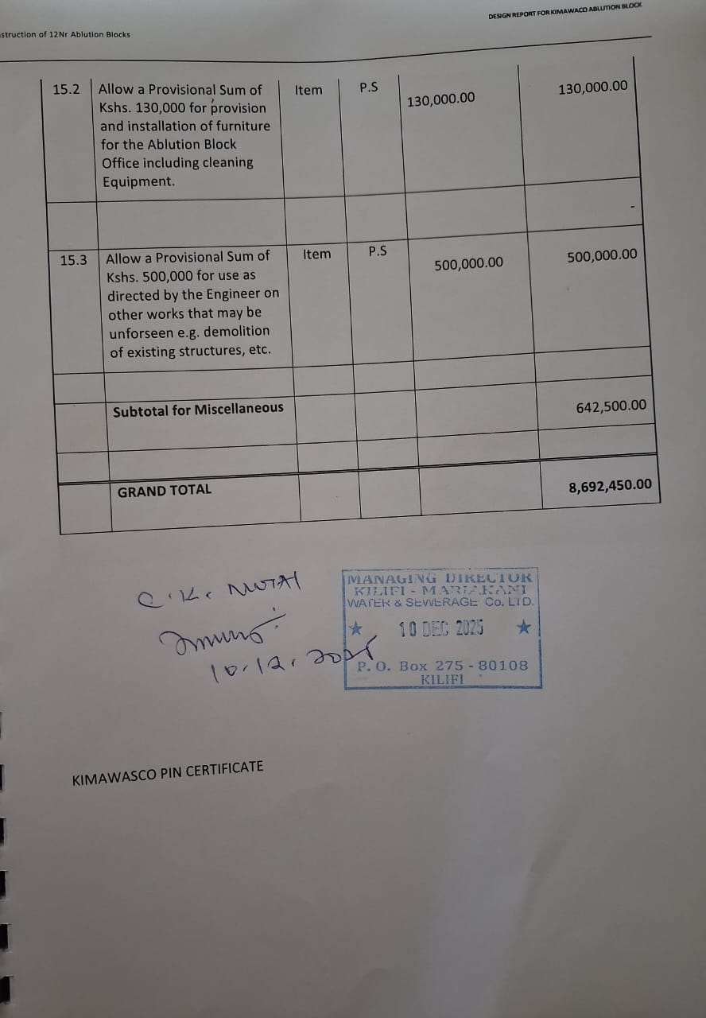

KIMAWASCO PIN CERTIFICATE



KIMAWASCO INCOPORATION CERTIFICATE
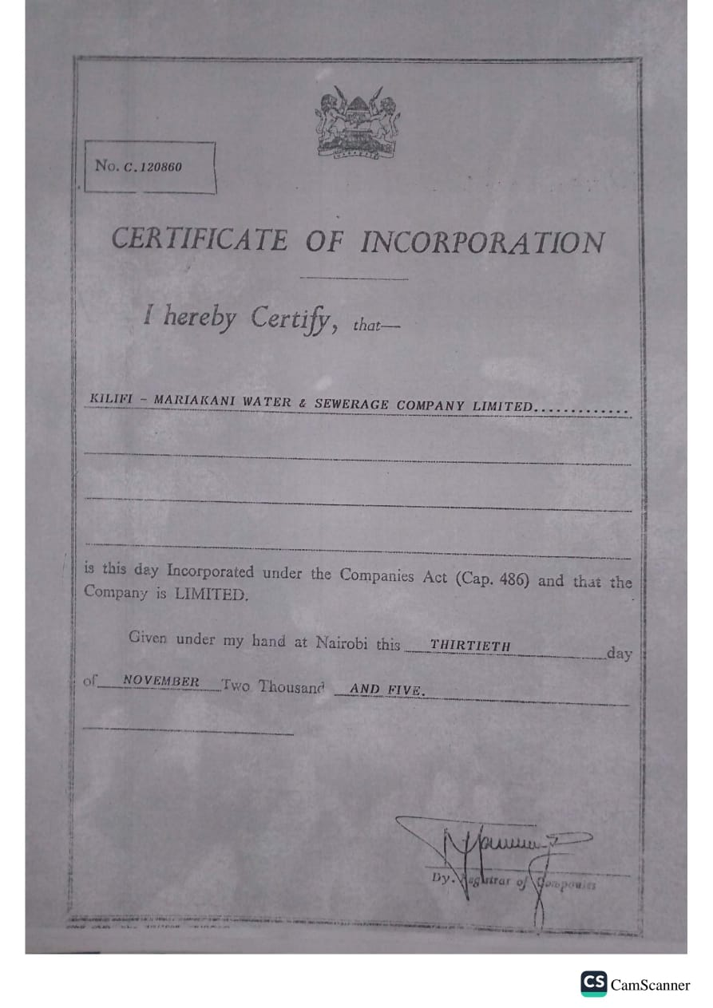

LEAD EXPERT LICENCE
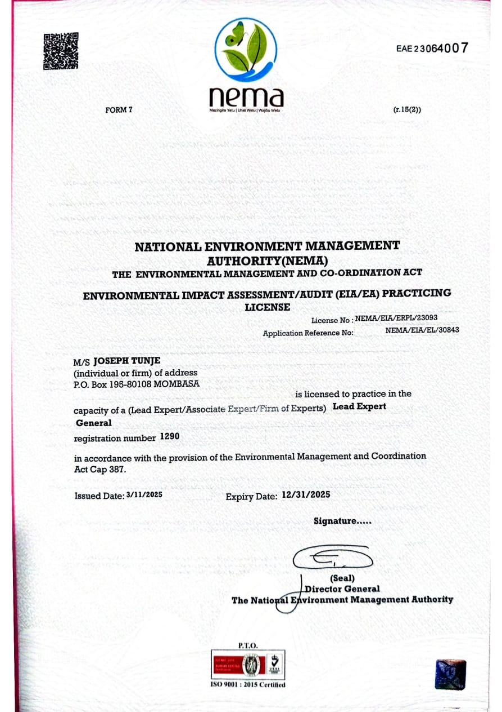

KIMAWASCO OFFICE LAYOUT

